
Campus Update

17th March 2023

Dear Parent/Carer,

We were pleased to be able to welcome parents to JGC on Wednesday evening for the first session of our “Raising Teens with Confidence” programme. Everyone in attendance was in agreement of the benefits of learning together in person, but we are aware that many parents who can’t attend the sessions are still interested in the content, so we are looking at ways we can support this. Further information will follow on the “Raising Children with Confidence” programme in the summer term.

Cyber security is another area where parents have expressed a wish for more information, with some of our primary and secondary families having recent first-hand experience of the challenges this can bring. You will have received a separate communication about an information session taking place in JGC next Tuesday, but a reminder of details has been included below. Again, we are looking at how we can share current advice and information with families who are unable to attend.

All parents should have received information about the inspection of JGC, which will be taking place week beginning 17th April. We are very much looking forward to welcoming the inspection team to Jedburgh and introducing them to our wonderful children and young people. If you haven’t done so already, we would be grateful if you would complete the online survey(s) – links below.

Many thanks



Susan Oliver
Headteacher

Learning Without Limits

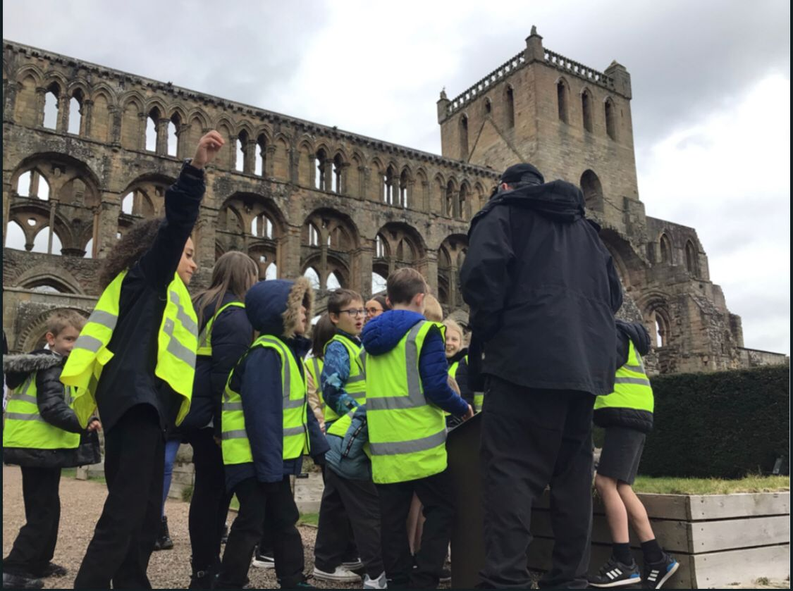
Jethart’s Here
P4 have been learning about local history and thoroughly enjoyed visiting Jedburgh Abbey this week. They were well looked after by Historic Scotland staff, including former pupil Daisy Findlay, and are looking forward to another visit next week.

Learning for Sustainability

Primary 7 pupils were involved in a litter pick event today, in and around our school grounds. Our Eco Team had much involvement in the organisation and S3 members supported our P7s throughout. An incredible 5 bags of rubbish were collected and pupils now have a better understanding of the impact rubbish can have on our community and ecosystem.
We are most grateful for the input and support from Border Organic Gardeners, who shared with pupils the differences between biodegradable material and litter. As a result, a number of P7 pupils have said they want to continue with litter picks to keep our Campus grounds looking good and safe for all.
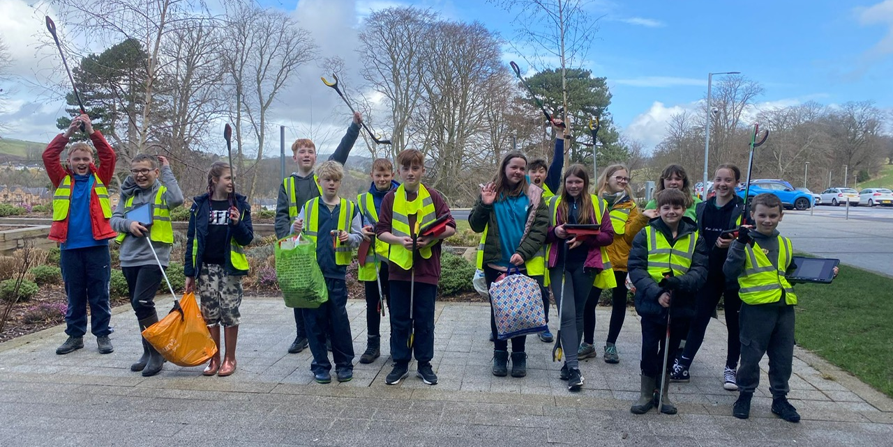

Pre♡Loved@Jedburgh:
In line with our focus on recycling, our Cinderella Project pop-up shop will be open during week beginning 24th April, in preparation for our Senior Prom. As well as a selection of fabulous dresses, we have also received donations of other formalwear and accessories.

Raising Attainment programme : N4-AH Extra Support & Tuition for S4-S6
In order to give our young people every chance for success we are offering a comprehensive range of supported study sessions during school time, after school and during the Easter break. Many of these sessions will be delivered in school, however, we are also offering sessions virtually. Next week all young people in S4-S6 will be issued with the complete programme. The Raising Attainment programme will also be available on the school website

It is essential that any young person who wishes to attend should let their teachers know in advance of the session.

Reminder that in addition to JGC support, there is a national programme of tutorials offered through e-Sgoil. Registration for their Easter Support Webinars is open. Click here to find out more. https://www.e-sgoil.com/easter-study-support-2023/

Parental Engagement & Involvement
Family Learning - Cybersafety Tuesday 21 March 6.15pm
Join us for a cybersafety event at JGC. As more and more of our lives take place online, it's important to stay informed and learn how to help protect your child's safety in this digital age. Our speaker will cover essential topics such as online privacy, social media safety, and more. You'll gain practical tips and insights for all ages that can help you navigate the risks and challenges of an increasingly connected world. Don't miss out on this valuable opportunity to learn and prepare yourself to help keep your child safe online.

Parent Feedback for HMI visit
The online survey is open until Friday 24th March. If you have children in more than one stage, you can complete the survey for one child or for each of your children who attend JGC. Please do not be put off when you click on the link if it takes you to JOSC or Jedburgh Grammar School! Education Scotland are unable to change these headings at present but they will collect information about each stage at Jedburgh Grammar Campus i.e. Jedburgh ELC not JOSC.
Parents/carers of children in the early learning and childcare setting | https://forms.education.gov.scot/s/03&cs=CS2014323656&t=1
Parents/carers of children in primary stages | https://forms.education.gov.scot/s/04&seed=5632730&t=1
Parents/carers of young people in secondary stages | https://forms.education.gov.scot/s/05&seed=5632730&t=1

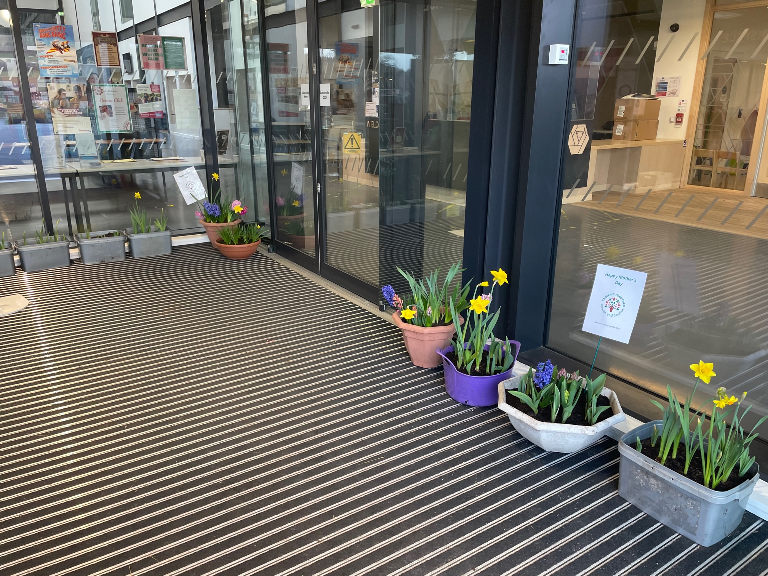
COMMUNITY

Intergenerational Working
We are very grateful to our “Growing Together” intergenerational team for providing us with a beautiful floral display in our entrance foyer, just in time for Mother’s Day. It certainly made us smile coming into school today!



Keep up to date with what’s going on in the campus by following our dedicated Facebook pages for Jedburgh Grammar Campus Primary & Secondary and our Jedburgh ELC closed Facebook group.

