
Campus Update

9th February 2024

Dear Parent/Carer,

As we approached the end of this term we said farewell to some much-loved staff members. Mrs Cuthers (Technical), Mrs Keddie (DHT) and Mrs Walker (PT Pastoral) have had a positive impact on many young people, families and colleagues in their time with us in Jedburgh and will be greatly missed. However, we wish them well for the future and the new adventures that lie ahead.
We have already had considerable interest in the DHT post since it was advertised a week ago, and we are looking forward to welcoming Miss Mackenzie, who is joining us after the holiday from Hawick High School to replace Mrs Cuthers.
We will recruit into the PT Pastoral post in due course, but in the meantime are grateful to our staff who have stepped in to ensure ongoing support for our young people. We are also delighted to have welcomed Miss Douglas and Ms Wilson to our team, in the new role of Pastoral Support Assistants. Miss Douglas and Ms Wilson are looking forward to getting to know children, young people and families from nursery to S6.

Our nursery will remain open to 50 week placement children only next week, but to everyone else I wish you a lovely holiday. Monday 19th February is an in-service day for staff, so we look forward to welcoming all of our children and young people back on Tuesday 20th February.



Susan Oliver
Headteacher

S3- S5 Options and Choices
As we return from the February week, thoughts will turn to course choice for the next year of study. To support you in advising your child we would like to invite you to an information session on Tuesday the 27th of February 6.30-7.30pm in the school Assembly Hall. Here you will learn about the arrangements for next year, more detail about new option choices and receive an advanced copy of the options sheet (they will not be released to the young people until the 28th of February.) In addition, you will shortly receive reports which will include recommendations on next level of study from each of your child’s teachers.

Escape Youth Services – Denholm Youth Club Consultation
Having recently visited Denholm Primary to gather views of pupils Escape Youth Services are now gathering views of parents/carers/guardians on the re-establishment of a weekly drop-in youth club in Denholm village. Your responses will assist with evidence of need and used to support applications for funding to help restart and run the service. The survey is open until Friday 16th February.
https://forms.gle/5N5qdcy8WyXfLWox5

Learning Without Limits

RSPB Big Schools Bird Watch
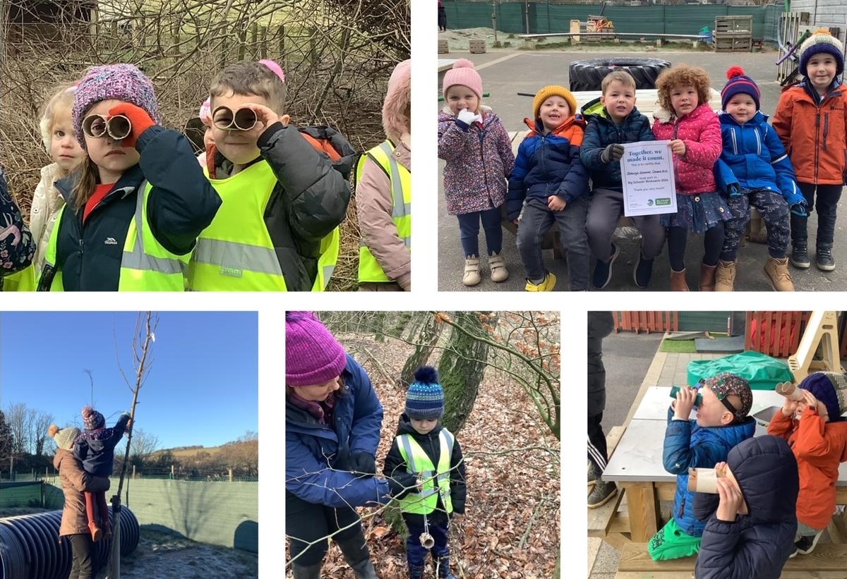
The nursery has recently taken part in this national initiative. Children have been helping to make bird feeders for the garden to encourage birds to visit. Some children also enjoyed a walk to look for wild birds who visit in and around the campus. Children have also made binoculars to watch the birds closely and to identify the different types of bird. The children saw a variety of birds: pigeons, crows, blackbirds, a robin and some starlings. The nursery was awarded a RSPN certificate for taking part.

Developing the Young Workforce
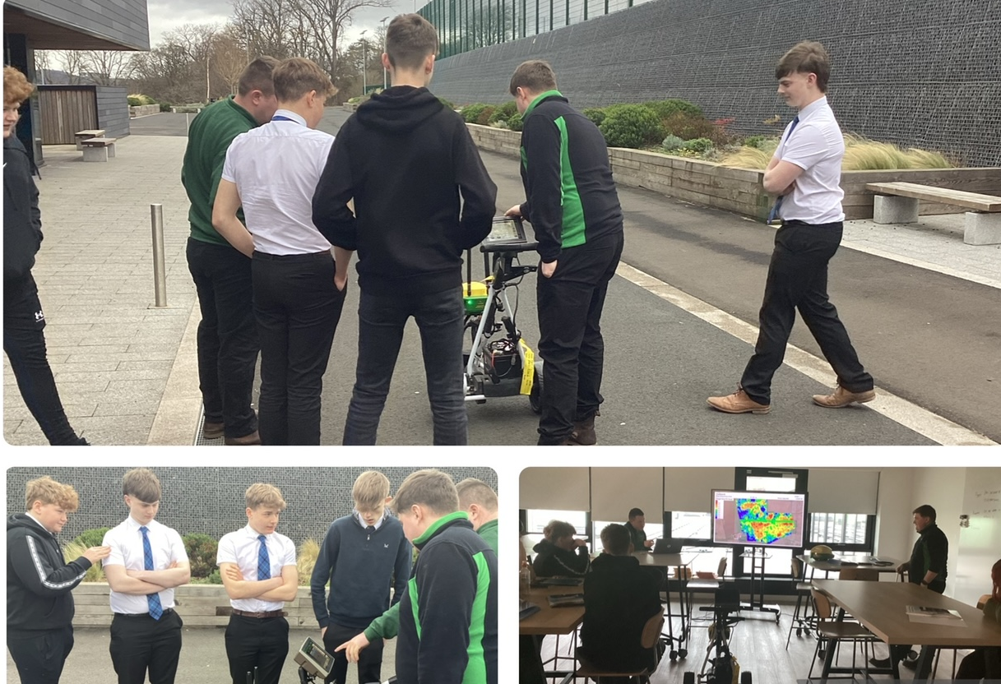
Our senior NPA Investigation of Modern Agriculture class had a visit from Thomas Sherriff on Monday. Our young people thoroughly enjoyed a highly interesting presentation on precision farming technology and how it helps farmers make more informed decisions that help them be more efficient and sustainable.
Yesterday we had the pleasure of sharing our work on the development of this course
with representatives of the Royal Highland Education Trust from across Scotland. We shared with members from each of the 13 RHET Countryside Initatives how working with RHET has increased learning opportunities for Jedburgh primary and secondary pupils and they are keen to adopt similar practice elsewhere.

Earlier this week, we were invited to give a presentation about this pathway, along with how we are developing other relevant pathways from nursery – S6, to representatives from schools in the Lothians, Fife, Edinburgh and here in Borders.

