
Campus Update

1st March 2024

Dear Parent/Carer,

Reminder that we are celebrating World Book Day on Thursday 7th March. Once again, nursery and primary children are invited to wear their pjs and bring their favourite book to share with their class. Secondary pupils will have the opportunity to participate in a range of themed activities, including a “Guess the Reader” competition. This year we are delighted to have the support of local bookshop, Heron & Willow.
As part of our celebrations, P3 parents/carers are invited to the class launch of “Read Write Count” on Tuesday 5th March at 2.50pm in the Assembly Hall. Come and see some of the games and activities in action before the bags of free resources are sent home.

It’s always lovely to welcome pupils back for a visit and today we were delighted to meet with former JGS Head Boy, Robbie Thomson. Robbie is in his final year studying law at Glasgow University and was visiting as part of his research into children’s rights. We are looking forward to Robbie returning in the near future to speak to pupils about his experiences since leaving school, including time spent working in the field of international law in Washington DC.

We also welcomed 4th Year Architecture students from Edinburgh University this afternoon, who have been studying the architectural features of JGC and were keen to see it in person. They were joined on their tour by S3 and S5 pupils who have expressed an interest in architecture related pathways.

Wishing you a lovely weekend.



Susan Oliver
Headteacher

Wellbeing

Dental health
Our dental health colleagues were in school recently explaining how important it is for children to have plain water in their water bottles and not juice. Sipping at juice through the day is very damaging to teeth. Water is also the best drink to keep hydrated.
We would like to remind everyone that bottles used in class should only contain water. Children having packed lunches can have a drink of juice with their lunch.

Community Support
Our thanks once again go to Jedburgh Co-op for offering financial support to extra-curricular sporting activities here at JGC. We are so grateful to be at the heart of such a supportive community 💗


Learning Without Limits

S2 Hot Seat
Here are the main characters of Frankenstein about to be "hot seated" by their S2 classmates in preparation for their essay writing. This is an exercise to deepen understanding of characters . . . and they were fantastic!

S3 Personalisation & Choice
All choices for S2 into S3 have now been returned and will be processed next week by Pastoral staff. Pupils will be interview if required starting the week 11th March.

Senior Phase Options
We were delighted to see over sixty parents and carers join us for the information evening earlier this week. Details of the choice process, including key information on arrangements from the Scottish Qualification Authority, new courses, Borders College Schools Academy Courses and supports from Pastoral and Skills Development Scotland staff were shared with all. All the presentations from the evening and links to choice sheets, course booklets and college options can be found on the school website here https://www.jedburghgrammarcampus.com/about-1 (Jedburgh Grammar Campus Website/Teaching and Learning/Options Process 2024/25)

Hard copies of the choice sheet have been issued in PSE classes and are available from the school office. Completed forms should be returned by the 15th of March.

Developing the Young Workforce
We are delighted to have Stacey Ballantyne take up post as our new DYW coordinator. Stacey will be with us two days per week and already has strong links within our community as a former pupil and local resident and has previously worked with us in her role at LS Starrett.
We are always keen to link with parents/carers who would be willing to share their employment experience with our children and young people, to raise their aspirations and awareness of the wide range of opportunities and pathways available. If you think you could help please email Stacey at sballantyne@dywborders.co.uk

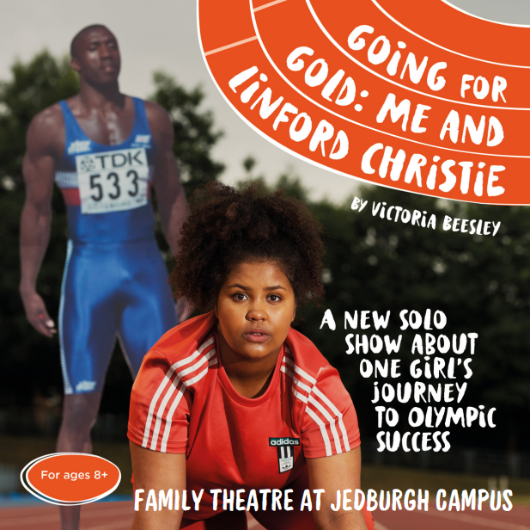
Family Theatre JGC Sunday 17th March
Vickie wants to compete at the Olympics. There is only one obstacle; she isn’t very good at sport. Yet, despite the odds, her love for athletics takes her all the way to London 2012. Inspired by Victoria’s own childhood obsession with athletics, this is a story about loving failure and dreaming big – even if there’s no chance you’ll make that dream come true. Read more and book your tickets here: Going for Gold: Me and Linford Christie @ Live Family Theatre @ Jedburgh Grammar Campus - Events - Live Borders

