
Campus Update

21st November 2025

Dear Parent/Carer,

The highlight of this week was our celebration of Scottish Book Week with our “Drop everything and read” session yesterday morning. This event reinforced our focus on reading for enjoyment and I had great fun with our Primary Reading Leaders capturing some of our campus readers in action. Here’s a small selection, but more to follow! Well done and thank you to Mrs Roper, Miss Makin and Mrs Hamilton for making this happen.
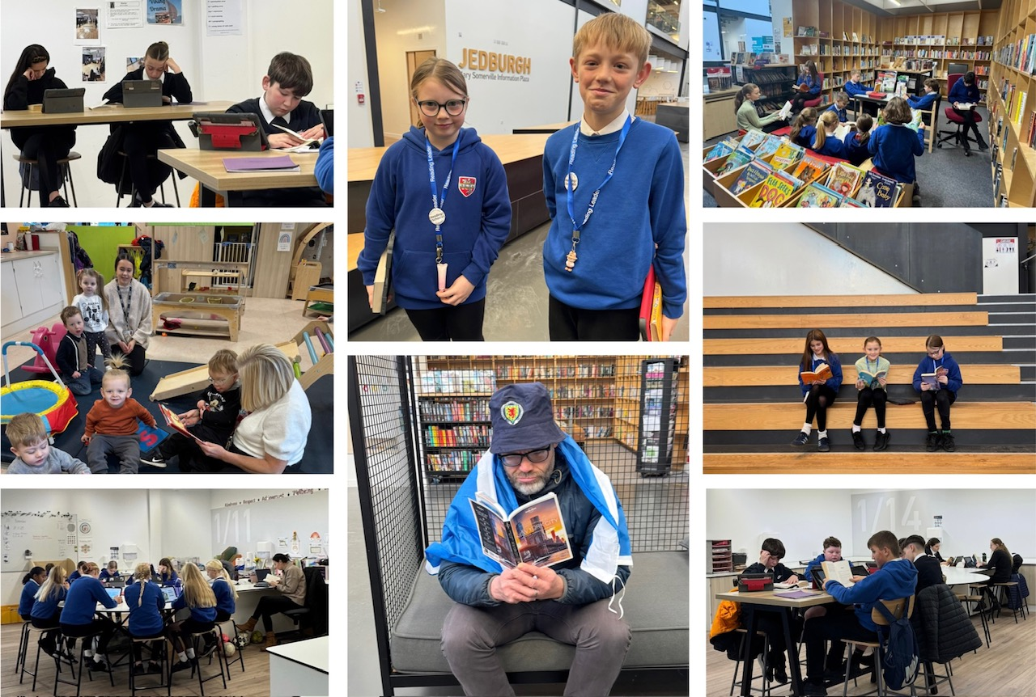

We are excited to hear that our Senior Head Team will be collaborating with the Reading Leaders to celebrate World Book Day in March and will keep you posted.

S6 pupils, Lacy McLachlan and Charlotte Robinson, completed the next part of their “Lessons from Auschwitz” project, by spending time with the Education Minister, Jenny Gilruth, at the Scottish Parliament last night. We are working on a date in the new year for them to share their experience with our community and will keep you posted.

Wishing you a lovely weekend.


Susan Oliver
Headteacher

SCHOOL TRANSPORT
All parents/carers of children and young people who travel on school transport should have received an email directly regarding procedures for transport during winter months. We have summarised the key points below but if you did not receive the email please contact jgc@scotborders.gov.uk for a copy.

- Updates on weather- or road-affected school transport routes will be posted on the Scottish Borders Council website from 7:30am when required: www.scotborders.gov.uk/wintertransport.
Local radio may share some cancellations, but the website is the definitive source for accurate, up-to-date route information.
School transport operators will report issues directly to the School Transport team.

- Groupcall will still be used for non-weather-related transport issues (e.g. breakdowns or delays).

- Children should normally wait no more than 15 minutes for the bus; in severe cold, parents/carers should use their judgement. Parents/carers decide whether their child should wait for the bus.

- If you choose to take your child to school yourself, you are responsible for collecting them at the end of the day.

PARENT PARTNERSHIP RAFFLE
Our Parent Partnership team are once again organising a raffle for the P1/2 Nativity, which takes place on Thursday 11th December.
Tickets will be on sale during the afternoon and evening performances and prizes drawn from combined tickets in the evening.
Donations of prizes would be greatly appreciated and can be handed into reception.
Please support this small but wonderful group of parents who extend the learning opportunities we can offer children and young people across all stages of JGC.
If you are interested in lending a hand or finding out more, please email jgcparentcouncil@gmail.com

KINDNESS AT CHRISTMAS
Our Eco Committee have started their annual Pre💗Loved@Christmas festive recycling programme and would welcome your support. Any donations of jumpers, t-shirts, headbands etc would be gratefully received.


LEARNING WITHOUT LIMITS

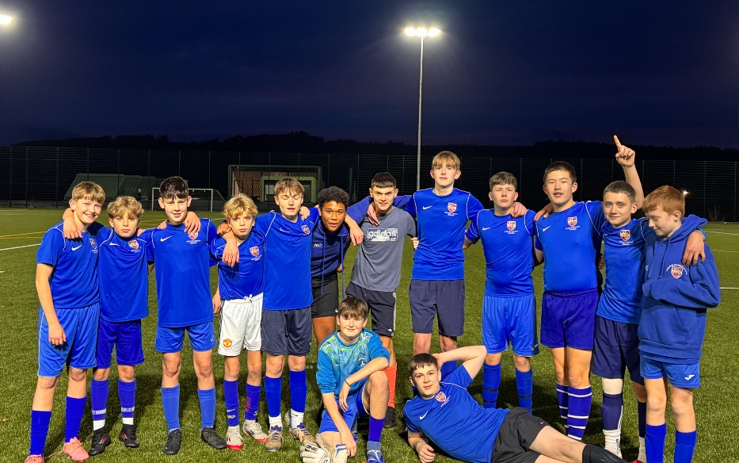
Our S2/3 boys football team played their first competitive game of football in several years last Friday as they took on Selkirk. The result didn’t go their way, but the boys showed real character and worked hard from start to finish.
For several of them, this was their first ever competitive match and they handled it brilliantly, showing great attitude and putting together some excellent football at times.
It’s a quick turnaround with Hawick up this week, and the boys are already keen to kick on and keep improving. Thanks to Mr Tait and Mr Campbell for organising this.




