
Campus Update

12th December 2025

Dear Parent/Carer,

We are definitely feeling in the Christmas spirit this week following our fabulous nursery and P1/2 nativities. The children were superb!

Today we had the pleasure of our P4/5 and P5 class assembly, titled “I’m a P4/5 – Get Me Out of Here!”. The children shared what they have been learning about rainforests in a highly engaging and informative manner, with family members and fellow pupils alike commenting on how much they’d enjoyed it.

Huge thanks to everyone who supported our Parent Partnership raffle at the P1/2 nativity. The fabulous sum of £383.60 was raised, which will be used to support activities and experiences for our pupils.

Thanks also to everyone who contributed to our “Christmas Jumper Day” collection for the local foodbank. We will continue to accept donations until next Friday at which point they will be passed to the foodbank team for distribution.

We can’t wait to party “Under the Stars” with our seniors at their dance this evening and next week we have the excitement of our primary and S1-3 parties, followed by our whole school celebration in Jedburgh & Oxnam Church on Friday morning and then carols in the primary playground at 12.30pm.

Wishing you a lovely weekend.


Susan Oliver

Headteacher

LEARNING WITHOUT LIMITS
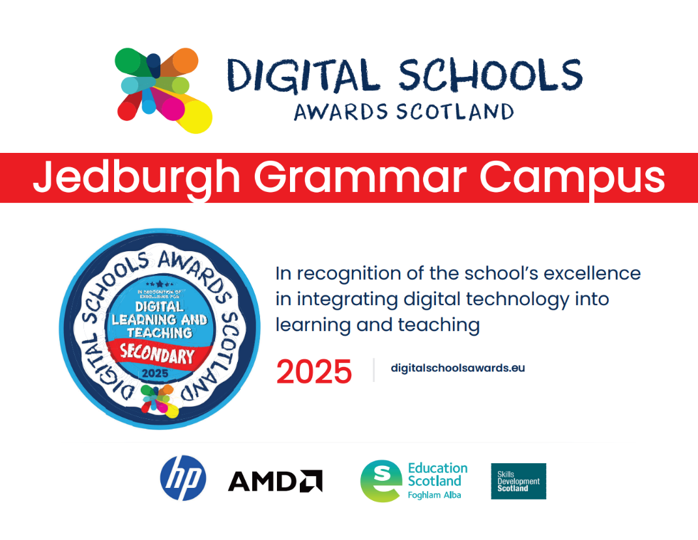

Digital Schools Award
We are delighted to announce that we have been accredited with the Digital Schools Award across primary and secondary, recognising the school’s strong and sustained commitment to embedding digital technologies across learning and teaching.

Inspectors from Education Scotland praised the school for successfully establishing digital learning as a natural part of daily practice, supported by clear leadership and a strong focus on continuous improvement. Teachers demonstrated confidence and enthusiasm in using digital technologies to enhance learning, support planning, and track pupil progress, while pupils spoke confidently about how digital tools support and enrich their learning.

The inspection team highlighted the positive impact of digital technologies in broadening learning experiences through meaningful connections beyond the school. Strong digital leadership was also recognised for effectively supporting self-evaluation, professional learning, and well-targeted digital development.

The school was further commended for its effective communication with parents and carers and the opportunities provided for families to engage digitally with the school.
The inspection team confirmed that Jedburgh Grammar Campus has met the criteria for the Digital Schools Award and recommended the school for Mentor School status, recognising its capacity to support other schools in developing digital learning!

Developing the Young Workforce
Mock Interviews
Our S4 pupils have recently been developing their interview skills during PSE lessons, they were able to put these skills into practice during our mock interview sessions last month.

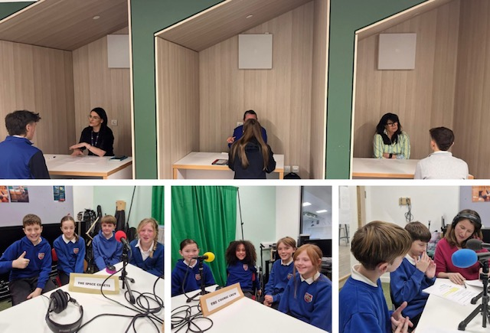
Many thanks to Eildon Housing Association, Oregon and South of Scotland Enterprise for supporting our interviews and providing valuable feedback to pupils in preparation for the world of work.

Primary 7 Podcast
We were delighted to welcome Borders Hospital Radio to the campus last week to record a podcast with a group of Primary 7 pupils.

‘Get Well Soon’ is a hospital podcast project supporting children and teens being treated by the NHS in the Scottish Borders. It offers peer support and social connection for young people affected by injury or ill health. Pupils did an outstanding job with their recording, and we can’t wait to listen to their fun quiz when it is released on the BHRS website next month.

Launch of the Participation Portal: Enhancing Insight Into Young People’s Pathways
Members of our Senior Leadership and Pastoral Teams recently attended regional training on the new Participation Portal, a comprehensive data platform managed by Skills Development Scotland.

The Participation Portal provides users with detailed information on young people’s immediate and sustained destinations after leaving school. By analysing these pathways, schools are able to identify emerging trends, understand areas of need, and ensure that appropriate support is in place for all learners.

The system also allows schools to track which universities, colleges, employers, and training providers are most commonly chosen by their pupils. This level of insight helps shape strategic planning and strengthens partnerships with further education institutions and industry.
Importantly, the portal includes a national feature linked to the My World of Work Profiling Tool, which enables young people to identify their achievements, skills, and aspirations. This tool will play a key role in celebrating success while also supporting the early identification of those who may benefit from additional guidance to achieve their full potential.

The introduction of the Participation Portal represents a significant step forward in ensuring that our curriculum and support structures continue to meet the needs of both present and future learners.

Roll out of the portal will begin in secondary and then extend to primary, with support from our Skills Development Scotland Careers Adviser, Andrew King.

