Starting Early Learning and Childcare at
Jedburgh Grammar Campus



2024 – 2025

‘Learning without Limits’

Dear Parents/carers
Welcome to Jedburgh Grammar Campus ELC. We are looking forward to you starting your time with us and we hope that you will be very happy here. We hope you find this booklet helpful in introducing you and your child to our setting. We hope it will answer most of your questions. However, if you wish any further information, please do not hesitate to contact the school.

The school telephone number is: 01835 863273

The school address Jedburgh Grammar Campus, Priors Road, Jedburgh, TD8 6HH.

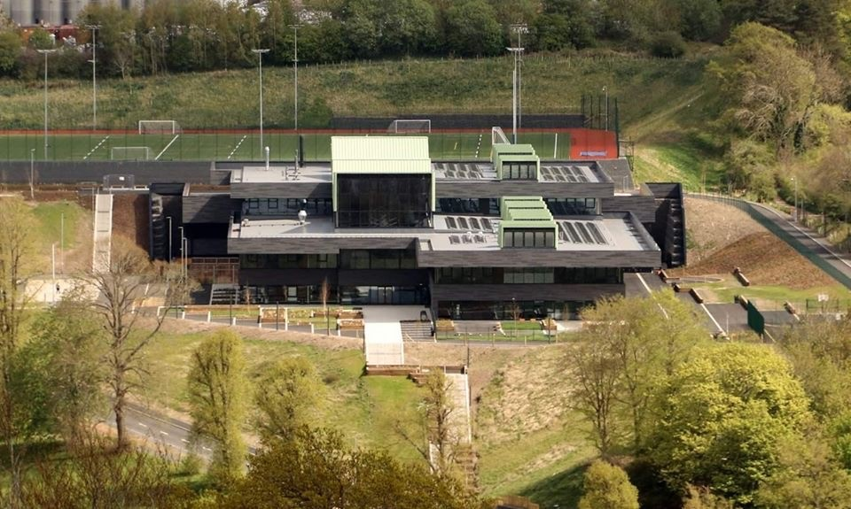

There will be many other children for your child to make friends with in the nursery. Some of them may be children your child may already know, and there will be new friends for them to meet too.


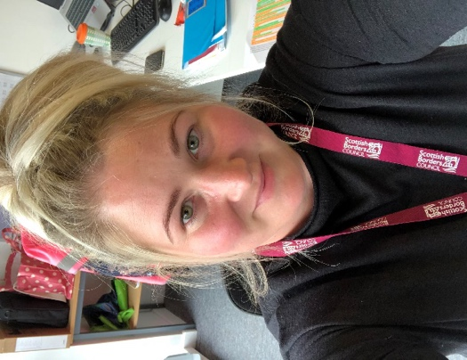

Our ELC Team

Miss Lindores Miss Wild Eilidh Wilson
Senior Early Years Officer Early Years Officer Early Years Officer
(SEYO) (EYO) (EYO)
  Mrs Cook  Early Years Practitioner |   Miss Yourston  Early Years Practitioner |   Miss Jacobs  Early Years Practitioner
  Miss Wright  Early Years Practitioner |   Miss Loftus  Early Years Practitioner |   Mrs Oliver  Early Years Practitioner      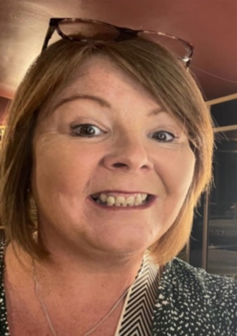  Mrs Stephenson  Early Years Practitioner  Mrs Fisher  Mrs Bell  Early Years Practitioner  Early Years Practitioner
  Miss Ewart  Early Years Practitioner |   Mrs Blair  Early Years Practitioner |   Miss Watson  Early Years Practitioner
  Mrs Richardson  Early Years Practitioner |   Ms Law  Early Years Practitioner |   Miss Currie  Early Years Practitioner
  Mrs Hume  Early Years Practitioner |   Miss Yeung  Early Years Practitioner | 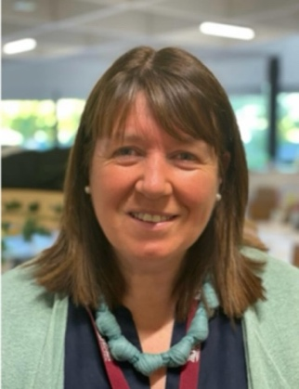  Mrs Stenhouse  Early Years Practitioner
  Ms Thomson  Early Years Practitioner |   Miss Thomson  Early Years Practitioner
  Mrs Weekley  Additional Needs Assistant |   Miss Douglas  Additional Needs Assistant |   Mrs Chambers  Additional Needs Assistant

People who can help:
There are lots of other people to help you in nursery. Here are some of the people who will help you.
  Mrs Oliver  Head Teacher | 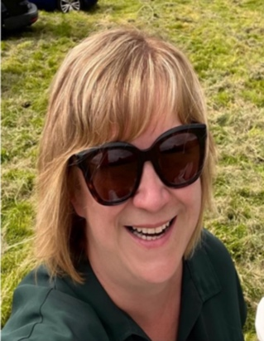  Mrs Warnock  Deputy Head Teacher |   Mrs Smithson  Equity and Excellence Lead

We have our Admin Team who help us with important jobs like answering phone calls and sending group calls, ordering snacks and new toys.

We have a team of janitors who help us aswell. They are kept busy doing jobs around the school both indoors and outdoors, keeping things clean and safe.

Induction
When your child is due to first start Jedburgh ELC, we usually ask parents to fill in a Personal Care Plan all about your child. This is to help us learn as many important things as we can about your child.
We will send the personal care plan out to you via email and ask you to fill in as much as you can before your child starts. We will also send an appointment time for you to come for a short visit. Parents must stay for the visit. During this time, you and your child can come into the nursery to see what it is like, have a play and a look around. Your child’s key worker will talk to you about the Personal Care Plan to ensure we know all about your child. Parents/carers can also ask questions about the nursery and their learning.

Our ELC day
We are a childcare hub and are open from 8.00am to 6.00pm Monday to Friday.
Usually, your child is entitled to 1140 hours of Early Learning and Childcare throughout the year.
On your enrolment form, you were able to choose how many weeks per year you would like your child to attend (based on 1140 hours entitlement). If you have chosen to attend during the school term (38 weeks), you will have 30 hours per week to use. If you have chosen to attend all year round (50 weeks), you will have 22 hours 45 minutes per week to use. Other options are available and can be discussed with our SEYO, Miss Lindores.
When you arrive at the ELC each morning, please wait outside the main Campus door and your child will be brought in by one of your key group staff members. They will be shown to you at your visit.

Collection at the end of a session
Children must only be collected from the setting by a responsible adult (over 16 years of age.) Parents must inform staff if an adult other than the usual one is collecting your child. During your induction visit you will be asked to set a password; the adult must be able to tell staff the password when collecting. Please can we also ask that parents arrive promptly to collect their child.

Session routine:
Rolling snack is offered between 9.45-10:30am and 1.30-2.15pm
Lunch is at 11.30am in the school dining hall.
Snack - children will be offered water and milk and a tasty bite to eat. There will be a wide range of healthy snacks offered daily alongside a variety of fruit.
Water station – we have a water station where fresh water is available throughout the day. You don’t need to send in a water bottle.
Please make sure the ELC staff are informed about any food allergies your child may have. We have paperwork to fill in detailing your child’s allergy and it will be shared with ELC and catering staff.
If you require any medication, we will also ask parents to complete a form with details. This will be shared with ELC staff. Staff in nursery are only able to administer prescribed medication. Both the box and the bottle must have a prescription label on it.
Settling in
The first few days of ELC may be rather daunting for your child, so your child’s key person or one of the staff in your child’s group will endeavour to comfort and help your child to settle in.
Each child has a key worker. Your child’s key worker will generally be the person who settles your child into the nursery working alongside the other staff in their group. They will be the person who updates your child’s Showbie account and any other paperwork. Parents/carers can speak to any staff member from your child’s group or an EYO.
Learning experiences
Within our ELC setting, we have lots of spaces where your child can play and learn. The emphasis in Early Years is on play based learning where your child learns through play. The setting is well equipped and set out in a stimulating and safe way. We have opportunities in all the groups so your child can experience lots of different learning to help them discover things about themselves, each other and the world around them.
Imagination space

In the Imagination space, your child will find activities such as our role play area/ house corner. This area could be a house, a dentist’s, a shop, the doctors etc, depending on what the child’s interests are. This helps to develop their imagination skills. This space also contains a small world area which includes the dinosaurs, cars, train set, different animals and musical instruments.

The activities in this space are chosen to develop your child’s social skills through language and sharing their ideas and resources.
Cosy and Investigation Space

In the Cosy and Investigation space, your child will be able to access water and sand play including filling, pouring, scooping and measuring. This is where many of our numeracy activities take place such as counting, patterns, playing number games, threading, sorting by colour or size. This is also where technologies can be used, e.g. programmable toys, torches to discover light and dark and activities which promote problem solving.
We also have a book corner where you can access books independently or with an adult. It’s a space where you can have a rest or quiet time if needed. This space helps children to develop self regulation skills.

Construction Space
In our construction area we have a range of resources for your child to build and create with, such as large and small wooden blocks, Lego, duplo and stickle bricks. There are also some larger blocks, tyres, gutters and pipes for the children to investigate ramps, building larger constructions and forces. We also have marble runs, magnetic bricks and k’nex which encourage children to use their creative skills and share their ideas and thoughts to help solve design problems.
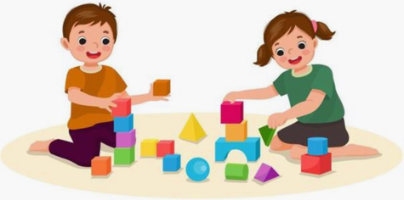
In this space we also have loose parts. These include large and small stones, cotton reels, cones, wooden slices, shells and wooden rings.
This space helps to develop your child’s fine motor skills, problem solving and enquiry skills.

Creative Space
In this area we do most of our art and craft activities. We have a range of mark making tools like paints, pens, crayons, marker pens etc for children to practice their mark making skills. We often have other mark making experiences like shaving foam, flour, salt etc which the children are free to explore with their fingers, hands, sticks and other tools. We also have white boards and pens, glue and junk modelling which children can use to create models along with various craft materials like lollipop sticks, pipe cleaners, feathers, sequins and buttons.
This area helps to promote a child’s creativity and gives them the freedom to be curious and creative.

Outdoor Space
We have an outdoor space to the front of our nursery setting; the space is safe and designed with children in mind. There is free flow access through the double doors with separate access to one of our toilet areas. The outdoor space is surrounded by fencing and includes different surfaces and a sand pit. All learning activities can be delivered in this space.
This space will help to develop the children’s social skills. It will enhance their physical development, help to develop resilience and encourage problem solving skills.
One day each week, we like to go out and investigate the local environment. This may be a walk up the woods, a visit to the shops or a local attraction (eg castle) or it could be a visit to the park. We go out in all weathers.

Showbie
Showbie is an app used by the nursery, and the Campus, to share your child’s learning and experiences. Each child has their own personal portfolio that parents/carers can access. Staff will upload pictures and information on your child’s learning regularly for you to view.
On Showbie we also have a home communication page which is for yourself, your child’s keyworker and the EYO’s and SEYO’s to post private messages on. It’s a way to communicate with your child’s keyworker if you need to. These messages could be relating to absences, change of person collecting or other important messages which need to be shared.
We also have an announcement page where we will post information about what’s happening in nursery, upcoming holidays, any special events coming up, our regular newsletters, parental involvement activities etc. At the end of each block (approx. every 6 weeks) staff will upload each space’s ‘floorbook’ to show you what learning has happened in each space.
A letter with access codes will be given out to you by staff once your child has started, so you can join the relevant groups. If you need any help or support with this, then please just ask a member of staff.

The cloakroom
In the ELC we have a space in the cloakroom area for each key group where your child will have their own peg with their name on it. They can hang up their jacket and their change of clothes bag. Underneath there is a small shelf for them to store any of their other belongings.
You don’t need to bring a separate pair of indoor shoes. It would be very helpful though, if you could bring a pair of wellies for messy play outdoors. They can be kept safely in our welly store.

What to wear in our ELC
We do not have a uniform for you to wear to nursery. However, there is an optional red ELC sweatshirt which you can purchase from Middlemiss Embroidery online.
We do ask that you do not wear clothes that are special to your child or are expensive. Nursery is fun but can be very messy and although your child will have access to aprons etc, it is inevitable that some clothes will get stained. Your child should also wear practical and comfortable play clothes which they can manage independently when going to the toilet. Please avoid braces, belts and too many buttons.
We would like your child to wear practical, comfortable shoes or trainers to nursery each day that again you can manage independently.
Children have access to the garden space every day and we are often outside for learning activities throughout the week, so we ask that parents provide a pair of wellington boots to keep at nursery, as the garden becomes wet and muddy over the
winter months. We will also be up in the woods exploring throughout the year.
What do you need to bring to ELC?
We ask that your child brings a small bag to nursery containing a full change of clothes. Any dirty or soiled clothes will be double bagged and put back into their bag to go home.
Please remember to bring a jacket every day. Your child will need a hat, scarf and gloves on cold days and sun hats on sunny days. We also ask that on sunny days that your child attends nursery with sunscreen applied and provide sunscreen for staff to reapply throughout the day.
We know your child may have lots of special things they would like to bring into nursery to share with us. However, please can we ask that these are kept safe at home as the nursery has lots of activities to keep you busy.

Don’t forget….
Please put your child’s name on EVERYTHING they bring to nursery, because we don’t want them to lose anything. Staff will help your child to look after their belongings when they first start nursery and will teach them how to be responsible for their own belongings. If your child does lose something, things with names on can be returned to them much quicker.
Lunchtime
Your child will be provided with a lunch each day from the school canteen. Lunch is at 11.30am in the school dining hall. Lunchtime is a very sociable time in the ELC, and each group eats together. Parents will be issued with a login for the ‘Parent Pay’ website, the website which lunches are ordered through. Your child’s account will have a balance that will allow you to order lunches. Please note that nursery children will have the choice of two hot meals or soup and a sandwich each day. Please order lunches by no later than 8.30am if ordering daily.
Please discuss with your child and order in advance. Meals can be ordered up to a term in advance.
If you need any help with Parent Pay, please speak to our SEYO, Miss Lindores.

What to do if your child can't go to nursery?
If your child is not well, they will need to stay at home. Parents/carers need to let us know by 9:00am that you are not coming in. You can send a message on your child’s Showbie home communication page to your child’s key worker, message on the Expressions app or phone the school office.

Please remember for any episodes of sickness or diarrhoea your child must be symptom free for 48 hours (2 days) before coming back to join us.
When you come back to the ELC, we will be very pleased to see you.

Visitors to the ELC

The Health Visitor and Childsmile (Dental workers) all visit the ELC throughout the year. We sometimes have visitors from other NHS services too.

At times, we invite other people into the ELC to teach us about their work or to show us interesting things.

Sometimes we have parents and carers come in to help with activities. We would love it if you would like to help in our ELC too. There are lots of different ways that you can volunteer in the ELC. You should let a staff member know if you would like to become an ELC volunteer.

Getting Ready

Your child could try practising these things at home with you which will help them at the ELC:
- Using a tissue to blow their nose and putting the tissue in the bin
- Looking after their toys and games.
- Tidying up once they are finished playing with toys.
- Putting on their own coat and shoes.
- Using the toilet properly (not all children come to nursery potty trained so please do not let this worry you). Remembering to wash their hands with soap and water, then drying them well afterwards.
- Having fun at home playing games and taking turns

- Practise using a knife, fork and spoon correctly at the dinner table and clearing their plate and cutlery away afterwards.

We are all here to help you learn and support your child with new things.

Will I get to play with their friends?
Yes! There will be lots of times when they can play with your friends.


Did you know that when they are playing, they are discovering new things about colours, shapes, numbers, reading, writing and much, much more.

Parents and Carers
Our ELC team hope that you will feel welcome and that you will enjoy a valuable experience. Our job in the ELC is to build on the learning and existing knowledge that your child already has by being at home with you, or that has taken place in their previous nursery. For this to be successful, we need to work together with you and your child.
If you have any concerns regarding your child, please speak to your child’s key worker, one of the ELC team, Nikki Lindores (SEYO) or contact the School Office to arrange an appointment with Mrs Warnock (Depute Head Teacher). We are all here to support you and your child on their learning journey at Jedburgh Grammar Campus ELC.
We hope that this booklet has been helpful for you and your child. We look forward to you joining us at Jedburgh ELC.

From everyone at Jedburgh ELC.

