
Campus Update

2nd May 2025

Dear Parent/Carer,

We were delighted to welcome visitors from Education Scotland to JGC on Tuesday. They were keen to find out more about our development of outdoor learning and community links and enjoyed their time with pupils, staff and volunteers so much that they are keen continue to work with us!

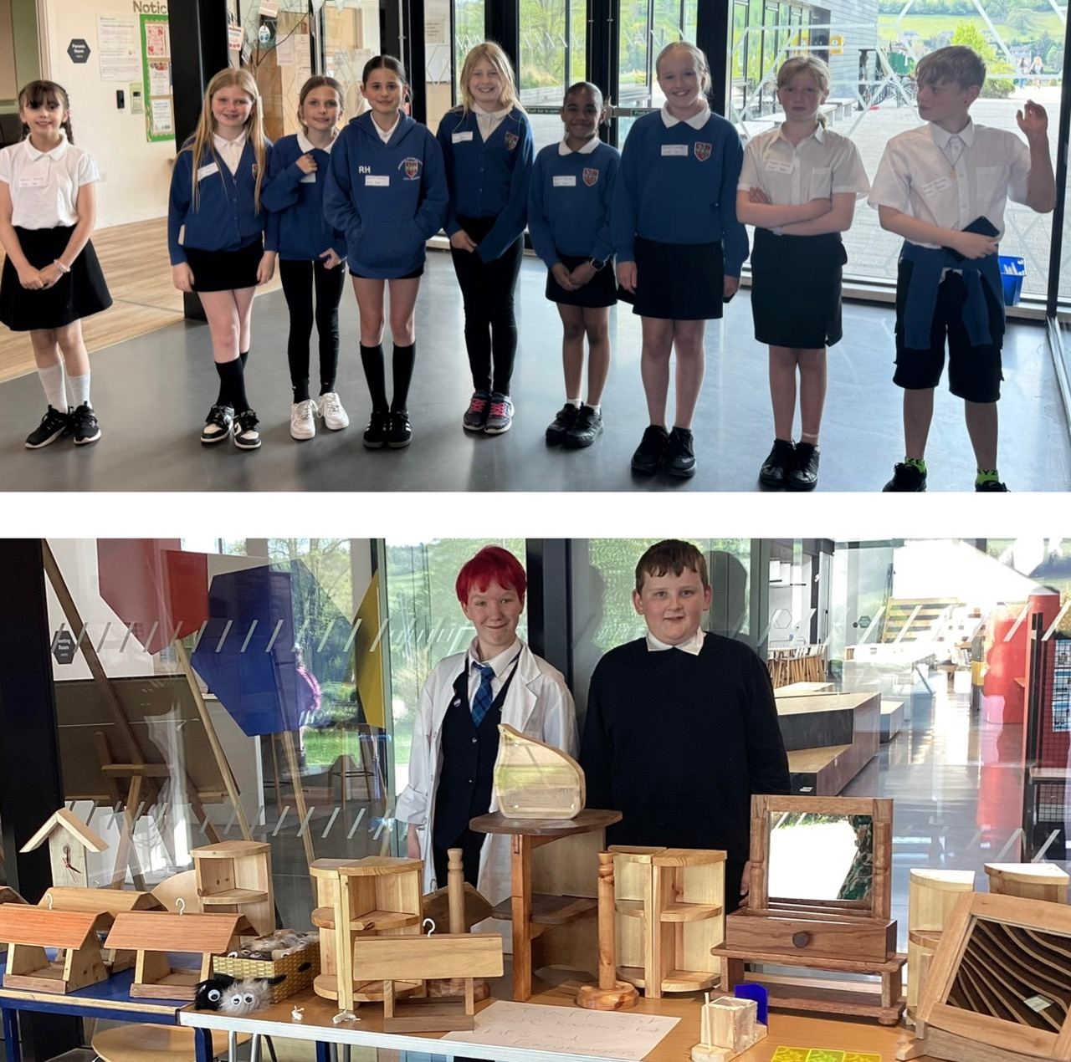
It was great to see so many of you at Primary Parents’ Evenings this week and lovely to receive lots of positive feedback on our P6 helpers. Parents were very complementary about the children’s helpfulness, attitude and social skills.

Thank you to everyone who supported our amazing S3 Creative Technologies class who were selling their products in the entrance foyer. Macey and Ashley did a roaring trade, selling over £120 of goods!

Reminder that the campus is closed on Monday and that Tuesday is an in-service day, so we are open to staff, year-round nursery children and our young people who are sitting National 5 and Advanced Higher English.

Wishing you a lovely, long weekend.



Susan Oliver
Headteacher
Learning Without Limits

Border Counties Rally
Congratulations to overall poster competition winners 1st Thea Crozier, 2nd Beth Hardie and 3rd Sophie Craig, who will be invited to wave off the cars at the start of the rally on Saturday 10th May. Class winners to follow!

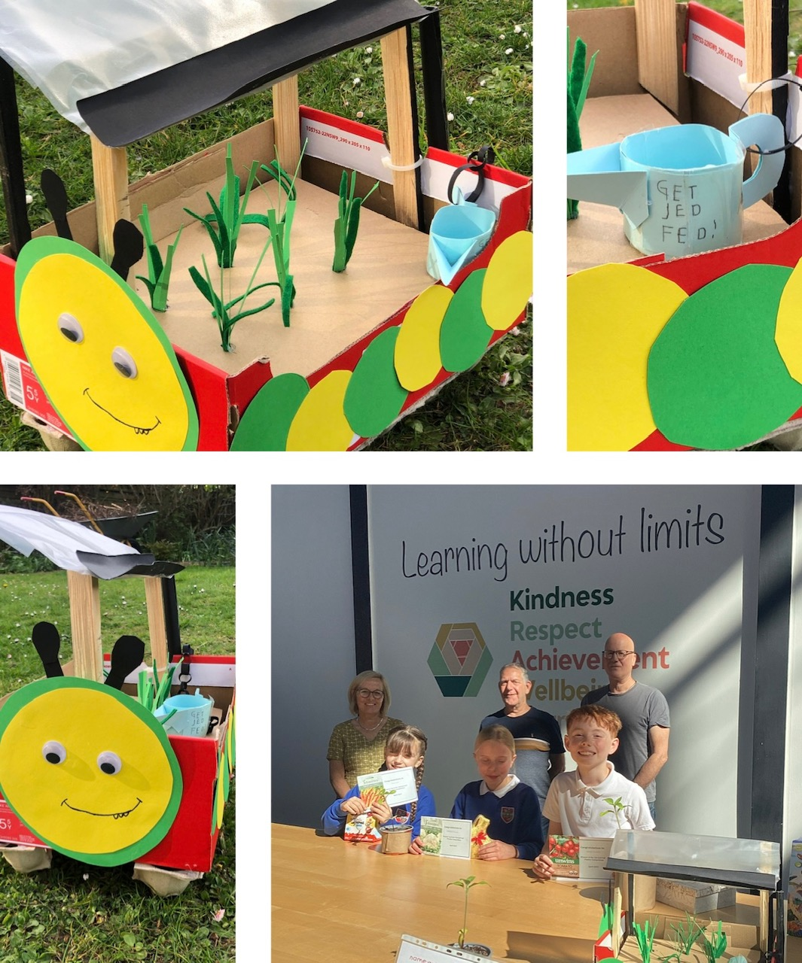
Get Jed Fed
The winners of the deign a planter competition were announced this week at assemblies. The overall winner is George Murdoch from P5 with his brilliantly detailed model which includes the hungry caterpillar and a ‘Get Jed Fed’ watering can. Runners up are Aria Scott from P6 with a baguette inspired planter and Charlotte Thomson from P6 with a crescent moon feeder. We are very grateful to the Get Jed Fed team for providing this opportunity, to the Co-op for providing prizes and to the Jed Shed who will be making the planters. We can’t wait to see them!

Senior Leavers’ Celebration & Prom
Parents of S4-6 pupils will have received an invitation to join with us in celebrating our wonderful young people who are moving on to new adventures in the summer.
Prom tickets are available via ParentPay.

Trout Fly Fishing
The Rotary Club of Jedburgh invites children aged under 16 years old, to come enjoy a Free Day Fly Fishing on Saturday 24th May. Instruction and equipment can be provided so everyone is welcome whether you are experienced or a complete novice.
The fishing will be at the Upper Hass Loch thanks to the generosity of the Jedforest Angling Association.
Children under 11 years of age must be accompanied by a parent or guardian. This is a great day out for all the family. A prize will be awarded for the biggest fish caught on the day.
James Hunt, Head Biologist at the Tweed Foundation, will be exploring the water life in the Loch.
Transport to the Hass can be provided, returning to Abbey Bridge Car Park by 4.30 p.m. For more information and a registration form, visit www.Jedburgh.rotary1320.org
A fond farewell

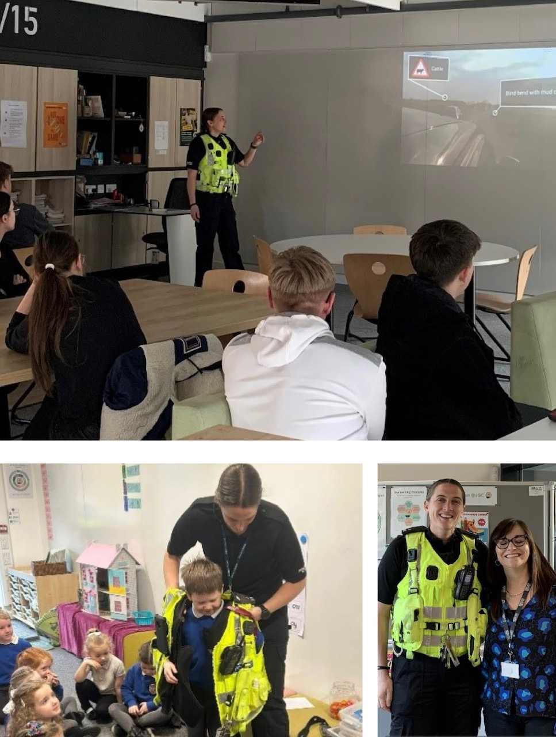
At the end of last term Ancrum and Jedburgh schools said goodbye to our much-loved Schools Liaison Officer, PC Carin Tait-Logan.

For the past 8 years, Carin has been the cheerful, friendly face of Police Scotland within the schools, providing invaluable help and support to all of our pupils, and many of our families.

As well as supporting pupils, families and staff with police matters, Carin has enhanced learning opportunities across all age groups. The highlight for our youngest learners was always when she talked to them about her role as a police officer, particularly when she brought the police van into the playground for them to explore.

Carin has delivered educational workshops across year groups, on a wide range of topics affecting young people today, including internet safety, sharing images online, substance use, sexploitation and road safety.

Over the years Carin has taken many of our pupils on the Drive Wise course where they got the experience of driving dual-control cars while receiving expert advice from police officers. Working with Scottish Borders Fire & Rescue Service, she has also brought the dangers of the road to life for senior pupils as part of the Drive to Arrive programme. In this she has drawn on her experience as a Rally Racing Co-Driver while discussing dashcam footage of serious road incidents and showing pupils around the wreckage of cars from road traffic accidents. These have always been thoroughly engaging lessons and will undoubtedly have helped some of our young people to resist peer pressure and drive more safely.
Carin’s last role was to introduce her replacement, PC Liam Lawrence, to both schools. Carin is not going far though. She is moving to a new role within the town as a Community Beat Officer in Jedburgh – a role that will put her at the heart of the community she loves. Best of luck Carin, we are delighted you will still be nearby.



