STARTING SCHOOL
AT
JEDBURGH GRAMMAR CAMPUS (PRIMARY)



‘Learning without limits’
2025 - 2026

Welcome to Jedburgh Grammar Campus. We hope that you will be very happy here.
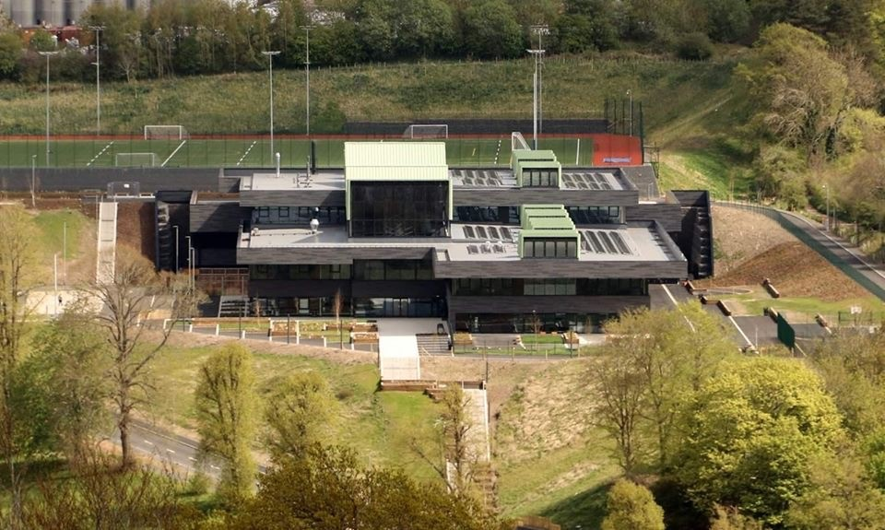

At Jedburgh Grammar Campus (JGC) there will be lots of interesting things for you to do and learn.
This book will tell you about some of the things that will happen in our school.
Who will be at school?
There will be lots of other children for you to make friends with in your learning spaces. Some of them will be children that you will know from nursery and there will be new friends for you to meet too.
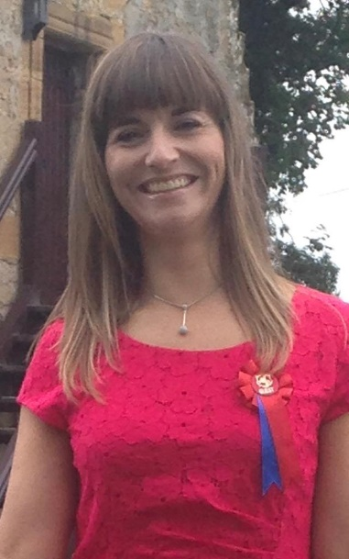
Mrs Oliver is our Headteacher.

Mrs Oliver’s email address is:
SOliver@scotborders.gov.uk


Mrs Warnock is one of our Depute Headteachers and she helps to look after ELC, P1 and P2 pupils.

Mrs Warnock’s email address is:
Katie.warnock@scotborders.gov.uk

The school telephone number is: 01835 863273.
There are lots of people to help you in school. On the next page are some of the people who will help you. In our new campus, P1 children will work closely together. We have added photos of some of the staff you will meet in the P1 learning spaces.
Mrs Hey  P1 class teacher    gw16heysarahjane@glow.sch.uk | Mrs Renwick  P1/2 class teacher  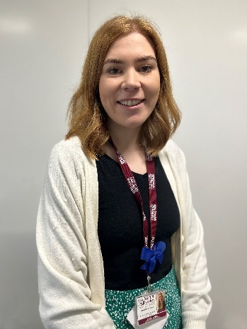  gw18mabongillian@glow.sch.uk

We have lots of teachers who may teach you PE.

There will be 2 classes with P1s in them next. You will have a class teacher but the other P1 teacher will work with you as well.

When will I come to school?
You will start school on Wednesday 14th August 2024.
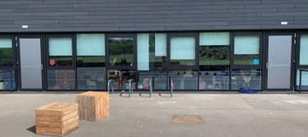
School starts at 8:50am and finishes at 3.25pm from Monday to Thursday and on a Friday, you finish at 12.50pm. It is very important to come to school on time, so as not to miss out on vital learning time. We would like you to come to the school gate. Your parents can wait there with you until it is time to come in. Parents are not allowed in our main playground as there isn’t enough room for us all.
At the start of the school day, your teachers will come to the door to meet you. At the end of the day, your parents/carers will wait for you outside the classroom doors to be collected.
If you come to school on a bus you will be collected from the bus bay and walked around to the playground by an adult.

What will my learning space be like?
There will be tables, chairs, toys, books and other equipment in your learning space where you will do activities and learn.
You will spend lots of time outside playing and learning with friends.
Your learning space is an important place for you. We want you to feel safe and happy there. Your teachers will plan exciting learning activities for you to take part in each day. Depending on what you are learning there will be different things out in the learning spaces for you to learn and play with.
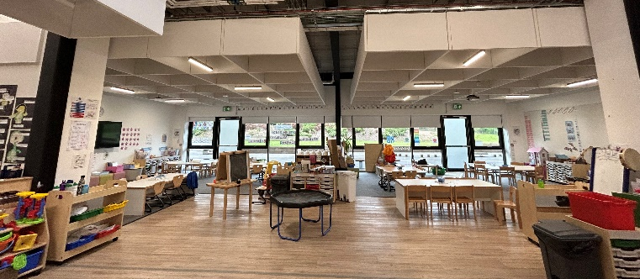

What will I wear to school?

We have a school uniform which we would like you to wear.
The uniform is:
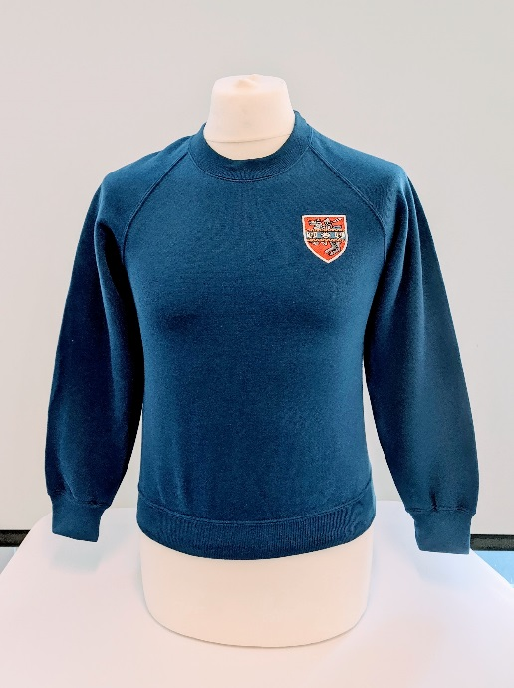
- grey or black trousers/skirts/shorts/pinafores
- white polo shirt or shirt and royal blue sweatshirts, jumpers or cardigans.
- sweatshirts can be worn with the school badge
- dark shoes
- plain royal blue sweatshirts, jumpers or cardigans are also acceptable
- blue checked summer dresses can be worn.
- PE kit is shorts and white t shirts. For school PE lessons a pair of trainers is required. No special footwear will be needed.
- You can wear a tie if you like.
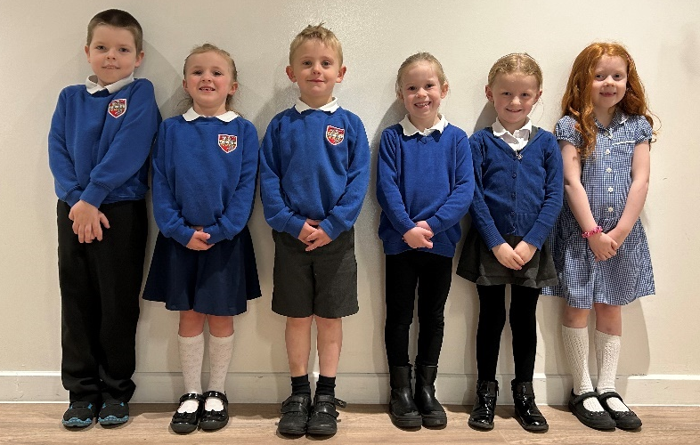
A range of suitable uniforms can be seen in this photo.
Notes for the adults:
You can buy these from Middlemiss Embroidery. Items will be available directly from their premises in the town, but there is also a web page for online ordering.
Scottish Borders Council are now accepting applications for clothing grants and free school meals for session 2023-24. For more information go to https://www.scotborders.gov.uk/fsm
If you require assistance completing an application, please email JGC@scotborders.gov.uk or telephone 01835 863273.

Going outdoors
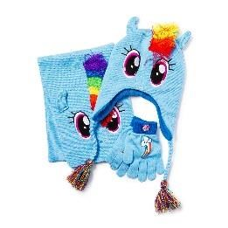

We go outside to play every day and we are often outside for learning activities throughout the school week, so you will need to bring a jacket with you each day, even if you come to school in a car. Please remember to bring your hat, scarf and gloves on cold days and label each item individually.

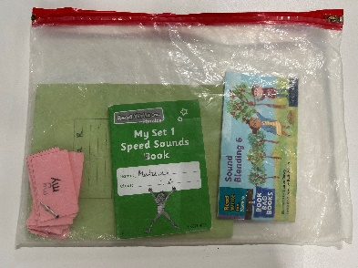
What do I need to bring to school each day?
Once you have started with us in P1, you will need to bring your reading folder to school with you every day. This is for carrying your reading books, home school work and letters.
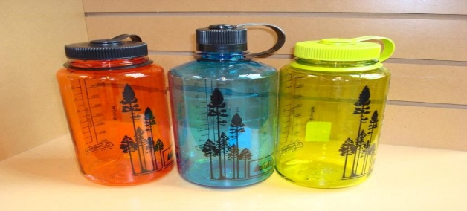
You should also bring a named water bottle to school with you. You are allowed to drink water throughout the school day when you are thirsty.

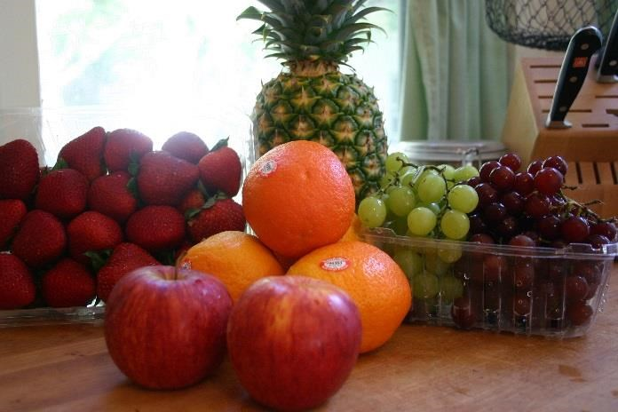
For morning breaktime you should bring in a healthy snack with you to eat.

Don’t forget….

Please ask someone to put your name on everything you bring to school, because we don’t want you to lose anything. Especially your uniform and shoes and coat.
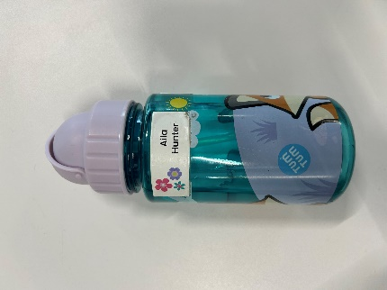
Using a Sharpie is a one of the most efficient ways to name items of clothing, please make sure you rename items as the school year goes on as they can wash off.
If you plan to order personalised labels online, please ensure you order them in plenty time before starting school, as they can take a long time to be delivered!

Coming into school in the morning
Whoever brings you into school in the morning will say goodbye to you at the gate and you will walk across the playground to your classroom. You can play in the playground before you go in if you are early. Your teacher will open the door to welcome you in at 8.50am.
Once you come in the adults will help you to put your snack in the snack box, hang up your coat, put away your bags and start the day by practising letter formation and pencil control.
Each day the teacher will tell you what you’re having for lunch.

Lunchtime
You can either bring in a packed lunch from home or you can order a lunch from the school canteen.

You can make your lunch choices at home with an adult using a system on the computer or a mobile phone, called ParentPay. Your parents or carers will be given an account login and it helps if you order your lunch a week in advance. Some people prefer to order lunches termly. You can go home for lunch if you like. ParentPay accounts cannot be activated until you are in the school building. Your parent/carer will get this during your first week. You can still order a school lunch by telling your teacher when you come in.
If you are entitled to a free school meal, please do apply for them as the school gets funded depending on the amount of applications.
Who will help me in the playground?
The playground supervisors will be outside at playtime and lunchtime to help you if you need it. The supervisors all wear high-vis vests so that they are easy to find. You will make lots of friends here at Jedburgh Grammar Campus, so there will always be someone to play with.
What if I can’t go to school?
If you are not well you need to stay at home. The grown up who looks after you will need to phone the School Office by 9:30am to let us know that you are not coming. You can also let the school office know that you are going to be off through the Expressions App. Details about this will go home to your parents once you have started in P1.
If you do not arrive in school, our admin team will send a GroupCall to your parents to ask where you are.
When you come back to school, we will be very pleased to see you.

What happens at the end of the day?
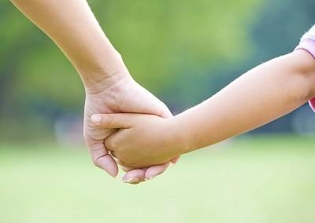
At the end of the day your teachers will make sure they can see the grown up that is collecting you. Your parent or carer should contact the office if you are not going home in the usual way. You must be collected by a responsible adult over the age of 16. P1 parents may come into the playground, to collect their children from the class teacher, outside the P1 learning spaces.

Will I get to play with my friends?

Yes! There will be lots of times when you can play outside with your friends. You will also have time to play and learn together in the learning spaces.
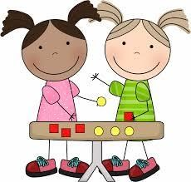
Did you know that when you are playing, you are discovering new things about colours, shapes, numbers, reading, writing and much, much more?
In your learning space, there are lots of exciting activities including sand and water trays, discovery areas, building blocks, painting areas and learning areas that change throughout each term.
We also have lots of exciting learning games for you to play on the laptops and on the Apple TV on the wall.
You could try practising these things at home which will help you when you come to school:
- It is very important that you know how to wash your hands thoroughly.
- Going to the toilet by yourself.
- Getting dressed and undressed by yourself.
- Using the toilet properly. Remembering to wash your hands with soap and water, then dry them well afterwards.
- Recognise your name.
- Looking after your books and games. Tidying up once you are finished with them.
- Practise counting things and use your sound book.
- Putting on your own jacket and shoes.
- Having fun at home playing games like; Dominoes, Pairs, Snakes and Ladders, children’s Monopoly and cards to name a few.
- Having fun doing jigsaws and colouring in.
- Practise using a knife, fork and spoon correctly at the dinner table and clearing my plate and cutlery away afterwards.

Parents and Carers
Our job in the school is to build on the learning and existing knowledge that your child already has by being at home with you or that has taken place in their nursery. For this to be successful, we need to work together with you and your child.
If you have any concerns regarding your child. Please contact the School Office to arrange an appointment to speak to a teacher or a member of our Senior Leadership Team; Mrs Oliver (Head Teacher), Mrs Warnock (Depute Head Teacher). We are all here to support you and your child on their learning journey in our school.
We hope that this booklet has been helpful for you and your child. We look forward to you joining us at Jedburgh Grammar Campus.
From everyone in the P1 Team.

