
Campus Update

18th August 2023

Dear Parent/Carer,

Welcome to our first update of session 2023-24. I hope you managed to enjoy the summer holidays with your families, despite the decidely unseasonal weather!
It has been lovely to see so many smiling children, young people and staff and feel the buzz around the campus this week. Those who have joined us this session are settling in well and I’m looking forward to working with all members of our school community in the year ahead.

As always, I am grateful to the members of our Parent Partnership (formerly Parent Council), who support the school in a wide range of ways, including fundraising to support additional activities and experiences for our children and young people. Their financial support makes a fantastic difference to the experiences we can offer, including recently funding transport to residentials and supporting our Senior Phase prom.

New members are always welcome to joint the group or support their work in any way you can. If you would like to find out more contact PP Chair Lynsey Graham, via jgcparentcouncil@gmail.com or come along to the next meeting at 6.30pm on Thursday 31st August.

We would love to welcome as many parents, carers, family and community members to the next fundraiser on Friday 22nd September. The evening promises lots of fun and laughter, alongside a bit of bargain hunting – what better way to spend a Friday evening?

For tickets please contact:
Lynsey Graham 07488299177
Lynne McKay 07709307071
Lynsey Laing 07815089391

Donations for raffle prizes would be welcomed and can be handed into JGC reception.

Wishing you a lovely weekend.


Susan Oliver
Headteacher

Learning Without Limits

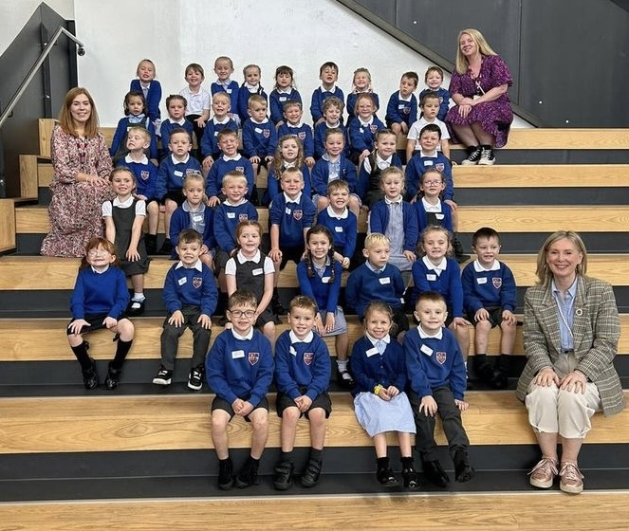
Here are our new P1s on their first day and some of our new S1s enjoying their outdoor social space.

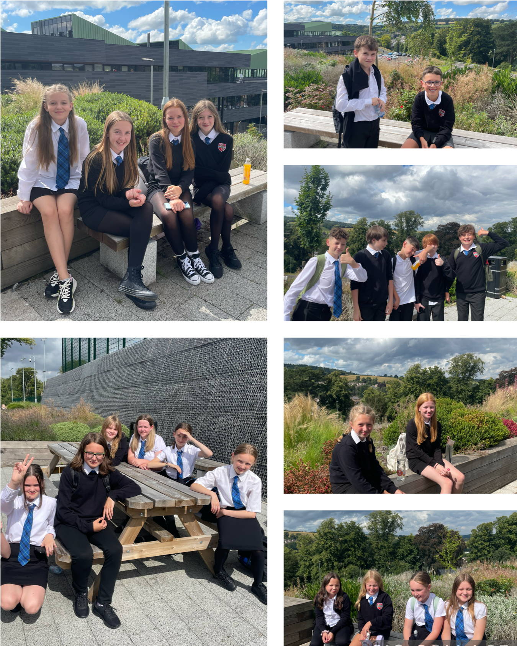

ELC on tour Summer 2023
During the summer holiday, some of our nursery children had a fabulous time visiting the town’s new bookshop, Heron & Willow.
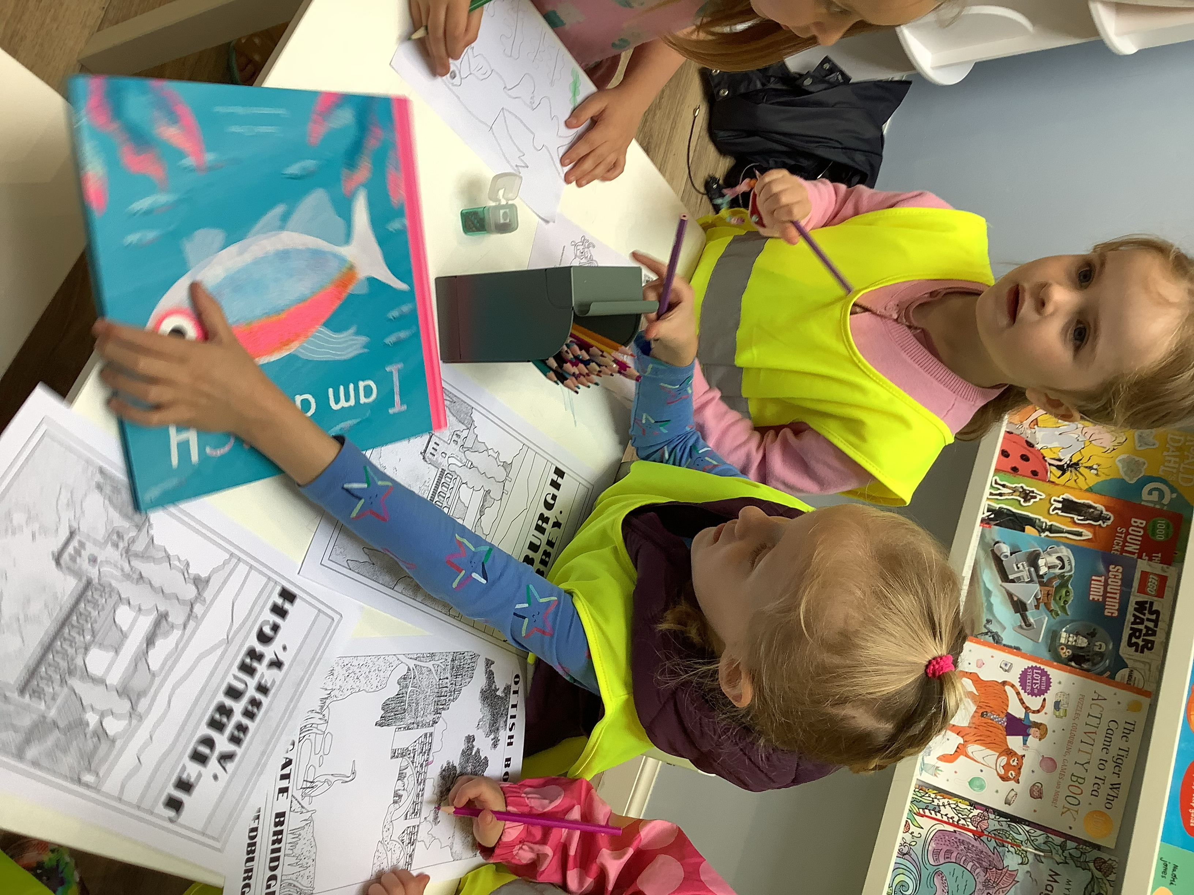
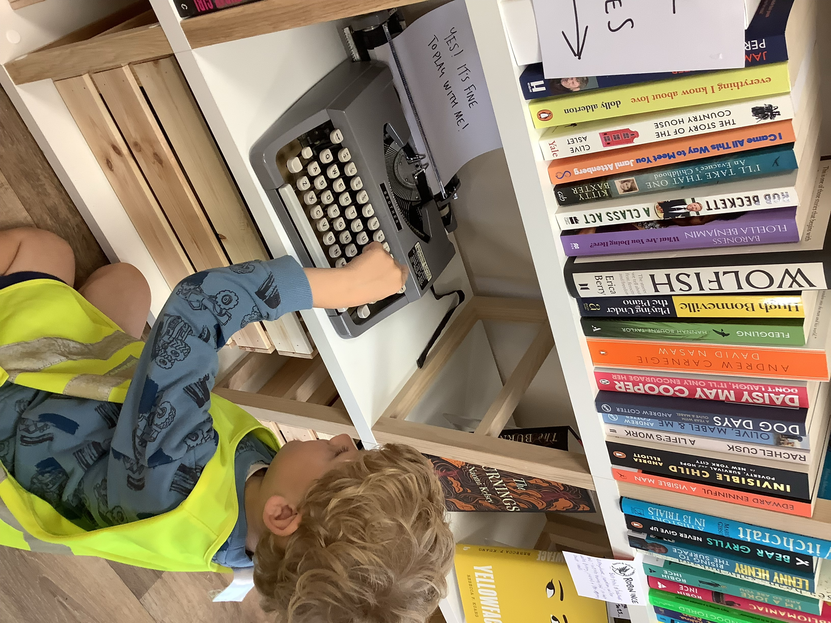
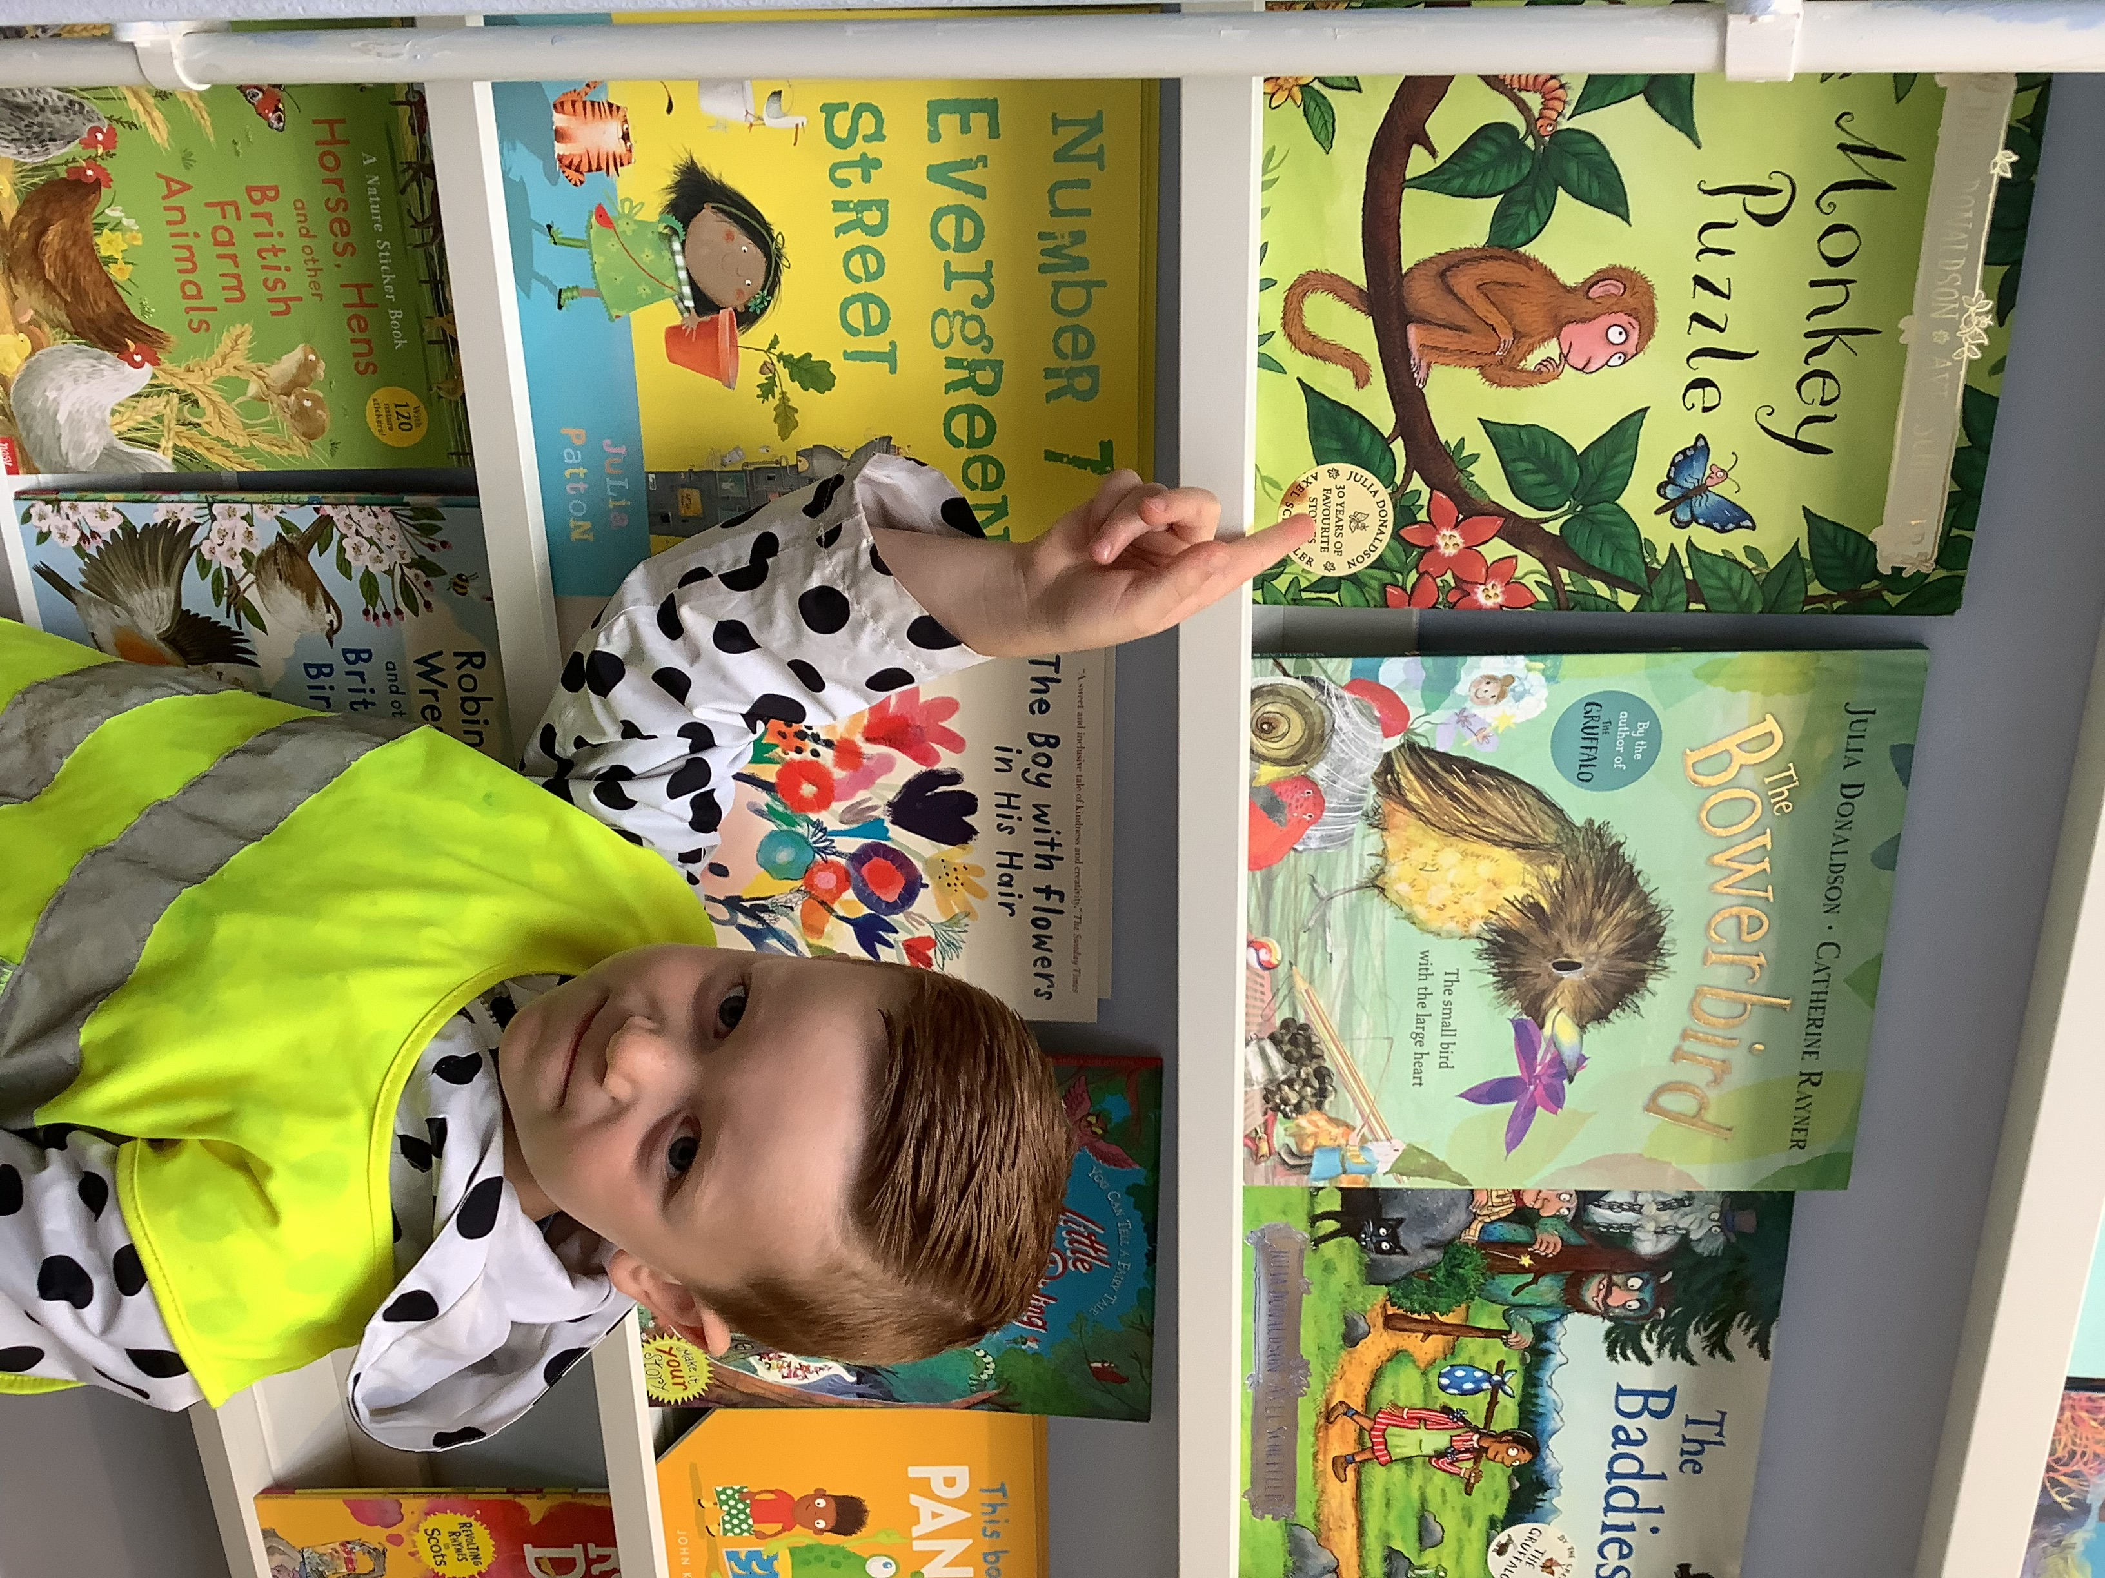

We are also really excited about the Festival of Stories which will be taking place on September 16th and 17th. For more information on events for families go to Festival Of Stories - Heron & Willow (heronandwillow.scot)

SQA results

This year our young people achieved the best set of results since records began! Despite a national downturn in results, Jedburgh Grammar Campus bucked this trend by increasing the overall pass rate from last year. Students in our fourth and fifth years set new records for the number of qualifications achieved in one year. The percentage of fourth year students achieving 5 or more awards at National 4 and National 5 level is the highest since the introduction of these qualifications in 2014. The percentage of fifth year students achieving three or more awards at Higher level is also greater than ever before.
We are delighted and proud of the superb achievements of our young people, who we have been celebrating at assemblies this week. We have shared the messages that there are many ways to achieve success. Whether they achieved 5 or even 6 As at higher level (as two of our young people did) or not, as long as their results represent their best efforts then they should be very proud. If the results were not as they wished then then they have time, support and opportunity this year to work towards achieving better results next year.

Developing the Young Workforce - Scottish Apprenticeships and Additional Support Needs webinar for individuals, parents and carers
Join a free Skills Development Scotland webinar via Microsoft Teams on Thursday, 7 September 6.30pm - 7.30pm
- Find out about the help in place to assist apprentices with additional support needs.
- Hear from those who support apprentices in training and in work to ensure they achieve and succeed.
- Listen to apprentices and their parents share their experiences of the help provided to meet additional support needs.
Examples and information will cover Foundation, Modern and Graduate Apprenticeships.
To support accessibility, this webinar will be recorded and British Sign Language translation available. Find out more and sign up on Eventbrite: SDS webinar

