
Campus Update

12th December 2025

Dear Parent/Carer,

I’m sure I’m not the only one who has been singing Grease songs all week and I know that everyone who had the pleasure of attending our school performances will agree that the standard was superb. The incredible talents, dedication and courage of our performers, combined with the team efforts of young people and adults from across our school community ensured our second JGC musical was a resounding success. I can’t wait to see what comes next!


Thank you and well done also our Winter Princess Charlotte Robinson and her wonderful helpers who supported Santa at the town’s Winter Parade last Friday night . . . before coming back to JGC to serve refreshments during the musical interval!

Next week brings the much-awaited P1/2 Nativity! Our Parent Partnership group will once again be running a raffle and would welcome donations, which can be handed into the campus reception.

Wishing you a lovely weekend.


Susan Oliver
Headteacher

LEARNING WITHOUT LIMITS

JEDBURGH TREE FESTIVAL

Our nursery children and staff have worked hard to create a Christmas dinner themed tree for the Jedburgh Tree festival.

Next week we will be taking groups of nursery and primary children to visit the festival, but the event is also open to the public until next Friday.

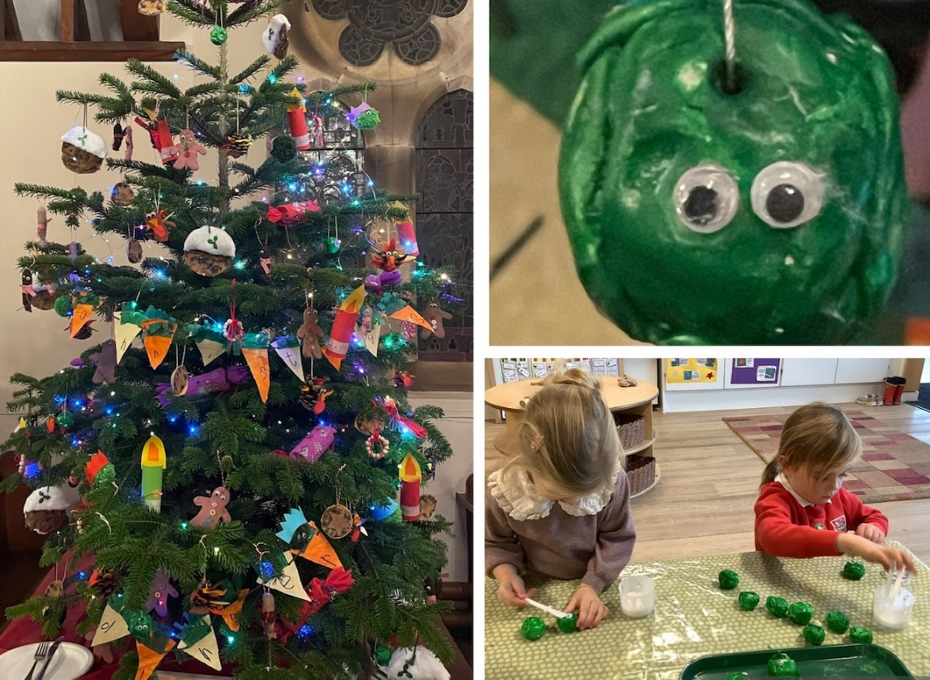
DYW
We were delighted to welcome former pupils Jamie Oliver and Grant Sandilands from Savills to talk to our Agriculture class last month, sharing valuable industry insight into rural estate management, food and farming consultancy and the wide range of career opportunities within the business. We’re grateful to them for taking the time to visit and sharing their own personal career journeys with us.


In addition, some of our Construction Skills pupils were invited up to the new housing development site in Jedburgh to meet with Cruden Homes. Pupils visited the site manager’s office and learned about the different trades involved in housing development, health & safety regulations and site management before having a tour of the first completed phase of the project.

Kindness at Christmas
Reminder that our annual JGC Christmas Jumper Day will take place next Friday (12th December).
Children and young people are welcome to wear Christmas jumpers, or other Christmas accessories, with their uniform on the day and thereafter until the holidays.
Rather than monetary donations, our S6 Head Team will be organising a collection for the local foodbank:
Once again, we will be supporting the Jedburgh Churches Foodbank in the run up to Christmas. The Foodbank is based at Jedburgh & Oxnam Church but is a joint churches initiative, including Ancrum Church.
As well as supporting the Foodbank, JGC staff can also make referrals for families needing assistance. All requests for referrals will be treated confidentially.
Suitable items for donation are dried, packet and tinned goods, toiletries and cleaning materials. They always need jam, cereals, tea, coffee, packet noodles, rice, biscuits like digestives and ginger nuts, baked beans, hot dogs, tinned tuna/ravioli/sausages and beans, tinned fruit and loo rolls. They cannot accept alcohol, homemade food, fresh food or items past their sell by date.
Children and young people can hand donations to their teacher (primary) or place items into boxes in the foyer at the campus entrance (ELC and secondary), preferably by Wednesday 17th December.
The Foodbank are also grateful for monetary donations that allow them to buy fresh food and babycare items. We can’t accept money in school so if you would prefer to donate in this way there is a swipe card donation point in Jedburgh Co-op.
Thanks in advance for your support.
Charlotte, Logan, Kian and Rebecca (JGC Senior Head Team)


Please do not buy anything especially for “Christmas Jumper Day”.
Our Eco Committee are also running their annual Pre💗Loved@Christmas festive recycling programme and would welcome your support.

Our young people who are members of the Jedburgh Action Group are also setting up a Swap Event next Wednesday (10th December) to help local families out in the run up to Christmas.

Please support them if you can!



