
Campus Update

26th May 2023

Dear Parent/Carer,

Witnessing the impact of our young people being involved in the Youth Philanthropy Initiative (YPI) has become one of the highlights of each school year for me. YPI is delivered to an entire year group in hundreds of schools across Scotland and in JGC all S3 pupils have the opportunity to be involved. Working in teams, pupils work together to identify a social issue they care about and a charity supporting that issue in our area. They then have to get in touch with the charity before presenting their research and potential impact of funding to their peers. Yesterday we heard from five finalist teams who made the judges task very challenging. The national representative from YPI who joined us said that in all the school she visits she rarely sees every group hit all the target criteria in their presentations, which is what she saw yesterday. All of our young people did a fantastic job, but Ava Gibson, Lucy Gibson, Rebecca Hill and Millie Stenhouse were successful in winning a £3000 grant for their chosen charity, the Rowan Boland Memorial Trust. For more information about this fantastic charity who support aspiring sportspeople from across the Borders, go to Home | Rowan Boland Memorial Trust
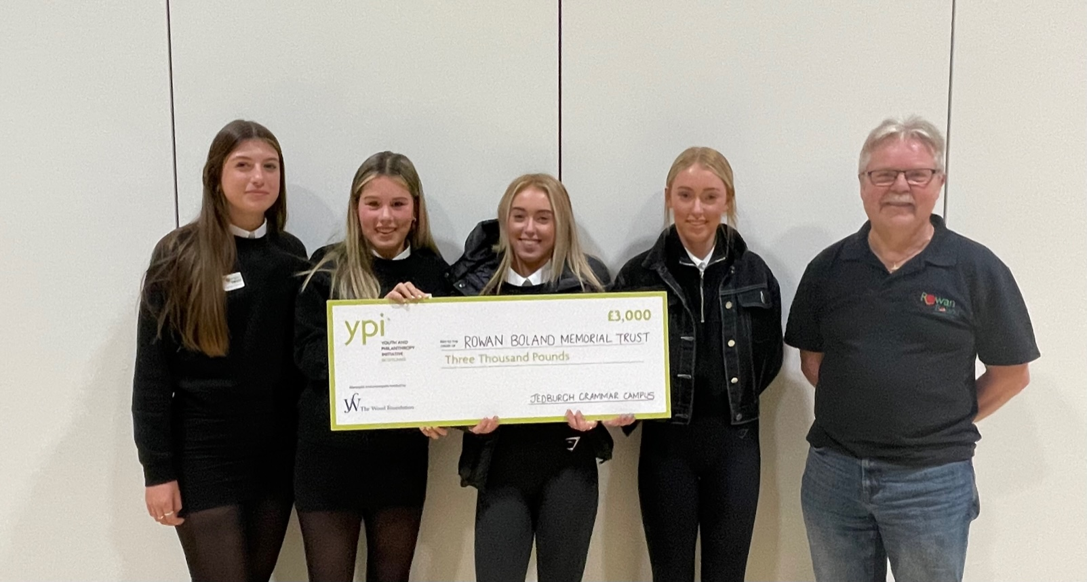

JGC is clearly the place to be this week, with international visitors coming to find out about the campus. On Tuesday we welcomed Dr Ros Harrington from Brisbane, who was interested in hearing about the intergenerational opportunities we are developing and yesterday we welcomed staff and pupils from the International School of Munich who were interested in the design of the building and how the flexible spaces support learning. JGC pupils and staff shared their experiences with our visitors and are already trying to figure out how we can secure a return visit!

Have a lovely weekend in the sunshine.



Susan Oliver
Headteacher


Wellbeing
Huge thanks to the P7 pupils who volunteered last week to help Scottish Borders Council’s Communications Team and PC Tait-Logan with the making of a video to promote safe use of school transport. We look forward to seeing the finished production!

Learning Without Limits
P7 on tour
As part of this terms topic “Scottish History,” they have been looking at key figures in Scotland, including Mary Queen of Scots and Scottish Architect Archibald Elliot who designed Jedburgh Castle & Jail. The Castle Jail was an exciting trip for the Primary 7s who were able to find out more about these key figures.
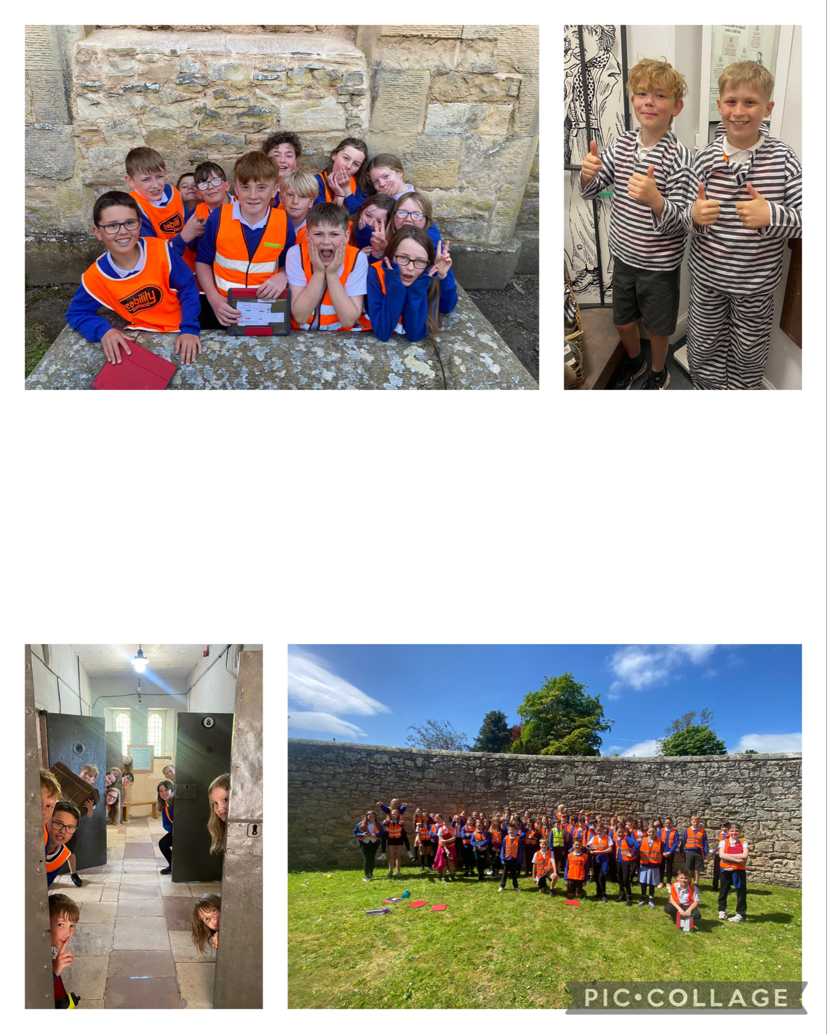

Chemistry Challenge
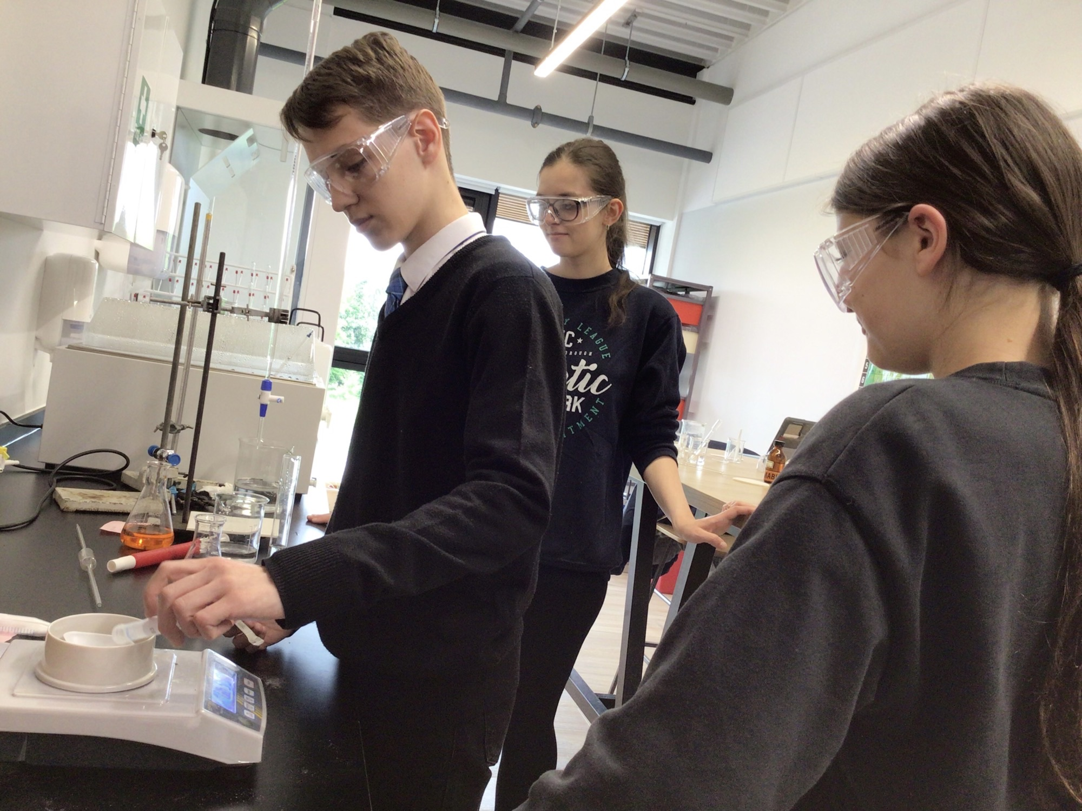
As if sitting exams wasn’t enough this month, yesterday three of our seniors competed in the Schools Analyst Competition 2023, delivered by Northumbria University. Mya Duncan and Danny Miroshnychenko from S5 and Ariana Ashkannejad from S4 were using their chemistry skills to work out who sabotaged the Bake Off. Their results will be entered into the regional heats with the possibility of going into a national competition. They were carrying out familiar and new techniques with plenty of calculations, demonstrating excellent chemistry skills!

Developing the Young Workforce

S2 had great fun developing their creativity in Art & Design this week during a workshop delivered by Heriot Watt University and Developing the Young Workforce Borders. We most definitely have some budding Fashion Designers in our campus. Pupils were recreating some iconic outfits. Teamwork, problem solving, leadership, creative thinking . . . the list goes on!
Special thanks to a wonderful trio of former pupils for organising the event – Nicola Shaw (DYW Borders), Hayley Blair (Heriot Watt) and our very own Mrs Gilfillan. What great role models for our young people!
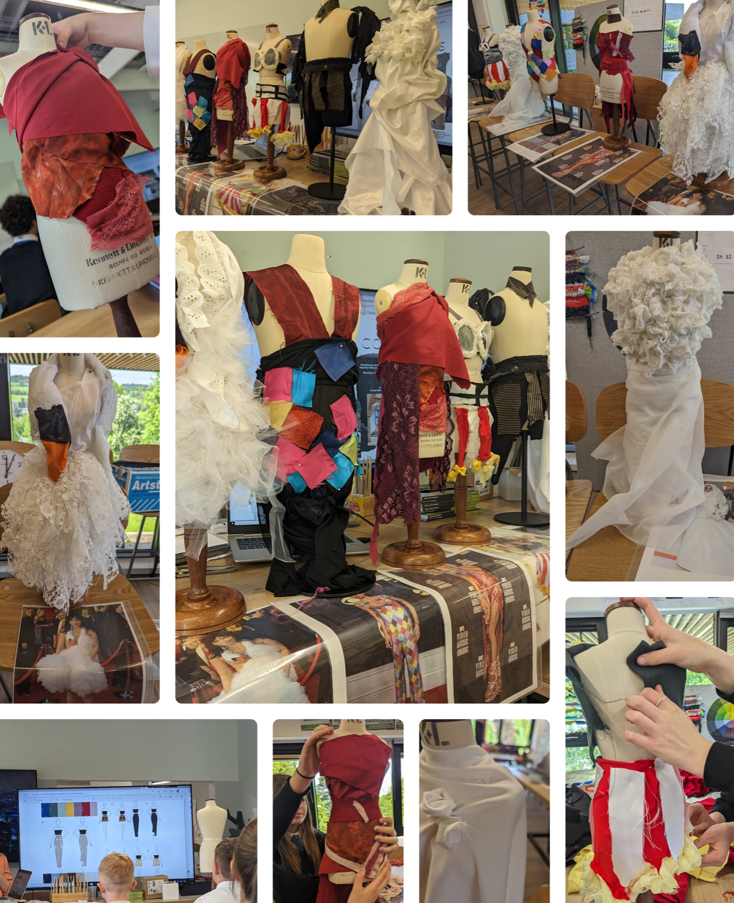

Feedback on Skills Development Scotland (SDS) Career Service
Reminder that that the SDS survey closes on Wednesday 31 May 2023 and our local team would greatly appreciate your feedback SDS parent/carer survey.
All responses are confidential and anonymous, and the results will be used to inform SDS services. The survey should only take about 10 minutes to complete.

Eco Update
Jedburgh schools have been involved in the ‘Rag Bag‘ recycling scheme for many years and it is a valuable way of fundraising to support our children and young people, while increasing recycling rates and ensuring less material goes to landfill. During our collection this week, the company reported that several loose items had been placed in the recycling bank in the bottom car park. These cannot be used, so please ensure that any donations are placed in a tied bag, before placing the bag in the recycling bank.
Many thanks for supporting this worthwhile venture and a reminder of the guidance shared by the ‘Rag Bag’ company:

We can accept the following items:
- Wearable Clothing
- Paired Shoes
- Handbags
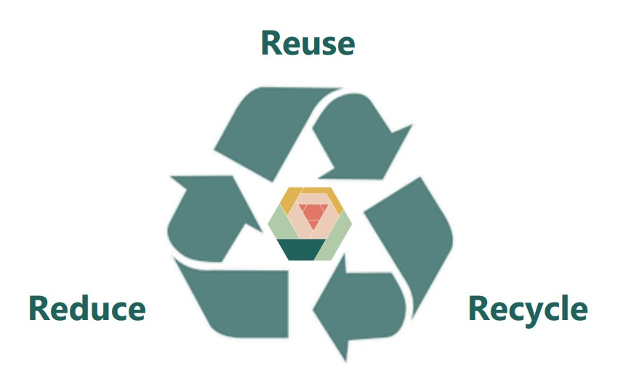
- Belts

We cannot accept the following items:
- Workwear
- Uniforms (including School Uniforms)
- Wet/Soiled Clothes
- Curtains
- Towels
- Duvets or Duvet Covers
- Pillows or Pillow Cases
- Blankets
- Table Cloths
- Linens
- Cushions
- Carpets
- Suitcases
- Books
- Bric a Brac
- Clothes Hangers
- Electricals



