
Campus Update

13th January 2023

Dear Parent/Carer,

Happy New Year! I hope you had a lovely festive season and that 2023 is a good year for you and your family.

This week we have launched our new values recognition programme, with children, young people (and staff!) being presented with values certificates and the all-important house tokens, for displaying one or more of our campus values of kindness, respect, achievement, wellbeing and learning.

Values certificates can be awarded for displaying values in classes or elsewhere in and out of school. Our Junior Head Team will collate and announce house points at the end of each month and we are looking forward to a range of inter-house events developing across the campus.

As you can see from the pictures below, recipients took great delight in adding their tokens to our house point collector.
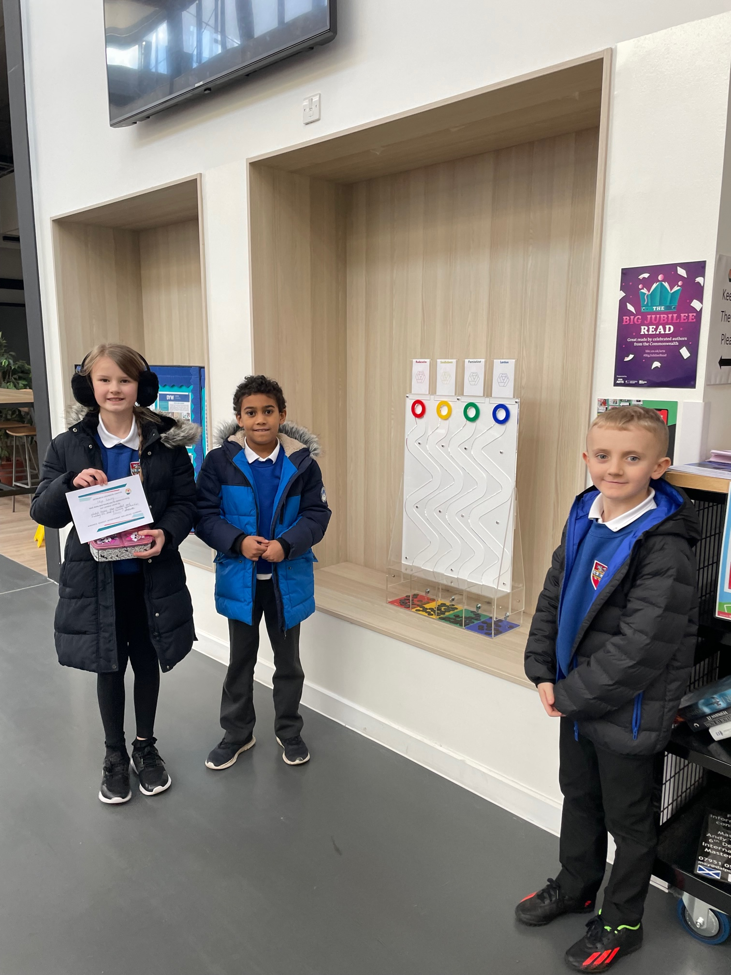
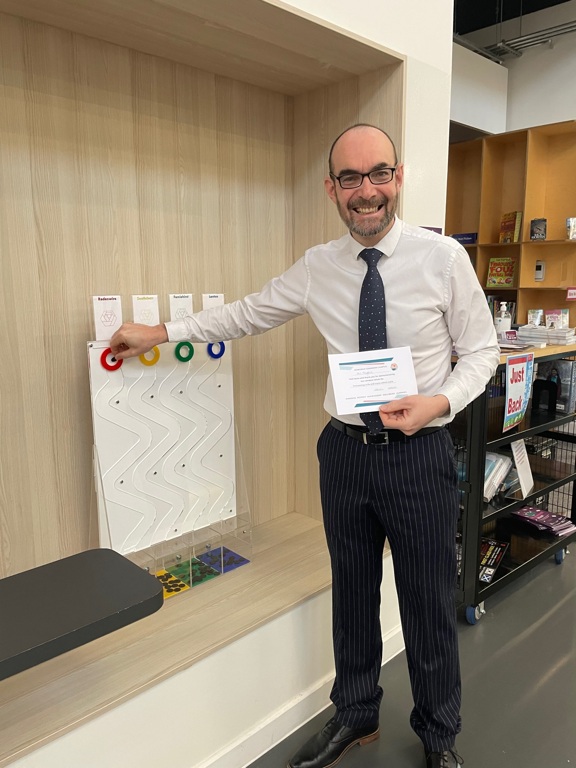
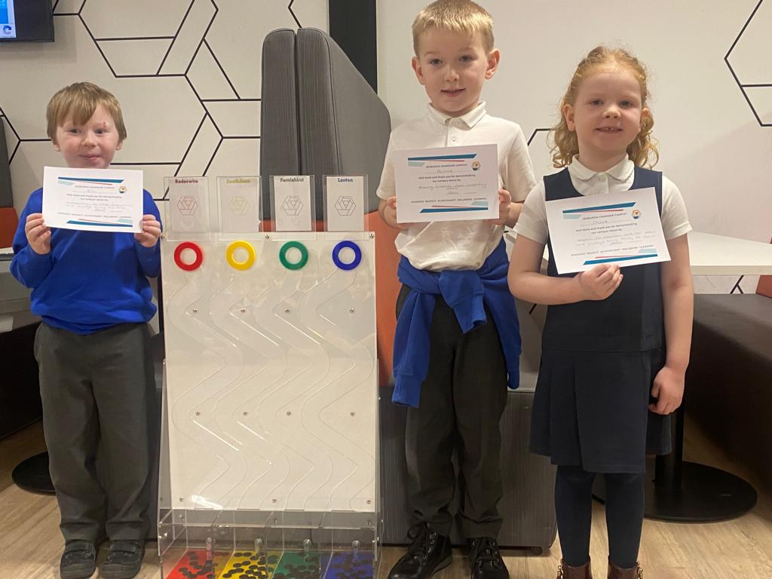

Have a great weekend.
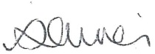

Susan Oliver
Headteacher


Parental Involvement
Our Parent Council had their first meeting of 2023 this week. New office bearers were elected at the November AGM and are now in place for 2023.
Lynsey Graham has taken on the role of Chair. Ellen Palmer is our new Treasurer and Jodie Sandilands and Debs Marshall are the new joint Secretaries. Huge thanks to our previous office bearers for all their fantastic work and huge effort in supporting the campus and previous schools.

New members are always welcome, and if you’d like to have an informal chat with our Parent Council, they will be in the campus in the Atrium area at the forthcoming parents evenings in January, February, March and April.

You can find out more about the Parent Council, the various volunteering roles and fundraising plans for the school. It’s not all meetings! Parents, carers and family members are all invited to help and support where they can. Whether that be volunteering some of your time to support one of our fundraising events or activities within school, donating a raffle prize or coming along and giving us some new ideas – all suggestions and support are welcome!

Senior Phase Prelims
Best wishes to all our S4-6 pupils who begin their preliminary examinations next week (Monday 16th and end on Friday 27th). Anyone who has misplaced their timetable can collect a paper copy from the campus office. Electronic versions are available in year group TEAMS.

During prelims, pupils should continue to wear uniform and attend their normal timetabled lessons when not in exams.

Please see below additional guidance which was shared during the Prelim Assembly.
- All exams will be completed under exam conditions
- Check you know the date and timing of all your exams. Arrive 5 minutes early. If your bus is late or something happens, call into the office on your arrival and we will help you out.
- If you have ANY issues with your exams tell a member of staff.
- Your seat number and location of your exams will be on display outside the Assembly Hall.
- Come prepared with a calculator, ruler, spare pencils, pens etc. No pencil cases are permitted.
- MOBILE PHONES – NO mobile phones or smart devices are permitted in the exam rooms. These must be left at the office. Failure to do this in final exams can result in no awards.

For additional information see the SQA booklet that was issues at assembly or click here –
Your National Qualifications 2022-23.

Developing the Young Workforce
Our Careers Adviser, Kim Ferguson, will be interviewing all S3s to discuss their options for Senior Phase. These meetings will start on Monday 16th January and last around 20mins per pupil. Kim is hoping to meet with all S3 pupils by the end of the month.

Our “Positive Futures” Careers Fair has been re-scheduled for Thursday 9th February 12 noon – 6pm. More details to follow next week.

Community
Advanced warning that this year’s Hand Ba’ falls on Thursday 23rd February. As previously, families wishing their children to participate/spectate at the youths event during the afternoon will be able to request that they can leave school early that day. A separate communication will be sent to all parents/carers. Our primary children will be discussing this local tradition during assemblies in the run up to the event.

