Learning, Teaching and Assessment Policy

March 2023

Contents Page
3. Overview
4. Aims
5. Principles of Learning, Teaching and Assessment Policy and Framework
6. How will we achieve this?
10. Roles and Responsibilities within the campus
12. Appendix 1 – Learning Principles
13. Appendix 2 - Lesson Evaluation Toolkit (P3-S6)
14. Appendix 3 – Lesson Evaluation Toolkit (ELC – P2)
17. Appendix 4 – Walk Through Observation Proforma
18 Appendix 5 – Inspire Feedback policy

Overview
Our Learning, Teaching and Assessment policy draws on the Scottish Borders Council’s framework to raise attainment and to achieve excellence in learning. SBC sets out that this can be accomplished by focussing on the following four core areas:
- Quality Improvement
- Learning, Teaching & Assessment
- Inclusion (Including Equity, Mental health and Wellbeing)
- Partnership with Parents
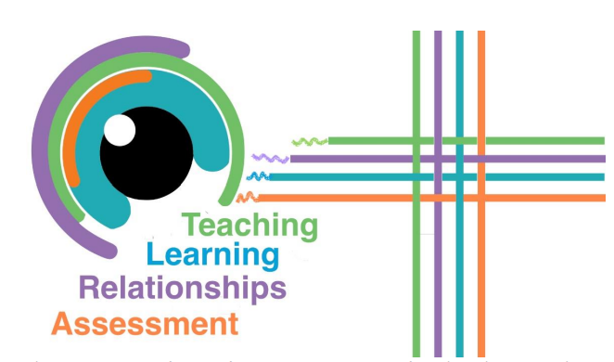

The guidance in our JGC policy also follows this structure and is appraised by research. It will ensure the continual progression of the quality of learning, teaching and assessment within our campus with the overall aim of raising attainment and supporting the learning of all our children and young people. It applies to learners of all ages and within all settings where learning occurs.
This policy should be used in conjunction within the framework of our wider learning, teaching and assessment resources (see appendices). This aligns with Scottish Borders Council Directorate’s vision for all young people – ‘In Our Sight, In Our Minds, In our Actions and Being Heard’.
Our policy models the key principles recognised to be essential for excellent learning while also reflecting the unique context of our school and our community. This is evident from our Curriculum rationale.

Aims
The JGC Learning, Teaching and Assessment policy aims to drive:
high expectations that encourage and support individual success

positive learning environments grounded in strong relationships

the planning of LT&A with Inspire Learning technology in mind

the delivery of inclusive practice through effective pedagogy

high quality LT&A in our campus for every learner, every day

The JGC Learning, Teaching and Assessment Framework:
- Encompasses a suite of resources that will help staff raise attainment through continual progression of the quality of learning, teaching and assessment.
- Upholds and promotes the purposes of education as outlined within Curriculum for Excellence and the central importance of the 4 capacities.
- Links our learning, teaching and assessment policy with the SBC Partnerships Framework, Inclusion Framework and Quality Improvement Framework.
- Ensures that every child and young person has the same opportunity to succeed, with a particular focus on closing the poverty-related attainment gap.
- Supports the implementation of evidence-based approaches by identifying and providing core professional learning and development for staff.
Positive relationships are at the heart of everything our campus does. Learning underpins everything.
This policy and our overarching framework’s objective are to maximise learning, teaching and assessment.
The key phases of learning i.e. Early Years, Broad General Education and Senior Phase will all look different. However, all should be underpinned by a foundation of quality relationships and high-quality learning.
To provide excellent teaching for every learner, every day.

To provide excellent learning for every learner, every day.

Our leaders to maintain a relentless focus on ensuring excellent learning every day.

Our profession to be informed by current educational research.

Our schools and settings are guided by national policy as set out in CfE, GIRFEC, HGIOS4? and the National Improvement Framework.

We have clear visions, values and aims that drive our collective purpose.

We have a curriculum rationale that drives the curriculum decisions.

Our Learning, Teaching and Assessment Framework will drive a relentless focus on high quality learning and teaching.
To provide excellent teaching for every learner, every day.

To provide excellent learning for every learner, every day.

Our leaders to maintain a relentless focus on ensuring excellent learning every day.

Our profession to be informed by current educational research.

How will we achieve this?
In order to improve the learning, teaching and assessment within our campus the principles and detail within the visuals below must inform and be visible in all our practice.

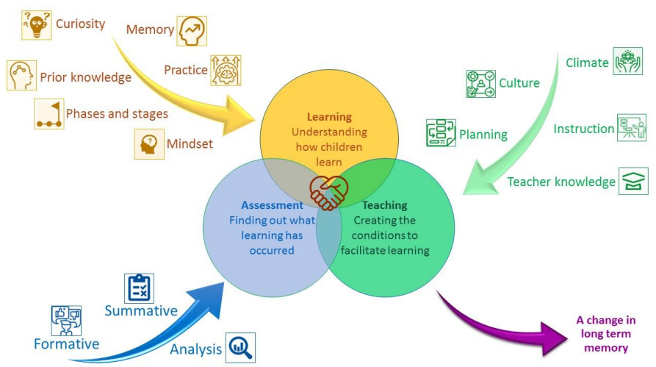

The essential components that feed into each of the 3 elements have been identified as an attempt to synthesise the wealth of educational research and literature on learning, teaching and assessment.
On the following pages, each of these essential components are explored in more detail, giving specific evidence-based statements to explain the principle. An SBC LEARNS Glow Blog provides examples of each principle and supporting professional learning resources.
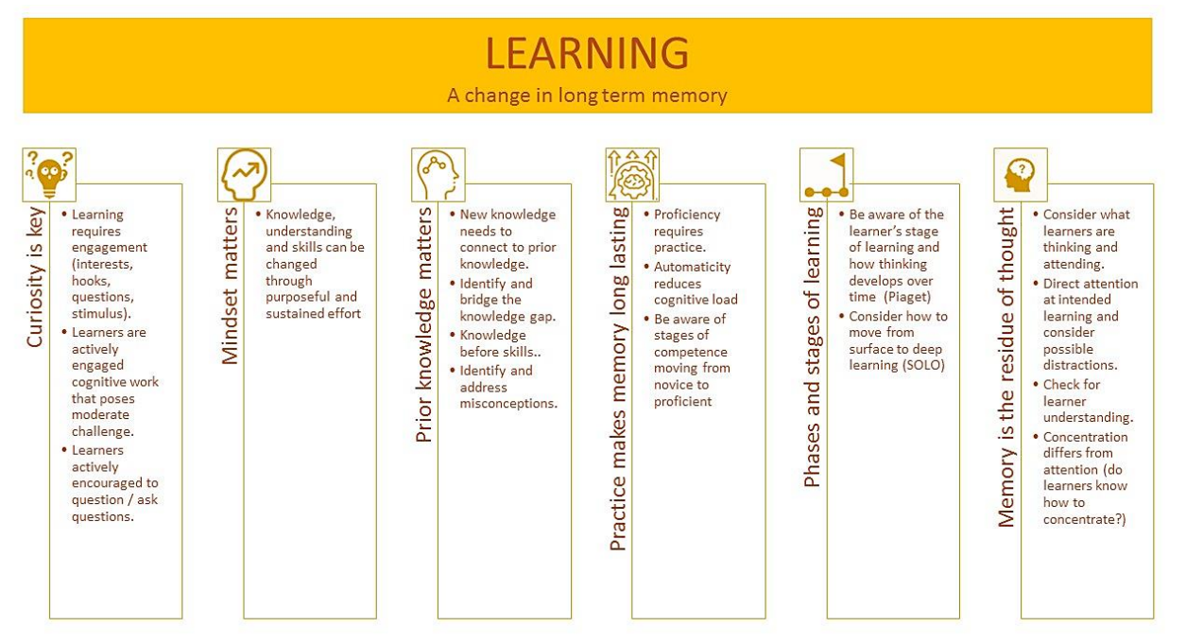
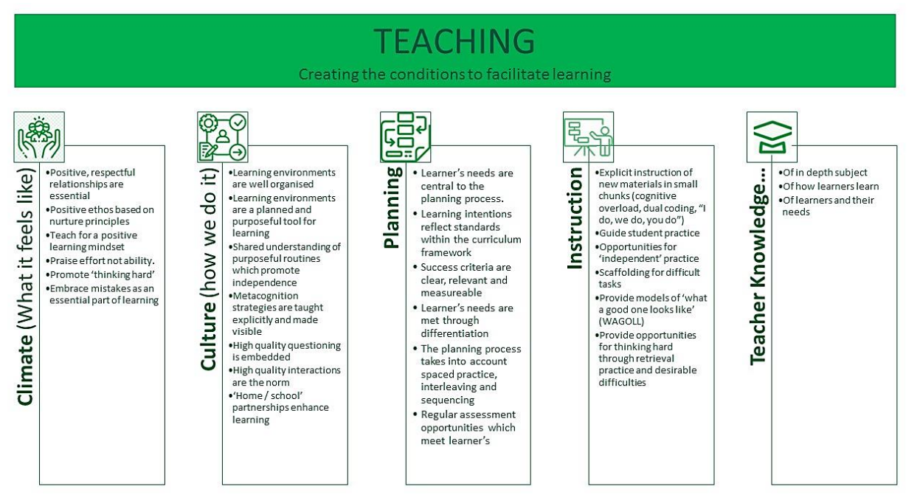

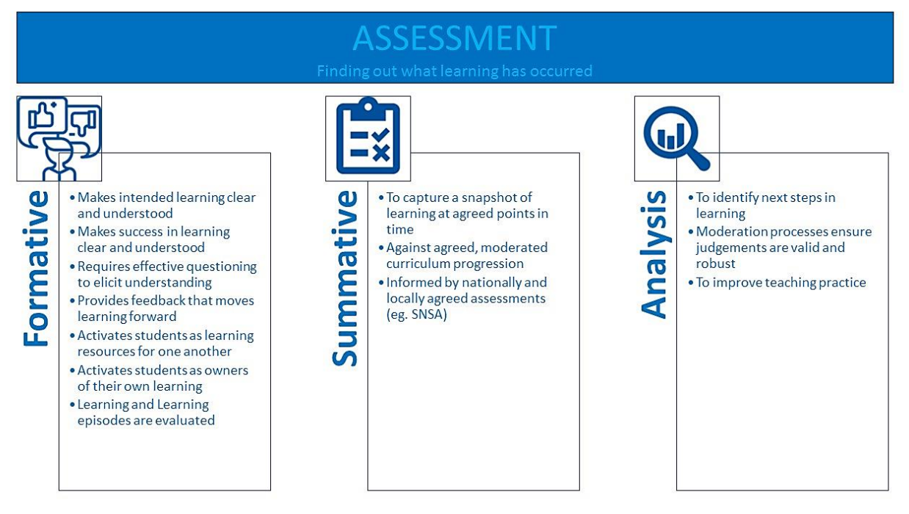

Roles and responsibilities to support LT&A within the campus
Responsibility | SLT | PTs | CTs
Ensure whole school LT&A guidance aligns with SBC framework, school vision and curriculum rationale. | x
Ensure whole school systematic approaches to LT&A are understood by all and lead to improved outcomes for learners. | x
Ensure that high quality learning and teaching within Literacy and Numeracy is informed by key messages outlined in the respective SBC Literacy and Numeracy Strategies. | x
Ensure quality improvement and self-evaluation approaches are focussed on continuous improvement in LT&A for all over time. This will be supported by a programme of quality assurance activity planned throughout the year. | x
Monitor the impact of Professional Learning and collegiate activity on the quality of children’s learning experiences. |  | x
Plan and manage resources proactively and efficiently to support the delivery of highly effective LT&A. |  | x
Nurture innovation within a culture of empowerment, encouraging staff to adopt a critically enquiring and evidence-based approach to continuous improvement as outlined in this policy. | x | x
Continue to nurture partnerships with families as equal partners in their children’s learning journey. | x | x | x
Seek out and contribute positively to local partnerships which will lead to better outcomes for children and young people and in particular for those at greatest risk in line with SBC Inclusion and Partnerships Framework. | x
Ensure appropriate systems for tracking and monitoring are in place to support analysis of attainment data as outlined within the framework. |  | x
Use all available data to set targets for improvement and understand role in improving attainment for all. |  |  | x
Plan for learning teaching and assessment in line with the school framework and SBC’s digital strategy. |  | x | x
Ensure that positive relationships are at the heart of learning. |  | x | x
Promote and contribute to a collegiate climate of high support and high challenge. |  | x | x
Hold high expectations and aspirations for all our learners, supporting them to be curious about their learning. |  |  | x
Demonstrate a commitment to adopting and modelling for others all elements of this Framework over time. |  |  | x
Actively seek the views and feedback of learners, and support them to be leaders of their own learning. |  | x
Actively seek out learning opportunities to improve your knowledge and skills in principles mentioned within this Framework. |  | x
Ensure that planning for high quality learning and teaching within Literacy and Numeracy is informed by key messages within SBC Literacy and Numeracy Strategies. |  | x
Ensure full involvement in evaluating the impact of Professional Learning opportunities and collegiate activity on practice. |  | x
Continue to nurture partnerships with families as equal partners in their children’s learning journey. |  |  | x

Appendix 1 – Learning Principles

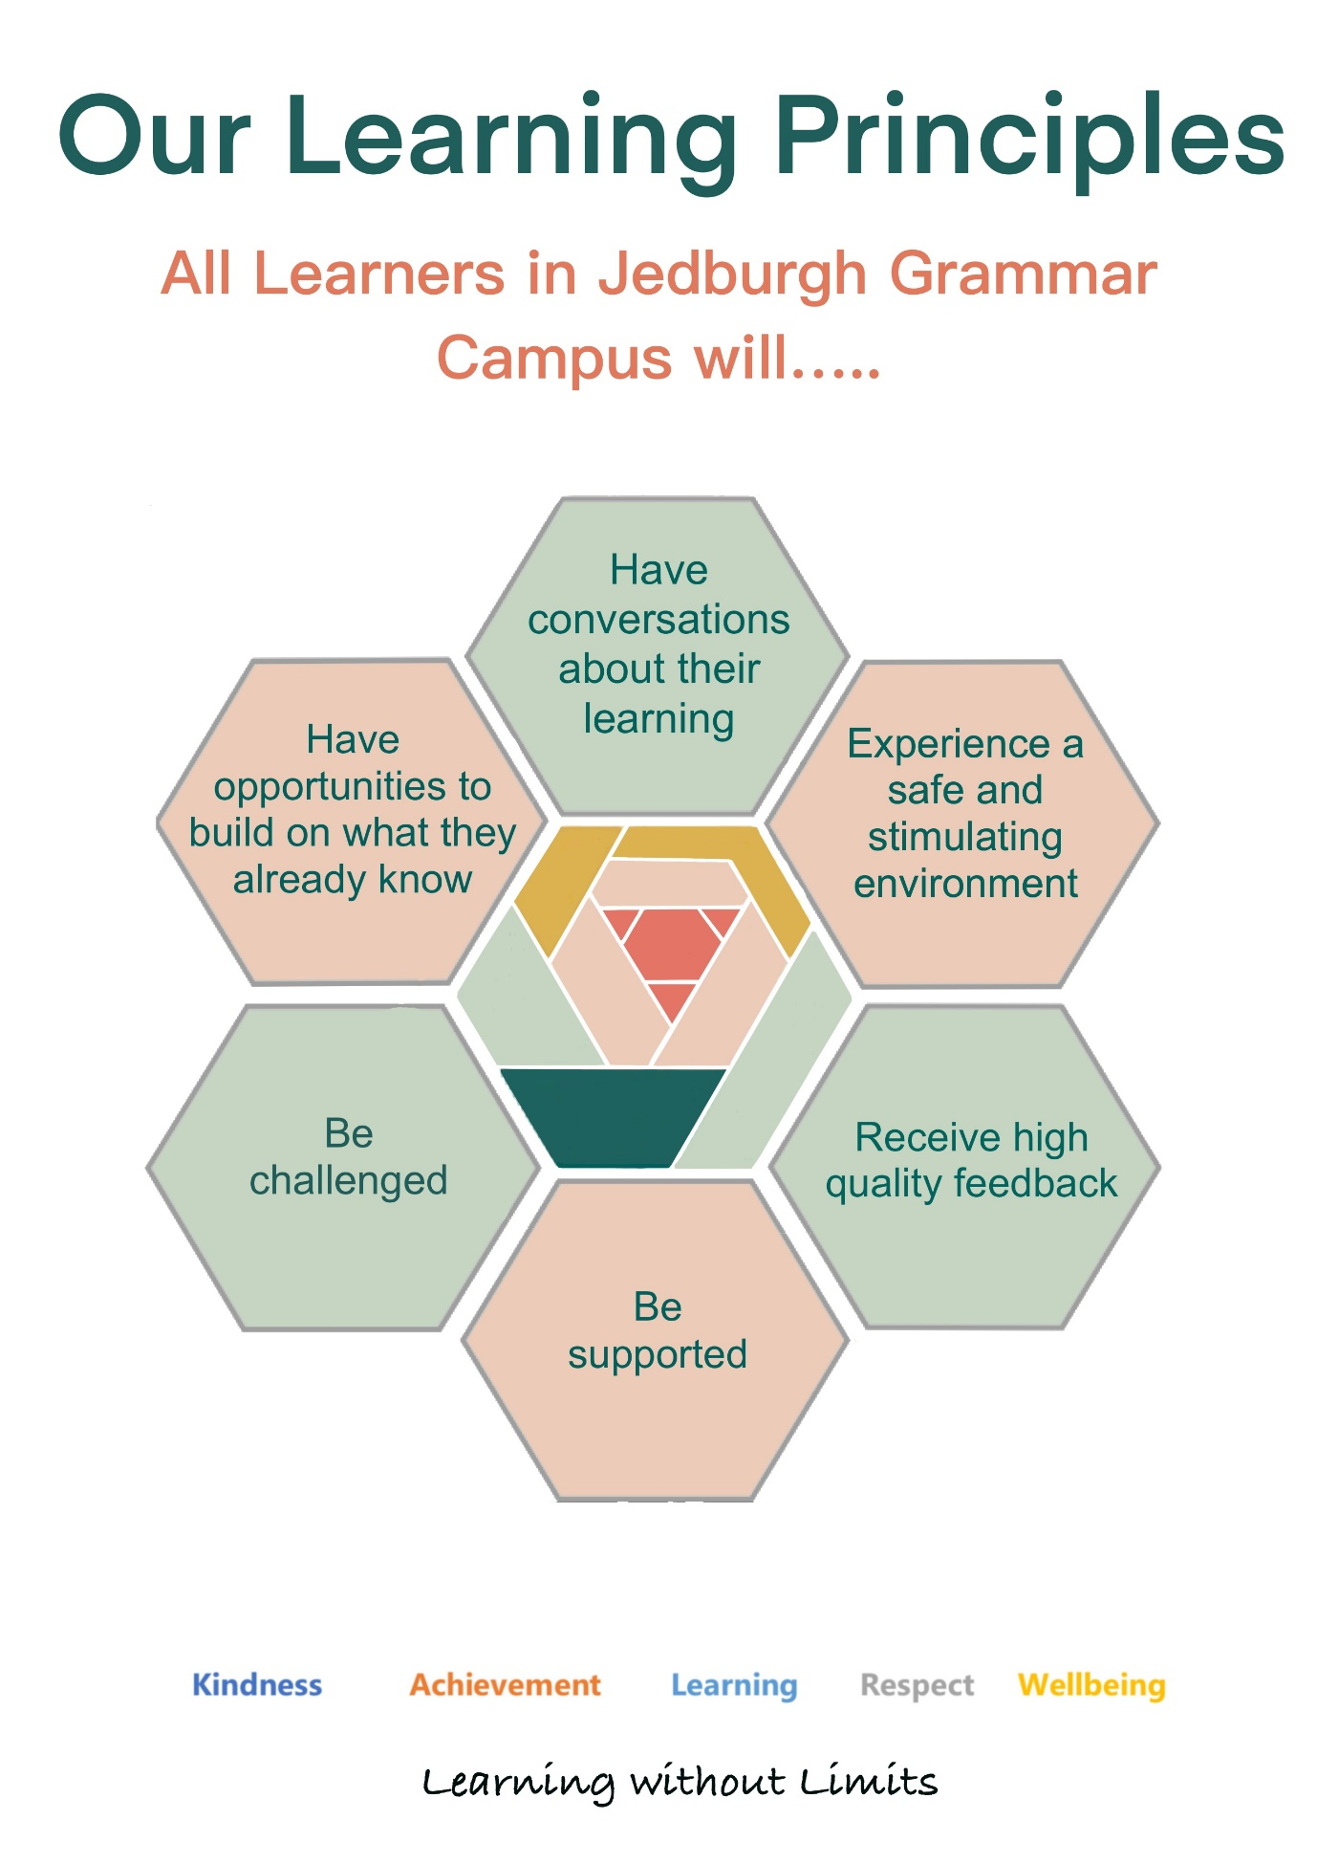
Appendix 2 - Lesson Evaluation Toolkit (P3 – S6)

Element | For example, but not limited to… | JGC Website links
Key Features
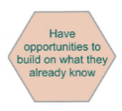  Starter/ beginning of the lesson | Low-stakes assessment:  Promoting recall (retrieval practice) from everyone. Could include material required for the lesson, recent and less recent material e.g. quizzes.
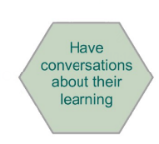  Learning intentions | Make clear what, specifically, students are learning about or to do:  Clearly communicated (verbally and/or visually) in student-friendly language. E.g.: ‘Know…’ ‘Understand…’ or ‘Be able to…’. Should be revisited during lesson and in plenary.
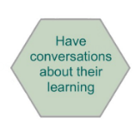  Success criteria | Clear communication of what success looks like:  • ‘I can…’ statements  • Key features  • Exemplars (‘good’ and ‘bad’)  • Used to support feedback, self-assessment and/or peer-assessment.
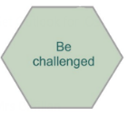  Delivery of new content | Linking prior learning, contextualising lesson (place it within its larger setting) and activating relevant schema (learners linking their existing knowledge):  • Explanations, demonstrations, modelling and/or visuals which stimulate interest.  • Checking what students know or can do already (encourage communication e.g. questioning).  • Interactive – includes frequent checks for understanding which influence progress of lesson.  • Repeating and summarising key points.
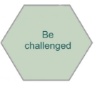  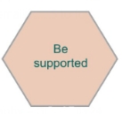  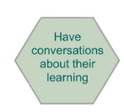  Practice | Applying knowledge and skills:  • Guided, supported, then independent.  • Co-operative learning opportunities.  • Over-learning – lots of opportunities to master content.  • Teacher circulating class.
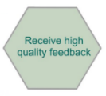  Plenary/ end of the lesson | Revisits the learning intention and success criteria:  • Reinforces the main learning points.  • Uses assessment to gather further evidence about what has been learned or not learned (e.g. via Exit Tickets).  • Summarises next steps
Pedagogy
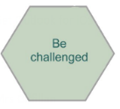  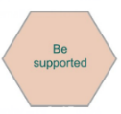  Differentiation | Adapted support via:  • Teacher/ANA/peer support  • Checklists and scaffolds  • Differentiated challenge, e.g. via choices within activities or outcomes.  • Balance of familiar and less familiar content.  • Digital accessibility tools used
Formative assessment  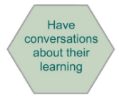  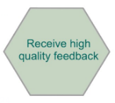 | Evaluation of the comprehension levels and learning needs of learners:  • Whole class participation (no opt out)  • Show-me boards  • Questioning: pose, pause,  pounce, bounce  • Discussion (‘chat to a partner’,  think-pair-share)  • Active assessment activities (such as true/false, multiple-choice, deliberate mistakes)  • Self and peer assessment, using  success criteria
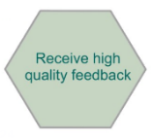  Feedback | A dialogue linked to LI/SC aiming to encourage students to reflect on their learning:  • Specific: clear and precise in accessible language for the learners.  • Supportive: what, how, and next steps.  • Focused on the learning and not the task  • Emphasis on how to move learning forward.  • Time available for students to act on feedback.
Learning Environment
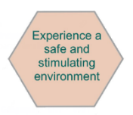  Relationships | Positive interactions promoting good choices:  • A culture of kindness and mutual respect.  • Knowing students well.  • A safe place for mistakes to be made.  • Sincere use of praise helping students be on task, engaged, interested, motivated.  • A restorative and nurturing approach is taken in all situations.
High Expectations  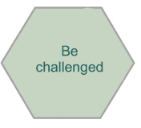 | Ensuring every child fulfils their potential:  • Learners are supported to try their best and produce high quality of work.  • Positive relationships with others (staff and peers).  • Encouraged to make good choices.  • Target/goal setting (e.g. personal bests).  • Effort not outcome.
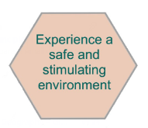  Management | An organised learning environment:  • Calm, ordered, safe, under control.  • Effective use of time, space and  resources.  • Appropriate pace.

Appendix 3 – Lesson Evaluation Toolkit (ELC – p2)
‘Typical’ elements of very good practice in JGC ELC – P2
The big 6! Elements we would expect to see on every visit.
Elements | Key Features – the ‘things’ I should be thinking about as I plan and evaluate a lesson or block of learning: | Notes:  In PLANNING ‘how can I make this as good as possible?’  In EVALUATION ‘How good was this?’
Role of the Adult  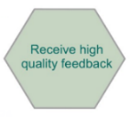  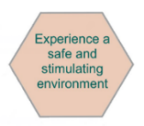 | - Builds positive, nurturing relationships  - Is responsive to children’s interests  - Uses sustained shared thinking:  Active Listening  Rich conversation  Open questions  Extend children’s thinking  - Skilfully uses resources to stimulate curiosity and thinking  - Recognises effort as well as achievement  - Is aware of and uses current policy and guidance to inform practice  - Has deep understanding of child development and early learning pedagogy  - Embraces partnership working with parents/carers and agencies for the benefit of the child  - Engages in high quality observations (during everyday activities and interactions) that inform planning
The Environment  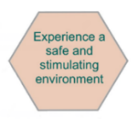 | - Adaptable to all children’s interests, progress (enhanced provision) and need  - Stimulates thinking and provokes curiosity  - Literacy and Numeracy ‘rich’  - Allows for free flow between indoors and outdoors to allow for choice  - Natural materials provide calming, nurturing atmosphere  - Promotes independence  - Promotes challenge and risk-taking, particularly outdoors but also indoors, eg. workbench and real tools  - Develops fine and gross motor skills and core strength  - Promotes physical development, movement and spatial awareness  - Promotes problem-solving and higher order thinking  - Promotes a range of opportunity for creative expression  - Uses digital technologies to support and enhance learning  - Is thoughtfully arranged and easily accessible  - Creates opportunities to forge new friendships
Learners’ Experiences | - Are informed by observations, children’s voice and intentional promotion  - Link to curriculum  - Provide opportunities for deepening learning  - Are responsive, personalised and child led  - Include them in decision making  - Provide challenge and choice  - Progress their learning  - Include a balance of different types of play, eg. imaginative, socio-dramatic, rough and tumble, role play, exploratory, mastery  - Develop creativity, resilience and independence  - Are not gender specific  - Provide opportunities to talk about learning with peers and adults  - Connect children with their community  - Are enabled by suitable clothing for all weather  - Allow children to talk about their learning with adults and peers  - Make use of real tools and real artefacts and include real life experiences when possible
Key references: Realising the Ambition (Education Scotland),

Appendix 4 – Walk through observations
Our Learning Principles:  All Learners in Jedburgh Grammar Campus will … | JGC Learning Walks
 | Class observed
 | Staff observing
 | Date
 | Observations and comments:
… have conversations about their learning

… enjoy a safe and stimulating environment

… receive high quality feedback

... be supported

… be challenged

… have opportunities to build on what they already know

Other observations/discussions
Feedback session (date)

Appendix 5 – Inspire feedback policy
The Inspire Learning Programme is the Council’s strategic education transformation programme which aims to deliver the very best technology to enhance the learning and teaching experience in the classroom. It is a sustainable commitment to technology at the heart of learning with a focus on improving outcomes for children and young people and our communities.
This policy will promote regular verbal and non-verbal communication with students about their individual progress in a form that students and teachers clearly understand. It will also help to ensure that all students have feedback on their work to encourage a higher standard of achievement, extend able learners, and provide meaningful feedback. All of our students require feedback that should encourage them to meet their potential. Therefore, our feedback must reflect our understanding of each child and their strengths and areas for development.
Teachers must ensure that students continue with pen/ paper writing as required by final exams. Students can upload handwritten work digitally through the ‘scan document’ feature for teachers to annotate using the ‘quality of feedback’ approach outlined above. As suggested by the ‘quality of feedback’ criteria, teachers will provide digested verbal feedback.
Feedback is most powerful when it is from the student to the teacher. Teachers should seek and be open to feedback from students about what they know, what they understand and when they have misconceptions. The process below is designed to encourage student feedback.
At Jedburgh Grammar Campus all parents/ carers should have the opportunity to access their child’s work, the mode of access for this will be primarily through the Showbie app.
At Jedburgh we have an Inspire Curriculum Support Team who support teaching and learning with iPads and help with technical difficulties, Karen Seaton (primary specialist) and Hamish Johnston (secondary specialist).
Every teacher at Jedburgh Grammar Campus has access to Inspire School House for CPD specific to iPads as well as Business World for professional learning opportunities. Staff are signposted to highlighted CPD via the monthly newsletter shared by email and twitter (@JGCampusPL).
Depending on the task pupils will be given opportunities to decide what app is most appropriate for their learning/ task.

Support for Learning:
To ensure we support every pupil at Jedburgh Grammar we use a variety of tools found on the iPad.
- Immersive reader and speak screen, speak selection will read text to pupils who struggle with literacy.
- Change the colour of background to support dyslexic learners.
- Using voice notes to provide feedback for pupils that have issues with literacy.
- Turning subtitles on for pupils that are hard of hearing.
ANA’s have been given iPads and training on how to best support pupils in classes. ANA’s should be added to all classes on Teams and Showbie of pupils that they are supporting in class.
Primary:
Teachers will effectively use ICT to:
- Support pupils with their learning
- Make teaching and learning motivating, stimulating and relevant for pupils
- Teach pupils ICT skills and use these skills to further develop previous learning across the curriculum.
Secondary:
There are a variety of apps used in the secondary to support teaching and learning. IPad's are the primary device for teaching and learning, teachers iPad’s screen mirror onto Apple TV’s to show presentations and all materials are available to pupils via the following apps.
- OneNote is used for pupils to access classwork, class notes and for teachers to access the work they complete in school.
- Teams is a used by teachers to communicate to the whole class and is required for OneNote.
- Kahoot, Blooket, Plickers and Socrative are used as quizzes for formative assessment.
- Sketch school is an effective app for Show me board activities
- Word and Pages are used for completing written work or when completing electronic booklets
Subject Specific apps include:
- Procreate and Sketches school in Art
- Mymaths, Desmos and Sumdog are used in Maths
- Bookzilla is used in English
- Digital Theatre plus website is used in Drama
- Ataea is used in music
- Phet is used in chemistry and physics
Feedback @JGC
This policy will promote regular verbal and non-verbal communication with students about their individual progress in a form that students and teachers clearly understand. It will also help to ensure that all students have feedback on their work to encourage a higher standard of achievement, extend able learners, and provide meaningful feedback. All of our students require feedback that should encourage them to meet their potential. Therefore, our feedback must reflect our understanding of each child and their strengths and areas for development
Showbie is the main app that is used from ELCC to S6 for teaching, learning, assessment and feedback.
ELCC staff will use Showbie to document pupil progress and development through learning journeys. They will also use Showbie as one of the primary ways to communicate with parents/carers through announcement groups.
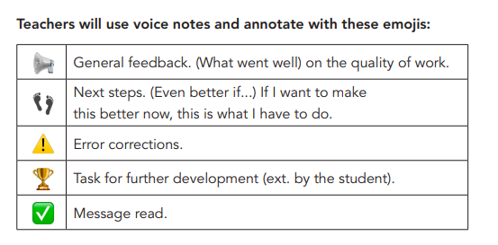
Primary:
Portfolios:
Primary 1-3 teachers will add a minimum of 3 pieces of work each term to every pupil's portfolio. Primary 4-7 pupils will add a minimum of 6 pieces of work to their portfolio per term and teachers will give feedback on each. Each term at least two pieces literacy and numeracy piece should be added to portfolios, along with two other piece of work from a different curricular area. Primary 4-7 pupils should add a voice note or comment on why they have selected each piece of work.
Feedback:
P4-7 teachers will give feedback via Showbie on a piece of work every 2 weeks. Ensure feedback includes aspects of the quality of feedback criteria. e.g. 👣 and/or 🏆.

Announcement Groups:
Each year group will have a Showbie Announcement Group set up which will be used as a means of communication to parents/carers. All teachers who teach the year groups must contribute to the Showbie Announcement Groups.
Information that is expected to be added to Showbie Announcement Groups:
- Curriculum Overviews pinned to the top each term.
- Reminders such as what days classes have PE, swimming, any extra activities such as bike ability etc
- Reminders about homework- what it is and when it is due.
- Reminders of letters or permission slips that are due in, for example trip letters, Christmas card designs etc
- Reminders about anything coming up in class and what pupils might need to bring into school, for example assembly date, costume for Christmas concert etc
- Minimum of 1 set of photos each week of something that has been happening in class or school. Try to vary these so it is not the same curriculum area that is being shown every week.
Secondary:
Feedback:
Detailed feedback is expected when using Showbie, there are several modes to deliver this such as; written feedback, automatic feedback, voice notes, individual video and class video feedback. Staff have opportunities to attend CPD to support high quality feedback being delivered using Showbie. Staff are encouraged to contact Inspire Leads for 1:1 coaching on using iPads/ Showbie.
Parents are encouraged to join Showbie and there will be increased messaging in the use of Showbie during reports and parents' evenings. Training sessions for parents of how to use Showbie to happen throughout the academic year.
Feedback will be given on a piece of work every 2 weeks for all senior phase certificated classes, maths and English S1-S3 classes. 2 pieces of feedback will be given to S1-S3 pupils per term. Type of feedback will be shown using feedback emoji key.
Homework:
In secondary, all homework will be set on Showbie but does not need to be completed there. A due date, clear instructions of what to do and a record of completion must be kept on Showbie using its in built functions.
Teachers and pupils have personalisation and choice of what apps are most appropriate to complete homework. This could include completing work on paper which can then be scanned into Showbie to allow for digital feedback such as video or voice notes.

Summative Assessments:
Assessment dates will also be shared on Showbie as a reminder for pupils and parents/carers. Feedback will be sent via Showbie which will at minimum include the result of the assessment. Pupils will also be encouraged to carry out self-evaluations after assessments to plan their next steps and close the feedback loop.
Quality Assurance:
A two-tier quality assurance structure will ensure the quality of feedback is outstanding.
Tier 1: Principal teachers / phase leaders will be involved in the quality assurance process and transparency over all students’ digital content. Random sampling should occur at an agreed time interval and frequency to ensure the quality of feedback is consistently good across all classes.
Tier 2: Senior leaders will also have transparency over work submitted by students. Random sampling should occur at an agreed time interval and frequency to ensure the quality of feedback is consistently good across all classes.

