

Campus Update
16th September 2022

Dear Parent/Carer,
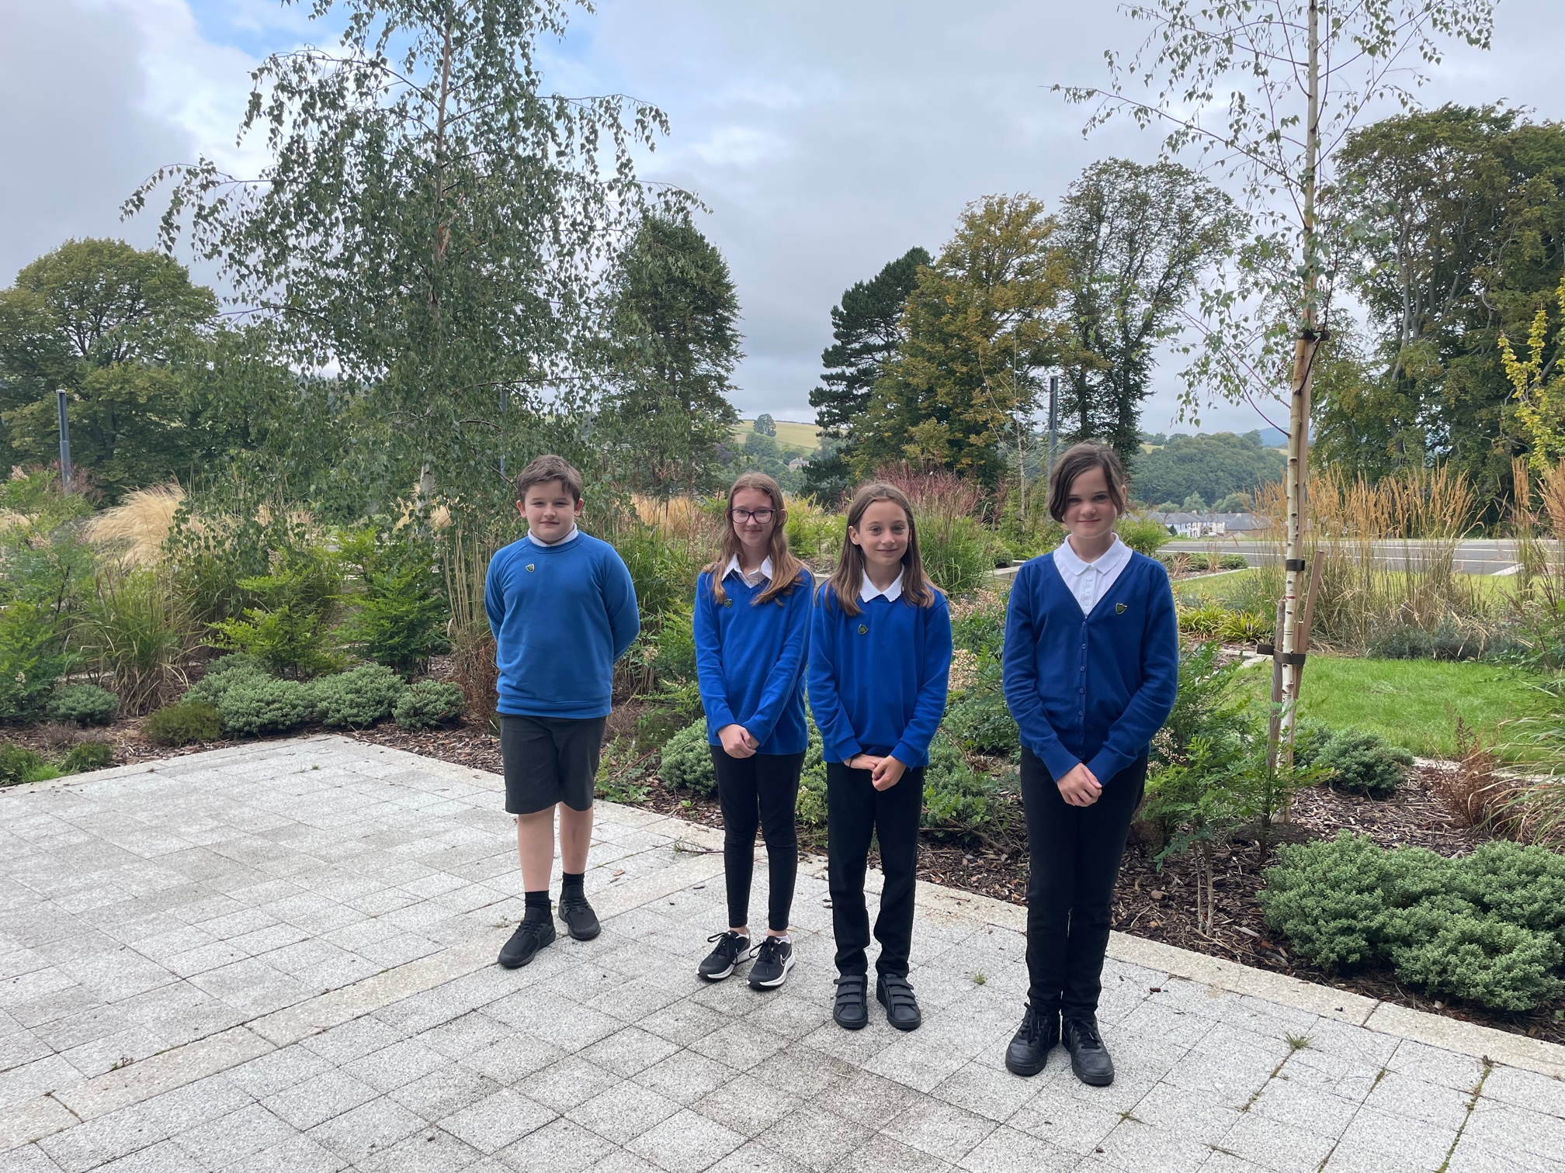
Many thanks to those of you who came along to our ‘Meet the Staff’ events this week. It is so nice to see children confidently showing parents round and for staff and parents to be able to meet face to face!

A great success last year was the introduction of our Junior Head Team and it gives me great pleasure to share with you our Junior School Captains for 2022-23.
Congratulations to Ellis Mackie, Kendra Cowan, Lily Henshaw and Kate McDonald (picture L to R), who will form our Junior Head Team.
We are really looking forward to working with them, alongside our S6 Head Team of Elle Cooper, Eleanor Lockey, Molly Noble and Kester Webster.

As highlighted last week, we received copies of “Queen Elizabeth – A Platinum Jubilee Celebration” for every primary pupil. Any child who would like a copy will have either have brought one home today or can collect one next week.

The campus (including nursery) will be closed on Monday 19th September, as a mark of respect to Her Majesty Queen Elizabeth, and we look forward to seeing everyone on Tuesday.



Susan Oliver
Headteacher

Parent Council
Our first Parent Council meeting of this session will take place on Wednesday 21st September at 6.30pm in the campus. We are keen to involve parents in shaping the school experience for our children and young people and would be delighted to welcome any parents who would like to come along and join us. Please just come along to the campus reception on the evening or email jgcparentcouncil@gmail.com for more information.

Wellbeing
Cyber First Aid Box
The Cyber First Aid Box is a new online resource for parents and carers to support their child’s recovery after a negative online experience. Designed in partnership with Decode Cyber Solutions and Education Scotland’s Digital Skills team, it is a free resource available to everyone.
The site will ask a series of questions to help families determine the best response to a harmful online incident, including how to approach the subject with children & young people, possible solutions, and the first steps to recovering from it.

Wellbeing Indicators
To ensure everyone has a common understanding of what wellbeing means, the Scottish Government describes wellbeing in terms of eight indicators.
This week P3 – S6 have been talking about the wellbeing indicators and we will continue to explore what the indicators mean for our children and young people and how they feel we can best support them in these areas.
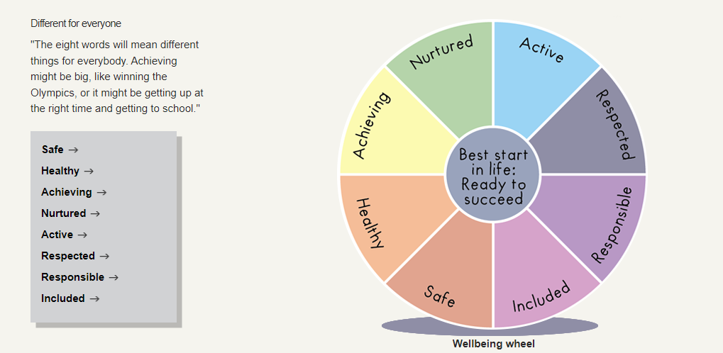

Learning without Limits

P7 Leaders
In addition to the announcement of our Junior Head Team last week, the following pupils have also been successful in their applications for leadership posts:

Lucy Gilfillan and Rory Henderson are our Junior Road Safety Officers for this session.

We will have a Sports Ambassador team for October to December and a new team for January – April. Before Christmas, our Sports Co-ordinators are Lili Hanlon, Katie Shaw and Kai Macsween and our Sports Leaders are Emma Cassils, Millie Kehoe, Erin Newing, Aaron Learmonth and Mason Thomson.

Millie Kehoe and Joseph Millar will continue the fantastic work they started last year in their role with the campus Eco Committee.

Congratulations to you all and thank you for putting yourselves forward for these important roles!

Senior Phase Information Evening
This event will take place in the campus on Wednesday 5th October at 6.30pm and is designed to help you better support your child in S4, S5 or S6.

There will be short presentations on:
Qualifications and SQA Exams in 2022/23 (P Fagan)
Choosing the right course and university or college (Edinburgh University)
Financial Support for students studying at college/university (Student Awards Agency Scotland)
Widening participation to further/higher education (Lothians Equal Access Programme for Schools)
Careers Guidance (K Ferguson)

Developing the Young Workforce
S2 pupils have been learning about Careers Education with Nicola Shaw (Developing the Young Workforce Co-ordinator) and Kim Ferguson (Skills Development Scotland Careers Adviser). They have been identifying their strengths and ideas for the future, whilst recognising their current hobbies and interests.

It is fantastic to see senior school volunteers spending time in our nursery and primary. They are a huge hit with the children and staff and gaining valuable skills for life as well as work.
Here’s India supporting in P2. She’s keen to become a primary teacher . . . we think she’s a natural!
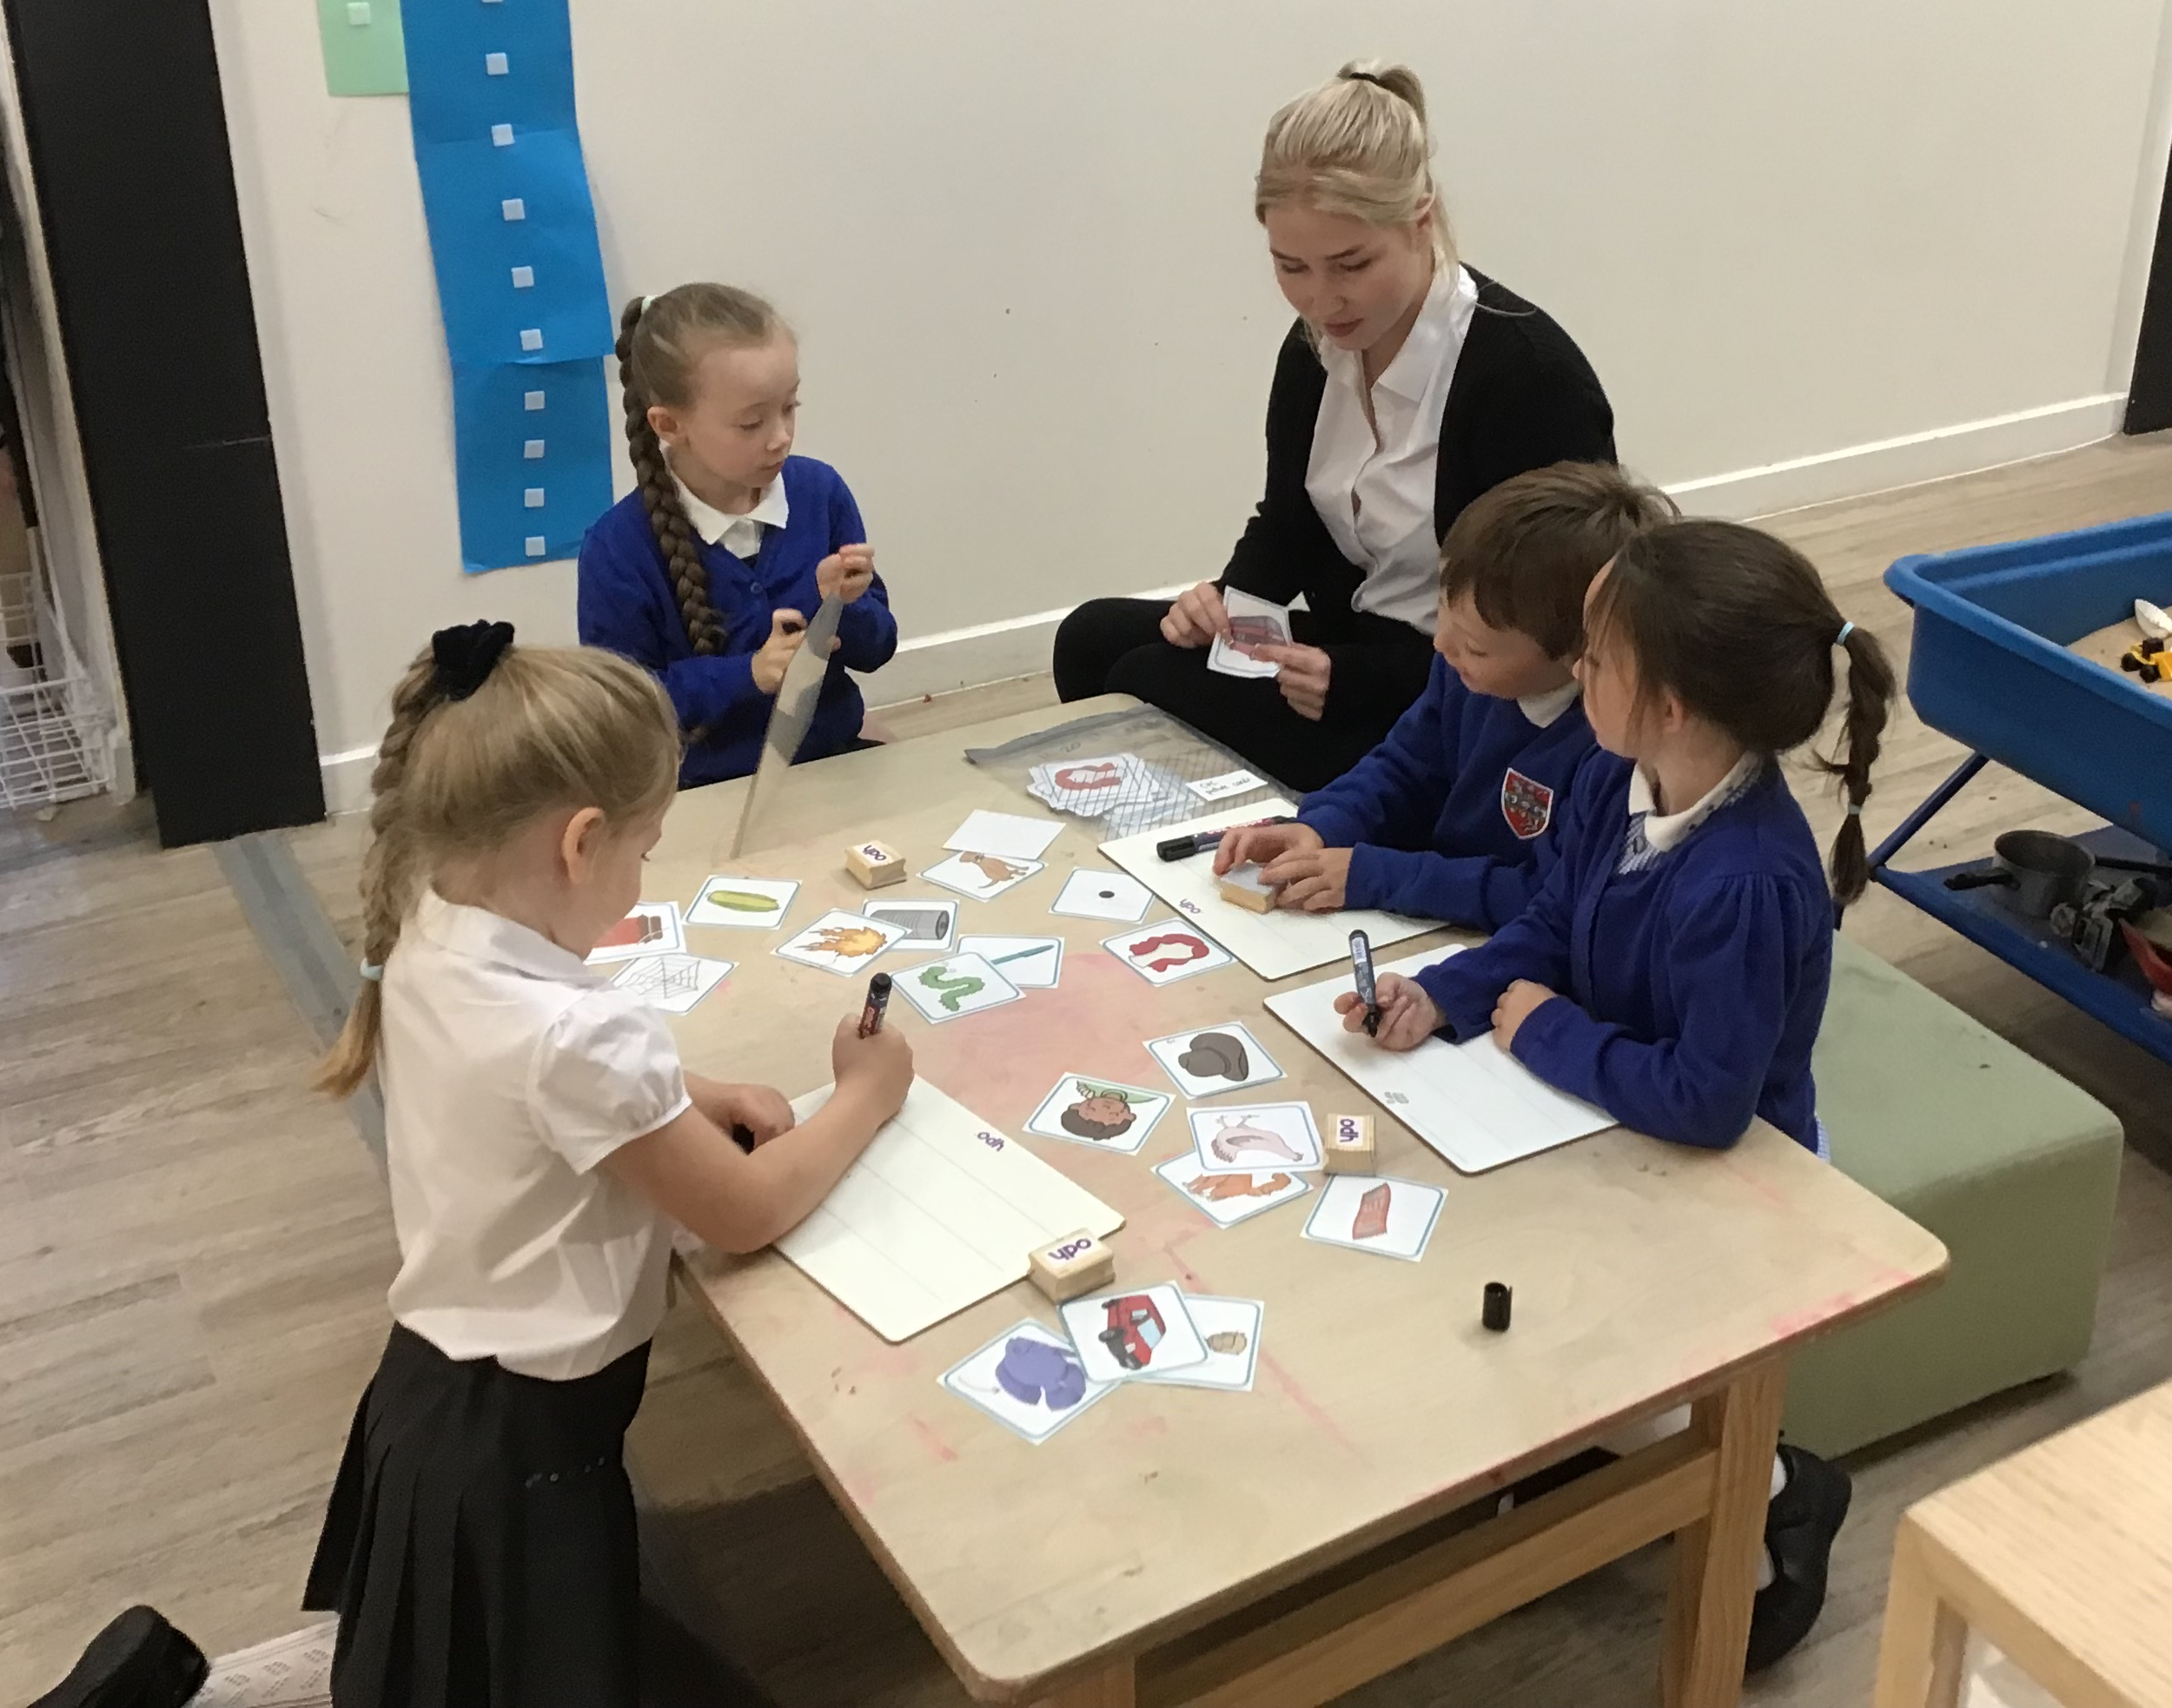

Skills Development Scotland are offering an introductory session for parents and carers of S1 pupils on Tuesday 4th October 6.30pm. Their careers advisers will support your young person throughout their time at school to make choices and plan for their future career. Sign up for this webinar to hear from them about the service on offer and the support available for you as a parent or carer to assist with career planning and discussions.
Parents and carers can register for the session here: https://fal.cn/parents_carers_webinar_s1

Kindness Achievement Learning Respect Wellbeing

Keep up to date with what’s going on in the campus by following our dedicated Facebook pages for Jedburgh Grammar Campus Primary & Secondary and our Jedburgh ELC closed Facebook group.

