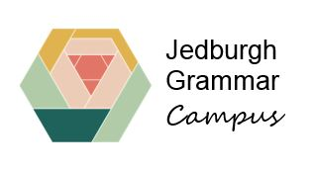

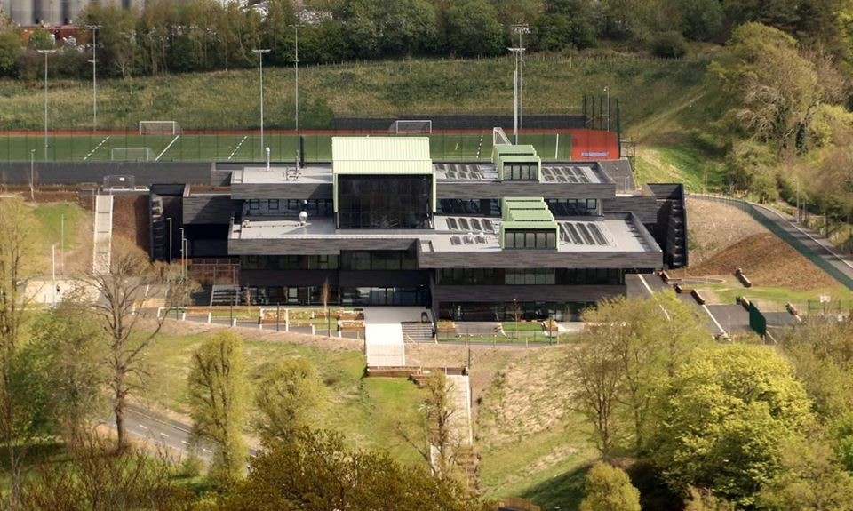

School Improvement Report
2022-2023
Review of Progress 2022-23

Context of the setting
Jedburgh Grammar Campus was established in April 2020, the product of an entire community coming together to support the transformation of education provision in the town. The vision, created with our community, was to establish an intergenerational campus, which would deliver health, wellbeing and learning opportunities for people of all ages from Jedburgh and the surrounding rural areas. This is summed-up in our vision statement:

Learning without limits

Our campus values of kindness, respect, achievement, wellbeing and learning were agreed through consultation with learners, parents, staff and community members and organisations.

We are proud of the fact that we successfully brought together four learning establishments during a pandemic, creating a 2-18 setting with a new secondary enhanced provision.
Our current roll is 863, comprising the largest primary provision in the Scottish Borders and the smallest secondary cohort.

Jedburgh Grammar Campus and Ancrum Primary School (roll: 27) work closely together, with learners from Ancrum attending the campus for pre-school education and from P6 onwards. P7 learners from Denholm Primary School may choose to attend the campus or Hawick High School. Currently the headteacher is supported in the leadership of JGC and Ancrum Primary School by five depute headteachers and nine principal teachers.

Jedburgh is a town of just under 4000, but around 20% of our learners come from outlying farms and villages, and we have seen an increase in school enrolments since the pandemic, through a combination of placing requests and families moving into the area due to the flexibilities offered by movement to home-working.

Jedburgh has been identified as an area “at risk” in terms of recovery from the pandemic, with the town’s two main manufacturing employers announcing between them around 200 redundancies in June 2020. Free school meal entitlement has increased from pre-pandemic and we are aware that many families are experiencing “in-work poverty”. However, the school benefits from being at the heart of a highly supportive community and from effective partnerships with a range of people and agencies who help us overcome potential barriers to learning and better meet the needs of our learners and their families.

A team of inspectors from Education Scotland and the Care Inspectorate visited the campus in April 2023 and reported that we had “established a new purposeful learning community, in which children and young people thrive and achieve successful outcomes”.
SBC priority 1: Develop high quality learning, teaching and assessment that leads to improved levels of attainment and achievement for all in our schools and settings.

What we have done this year and what has improved for learners as a result?

- Embedding our campus values has created an aspirational ethos and shared sense of purpose. The values underpin positive relationships, school improvement and purposeful partnerships across the school community.
- Embedding our learning and teaching framework has helped us to improve the quality of learning, teaching and assessment across the campus. Dedicated time during inset days and staff meetings ensured that progress was shared and consultation/discussion took place. We have introduced PT/DHT led QA observations based on our toolkit along with ‘walk through’ observations led by primary and secondary PTs. Our learning principles were created with input from all staff as essential elements of best practice, and are clearly displayed in all learning spaces.
There is now greater consistency in approaches to lesson planning with learning intentions and success criteria being shared and discussed with learners. Effective use of plenary sessions are made to support learners to reflect on their learning and plan next steps.
- Our cluster professional learning focus this session was on using digital technology to enhance teaching and learning. We identified the need to improve feedback to learners, so they were clearer about next steps, and have focused on this area for improvement across the campus. Our main vehicle for providing high quality feedback is now Showbie and as result of our professional learning focus this session, the number of parents/carers recently reporting they receive helpful feedback has increased from 53% to 81%. On-going evaluation has ensured practice has improved in order to meet learner’s needs and support increased challenge.
- We have developed our own BGE and Senior Phase tracking systems that are used by teachers and SLT to track learner progress and identify interventions. Within the BGE Literacy, Numeracy, HWB and attendance are tracked and each subject is tracked in the Senior Phase.
- We supported equity of learners through targeted use of digital technology. An iPad skills group was created that delivered interventions for young people in P6, S1 and S2. Focussed on pupils who have literacy difficulties and training them how to use technology to help them access the curriculum e.g. showing them how to use the iPad to read text to them, how to dictate into the iPad, accessibility features such as screen colour filter and increasing text size.
- The digital literacy of children and young people was enhanced through the continuous professional development of their teachers in session 2022-23. With the support of the Inspire Community Link Team (ICST) staff developed skills and knowledge on how to better incorporate ICT into their classroom learning how to make use of different tools such as Microsoft Lens and Speak Selection, Socrative, Keynote and Pages. Children in Primary 2-P7 worked with ICST on digital projects involving, iMovie and coding. Young people in S1 developed their ICT skills and confidence by incorporating Showbie into their IDL “Storyline” event. The experience of the event was the foundation of pupils gaining the John Muir Award. Following the successful pilot of Digital Skills Award this will now be incorporated into the S2 core curriculum.
- Ambitious stretch aims were set for 2022-23, in order to raise attainment and ensure positive destinations for all our young people. All teachers engaged in analysis of data and identification of next steps. Throughout the year staff targeted supports at key individuals identified through robust tracking and monitoring process. Progress was monitored throughout the year. Predictions for stretch aims are very positive, with improving attainment across the BGE and young people in the Senior Phase expected to equal or exceed targets for N5, Higher and positive destinations.
- Primary cluster staff participation in moderation of writing across Cheviot learning community, increased consistency and understanding of standards, leading to improved feedback for learners.
- Use of the Agile Leadership approach has improved identification and delivery of strategic priorities, ensuring manageable changes which have impacted directly on learners’ experiences.

The recent inspection confirmed that our teachers are highly skilled in using digital platforms to create stimulating activities. Inspectors saw this as a strength across the school, resulting in children and young people who are proficient in using digital approaches to support their learning.

Next Steps

We will continue to
- improve learning, teaching and assessment across the campus to ensure consistently high quality learning experiences. Our focus for 2023-24 will be pace and challenge.
- improve attainment across the curriculum, including a focus on literacy and numeracy across the BGE and the delivery of new opportunities across S3-S6. This will include engagement with the #SBCWay to improve consistency and effectiveness of teaching and learning of literacy and numeracy across the cluster.
- develop clear, effective systems for monitoring young people’s progress in learning at each stage of the school
- develop the digital literacy of whole community to enhance quality, frequency and engagement with feedback on learning

SBC priority 2: Develop inclusive practice with a focus on universal and targeted provision in all schools and settings.

What we have done this year and what has improved for learners as a result?

- We have worked on increasing understanding of the wellbeing indicators. This has included pupil voice evaluation of what the wellbeing indicators mean for learners at JGC, which has been shared with all learners and staff. This focus has led to children and young people having a strong understanding of wellbeing and regular opportunities to explore the indicators and evaluate their own wellbeing in relation to them.
- JGC inclusion improvement team led a review of our Positive Relationships framework, involving staff, learners and parents. The updated framework and procedures were launched in January, reflecting our values and new house recognition system. This has supported our work with learners and staff to embed our campus values, which HMI reported have been embedded and are supporting positive relationships where children and young people feel valued.
- We introduced the Glasgow Motivation and Wellbeing Profile (GMWP) to track the wellbeing of learners from P3-S6. This has helped us identify areas of improvement for the whole school, class level and individual learners requiring targeted intervention or even an immediate welfare check-in.
- A new format has been introduced for Health & Wellbeing partnership meetings and the BGE Tracker has been extended to include Attendance, Risk Matrix, Pupil Equity Funding and Additional Support Needs information. This has resulted in a more strategic approach to the deployment of Pupil Support staff, as well as ensuring that we are tracking and monitoring specific pupils and measuring the impact of interventions. Pupil Equity Funding has been used to support delivery of targeted interventions.
- Learner feedback linked to values has led to the development of our achievement recognition programme whereby learners are recognised for exemplifying JGC values in and out of school, through certificates and house points.
- Evaluation of what wellbeing indicators mean for learners at JGC has being shared with staff and wider community.
- Introduction of Positive Futures Careers Fair with young people from P6 upwards, parents/carers and community invited to attend. This encouraged all to think about learning pathways beyond school and raise awareness of current local employment and training opportunities.
- Extension of curricular offer in response to pupil feedback and need, with new opportunities for personalisation and choice in S3 and certificated courses in the Senior Phase.

During the recent inspection, the learning community’s shared understanding of wellbeing was highlighted as a strength. Inspectors noted that this contributes to children and young people feeling safe, supported and valued and that learners’ wellbeing is strengthened through the effective work of staff and partners.
Next Steps?
We will
- develop our cluster targeted families approach, to help us support children, young people and families to overcome barriers to learning.
- address areas for improvement identified through GMWP feedback by continuing to develop the newly established house system and inter-house competitions, which are beginning to give pupils a stronger sense of identity and belonging. We will increase opportunities for children and young people to share their views and inform improvements across the school. This will include further opportunities for them to be involved in decision-making about their learning.
- continue to use the GMWP to inform our short/medium/long term improvement priorities and support to individuals and groups. This will include establishing pupil Wellbeing Ambassadors to support this work.
- formalise the process for gathering information about achievements and engagement in activities in and out of school, and use this to identify next steps for individuals/groups.
- review our Relationships framework in line with the new SBC framework and will use the campus values as the basis for beginning work towards achieving Bronze level Rights Respecting Schools.
- continue to work on developing a 2-18 Health & Wellbeing progression pathway, in line with the #SBCWay – 2024-25? Focus will be on RSHP during 2023-24.

Early Learning & Childcare provision
Jedburgh ELC is a hub and children can attend for term time or 50 week places or a combination of both. The nursery is open from 8.00am-6.00pm, 50 weeks of the year.
Our current role is 105, which is made up of 2, 3 and 4 year olds.
Staffing consists of one SEYO (Senior Early Years Officer) and 3 EYOs (Early Years Officers) and 19 EYPs (Early Years Practitioners, which consists of both full and part time staff.

What we have done this year and what has improved for learners as a result?

- Thorough self-evaluation has been used to identify next steps, leading to improvements to the quality of provision for all of our learners.
- The Equity and Excellence Lead has worked with practitioners to ensure up to date assessment information from the Developmental Overviews and the curricular trackers is being used when planning to inform next steps in learning.
- SBC’s Early Years teacher has worked with staff to improve the snack and lunchtime experiences for all. Staff use this time to discuss healthy eating and to develop children’s literacy and language skills.
- Developed family learning opportunities (Stay and Play, PEEP, PoPPs)
Parents have benefited from a better understanding of the learning taking place in our ELC and the impact they can have at home by supporting their children.
- Environmental and planning changes/Planning Cycle/Experiences and spaces have focused on the development of Literacy skills
Staff use the Planning Cycle to ensure coverage of the curriculum (depth). The improved environment means that children are experiencing relevant and motivating learning opportunities.
- Improved staff team capacity to drive improvement due to work on roles and responsibilities work. Clarity around staff awareness of their roles and responsibilities means that children experience improved opportunities for learning.
- The creation of a supported learning space has supported our youngest learners and also any learners experiencing barriers to their learning.
- Wellbeing of children and staff has been our priority. Staff have created Care Plan + documents to support those experiencing barriers to learning/difficulties in emotional regulation.
- Strong relationships established between adults and children and children and children have resulted in children feeling happy, settled and safe in our ELC, which leads to improved learning experiences.
- Medication storage and record keeping has been improved.

Inspectors from Education Scotland and the Care Inspectorate recently reported that the setting provides a calm, supportive ethos and a nurturing environment where wellbeing is paramount.

Next Steps?
We will
- deliver professional learning opportunities to support restorative approaches
- continue to embed the Wellbeing Indicators
- ensure pace and challenge for all
- engage with the #SBCWay to improve consistency and effectiveness of teaching and learning of literacy and numeracy
- continue self-evaluation using HGIOELC and Care Inspectorate Quality Framework to ensure improvements are continued
- develop ELC version of JGC Curriculum Rationale
- establish year-long transition programme to support move from ELC4 to P1
- continued to develop aspects of planning including schema and levelling
- consider the deployment of staff to ensure those most in need get the support they require
- continue to review learning experiences and spaces to ensure needs are met.

