
Campus Update
21st October 2022

Dear Parent/Carer,

I hope you all enjoyed the October holiday.

It’s been a shorter week but a busy one, with flu vaccinations and photographs. It was our first experience of organising photos for nursery to S6 and all went smoothly with both vaccinations and photos, thanks to the military precision planning by our Business Support team.

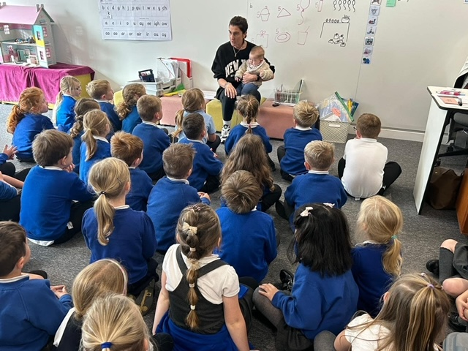
P1 welcomed two very special visitors – Mrs Spiteri and her beautiful daughter, Renzo. The children loved meeting Renzo and learning about what babies need to eat and how grown-ups look after them. It was lovely to see Mrs Spiteri and we look forward to her returning to JGC in 2023.

Wishing you a lovely weekend.


Susan Oliver
Headteacher

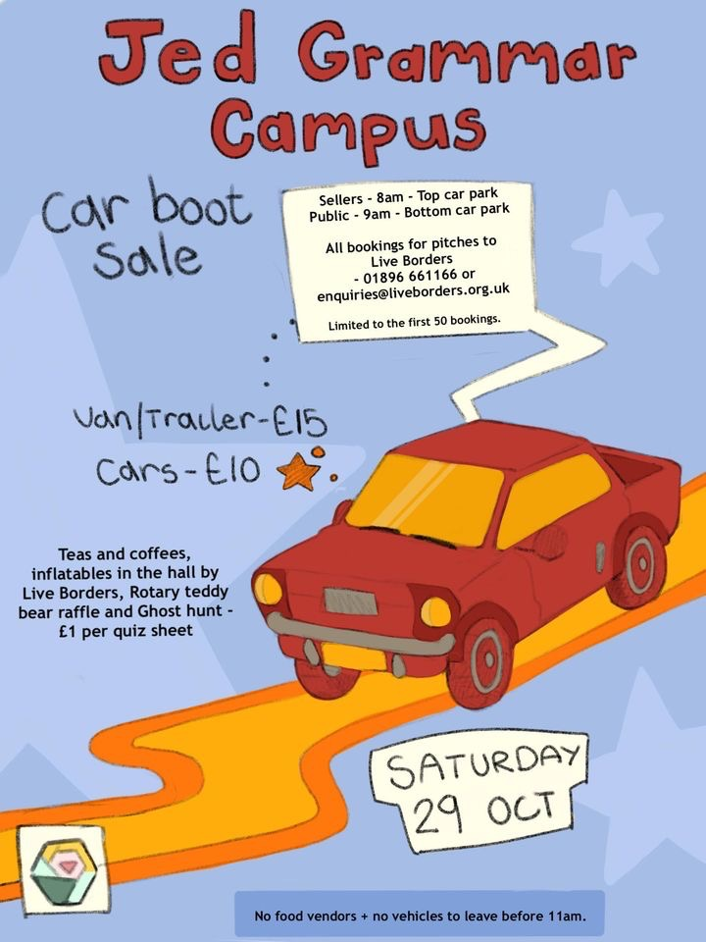
Halloween 2022
​
We have decided to make Friday 28th October a Halloween themed day for our nursery and primary classes. If children have costumes they would like to wear they can do so, but please do not buy anything especially for the day. We have lots of dress-up items in school, for any child who wishes to borrow something!

Saturday 29th October is the Parent Council Car Boot Sale in the car park outside the Campus, including a spooktacular Ghost Hunt competition. Our P7 pupils will be serving refreshments, the Rotary Club of Jedburgh will be running a competition to win a giant teddy and Live Borders are setting up inflatables in the Games Hall. Book a pitch by emailing enquiries@liveborders.org.uk or phoning 01896 661166.
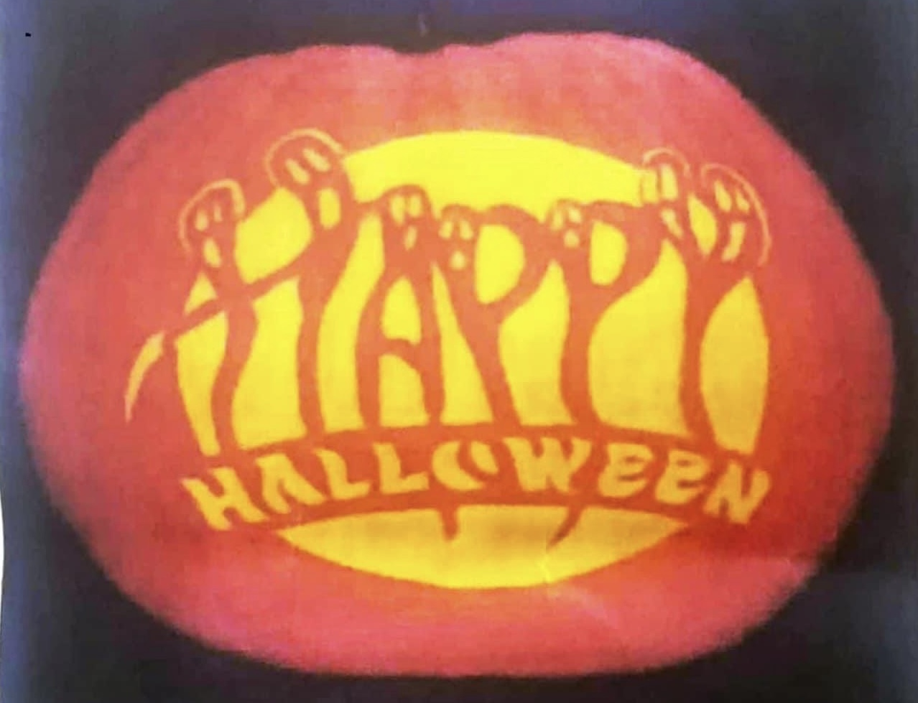
​

There will be a Halloween themed lunch on Monday 31st October and the Jedburgh Traders are once again organising a Halloween event in the town. For those of you who are new to the area, we can highly recommend this community event. It will take place 6pm – 7.30pm so look out for businesses displaying this sign.
Staff Update
We are very sad that next week we will be saying goodbye to our Youth Worker, Matt Brown. Matt has had a hugely positive impact on the children and families he has worked with in our community and we will miss him lots. We wish him well in his new job.

Learning without Limits

P3 Project
Primary 3 recently displayed their 20-minute communities in the atrium, alongside a survey to find out what people think they need and/or want in Jedburgh e.g. supermarket. The aim of this survey was for the class to find out if different people have different needs and wants.
The projects were admired by everyone who saw them and photographs of the work were shared by SBC’s Community Learning & Development team with groups who are considering how to engage communities in planning for the future, as a great example of how to involved children and young people!
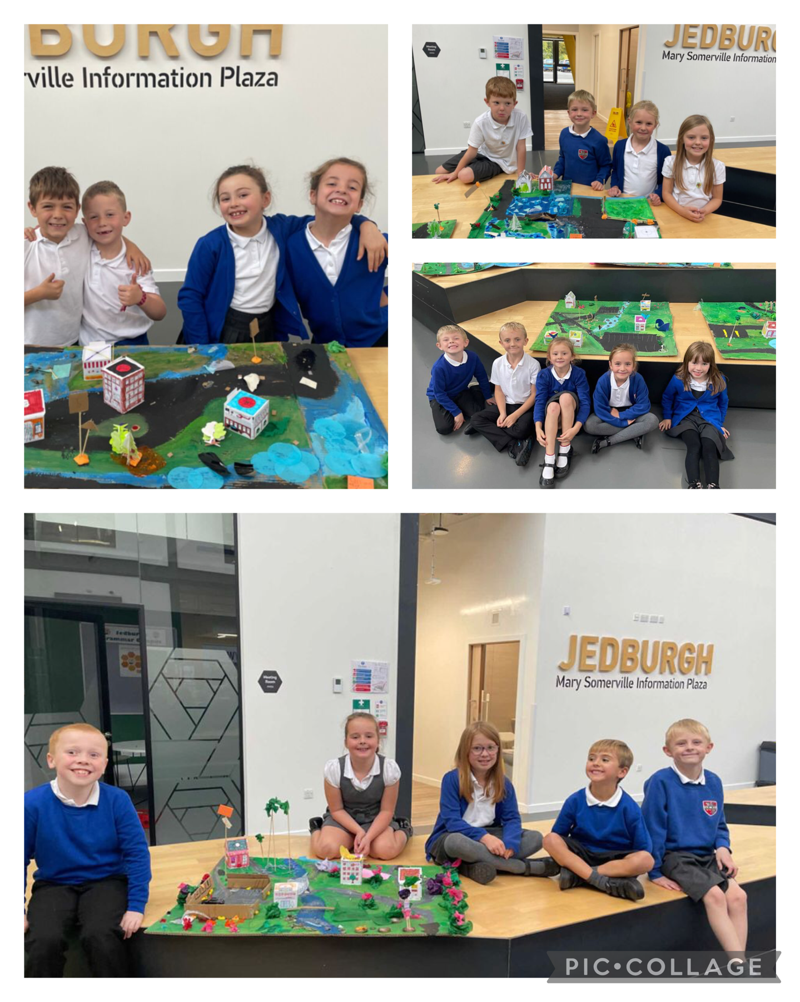

S1 STEM (Science/Technology/Engineering/Mathematics Club

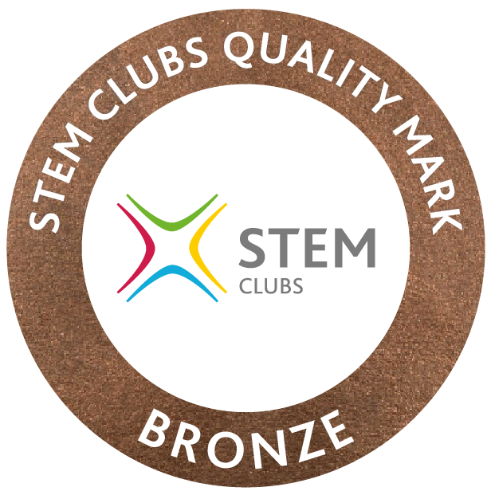
We can now proudly display the Bronze STEM Clubs Chartermark, which we were awarded earlier this session.
STEM Clubs create a solid foundation for the enhancement of STEM subject knowledge and practical application in a relaxed and engaging setting. The STEM Clubs Quality Mark (SCQM) validates the success and high standards of a STEM Club and showcases their commitment to young people’s education, equipping them with the skills and knowledge to fulfil their potential.
Well done to all pupils and staff who have been involved in the club since it was established in 2021.

Modern Studies Field Trip
Advanced Higher Modern Studies pupils from JGC visited HMP Saughton this week, along with pupils from Kelso and Earlston high schools. The aims of the visit were to gain primary research evidence on prison life for the AH Modern Studies course/dissertation and to gain a deeper knowledge and understanding of the different elements of custodial sentences. All reported a very interesting and worthwhile visit.

Developing the Young Workforce
S4 and S5 Business Management pupils thoroughly enjoyed a visit to Starrett yesterday. It was a great opportunity for them to deepen their understanding of the role various departments play in the success of a business and to be able to see the operational elements of a successful local business.


