
Campus Update

8th March 2024

Dear Parent/Carer,

Following two rounds of interviews, with an incredibly high calibre of candidates, I am delighted to be able to share with you that Mrs Ali Wilcock has been appointed as Depute Headteacher of Pupil and Family Support across JGC and Ancrum Primary.
Ali has been supporting our Senior Leadership Team in the role of PT Pastoral since 2022. In addition to this role working with secondary pupils and families, she has been working with a number of our primary children and families and will be a familiar face to parents who drop off at the primary gate in the mornings.
Ali brings a wealth of skills and experience from her time as a senior leader in England, along with a passion for working with all members of our community to developing all-through support across our cluster.


It was great to see the children having so much fun celebrating World Book Day and sharing their favourite books with their classmates (pictures below). Hopefully “Pyjama Day,” as many of the children referred to it, made it a little bit easier getting out the house yesterday morning!

Secondary pupils and staff also enjoyed celebrating the joy of reading in a range of ways, including a ‘Guess the reader’ competition.

This picture from the Scottish Book Trust, highlights some of the benefits reading can have for all of us.

Wishing you a lovely weekend . . . maybe including some time with your feet up and a good book!



Susan Oliver
Headteacher

Learning Without Limits

Duke of Edinburgh
Our thanks go to Borders paramedic and Mountain Rescue volunteer Jamie Lawson who very kindly came in to JGC today to meet with our Bronze D of E cohort. Jamie talked through some expedition specific first aid scenarios and also shared his route into becoming a paramedic and member of the local Mountain Rescue team.

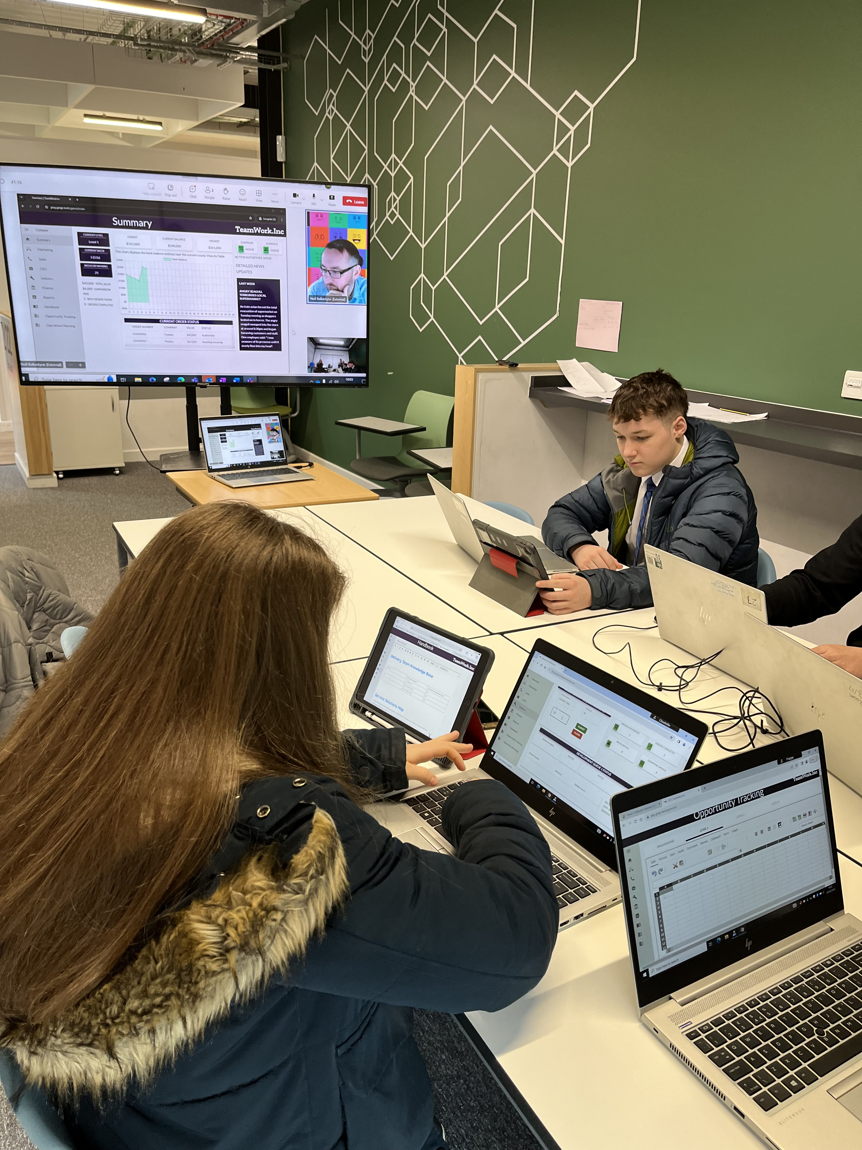
Developing the Young Workforce
Well done to our senior Business students who took part in Gingrtech Business Simulation competition last week. They competed against two other secondary schools in Borders region to run a business with 26 weeks of trading in 26 minutes. JGC won overall with a fantastic £600,000 profit!
Our business team comprised:
CEO – Jan, Sales – Josh, Finance – Finlay, Marketing – Poppy and Delivery – Charlotte.
The group showed incredible teamwork, problem solving and communication skills and had a fantastic opportunity to gain an insight into running a business.
Best of luck to the group who will now compete in the South of Scotland trials against the winners from Dumfries & Galloway.


Family Theatre
Reminder that this play is being performed in JGC on Sunday 17th March.
Vickie wants to compete at the Olympics. There is only one obstacle; she isn’t very good at sport. Yet, despite the odds, her love for athletics takes her all the way to London 2012. Inspired by Victoria’s own childhood obsession with athletics, this is a story about loving failure and dreaming big – even if there’s no chance you’ll make that dream come true. Read more and book your tickets here: Going for Gold: Me and Linford Christie @ Live Family Theatre @ Jedburgh Grammar Campus - Events - Live Borders





