
Campus Update

26th January 2024

Dear Parent/Carer,

It was an absolutely pleasure to join our P6 and P7 pupils yesterday, as they celebrated our national bard, Robert Burns.
Our Junior Head Team did a fantastic job of running the celebration, where they recited the Selkirk Grace & presented interesting facts about Robert Burns in a well thought out and well delivered Immortal Memory tribute. S2 pupil, Callum Yourston joined us and impressed everyone with his rendition of Address to a Haggis.
P7s then gave an entertaining toast to the P6s which was followed by an equally funny response by pupils from P6. P7 had the opportunity to taste the cooked haggis after break, with a few mixed reviews but many went back for a second helping!

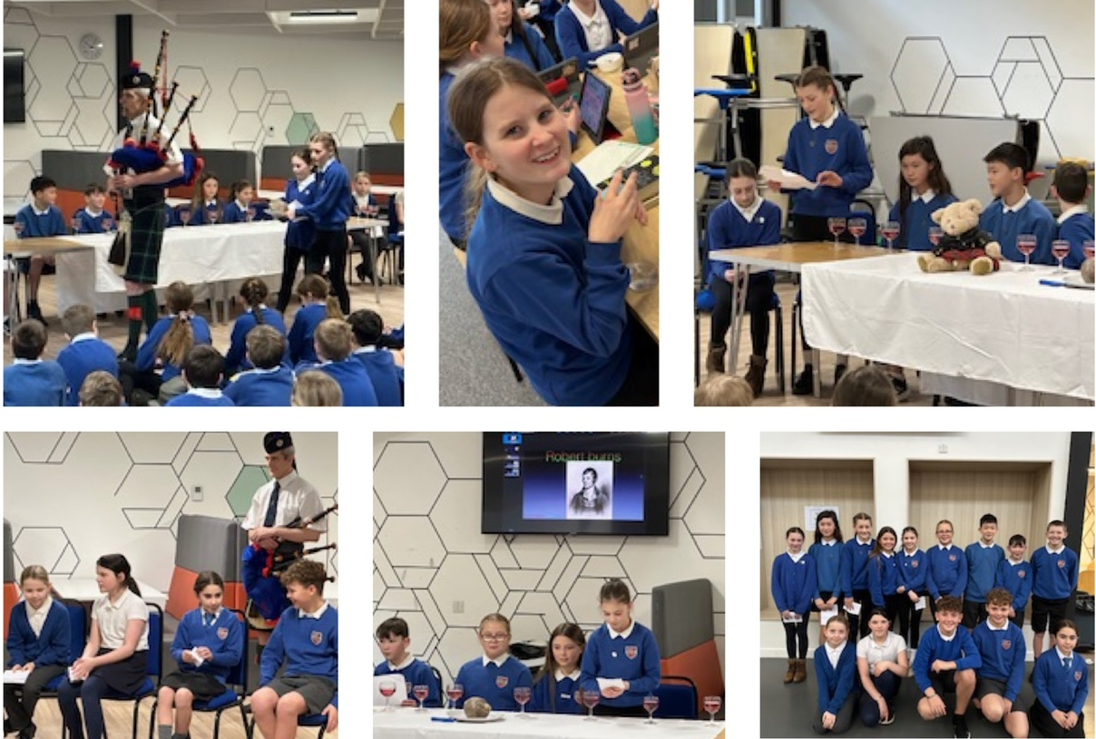

Once again we are grateful to members of our wider community for their support, with Darren Scurfield joining us from the Jedburgh Pipe Band and local Rotarians, Roger Bamkin and Bob Dawson, judging our poetry competition.
Congratulations to our Scottish poetry recital winners P3: Ruari Heard P4: Beth Hardie P5: Neve Hyland P6: Scott Turnbull P7: Chené Morrison & Munro Currie
We look forward to hearing them perform and finding out who our overall champion will be at our P1-7 Scottish Culture Assembly next Friday.

Wishing a lovely weekend to all, in particular our senior pupils who have now finished their prelims and can hopefully relax . . . for a couple of days at least 😊



Susan Oliver
Headteacher

Learning Without Limits

PENGUIN PARADE
P1 have been learning all about penguins this week.
They learned lots of facts about them and created their own too!

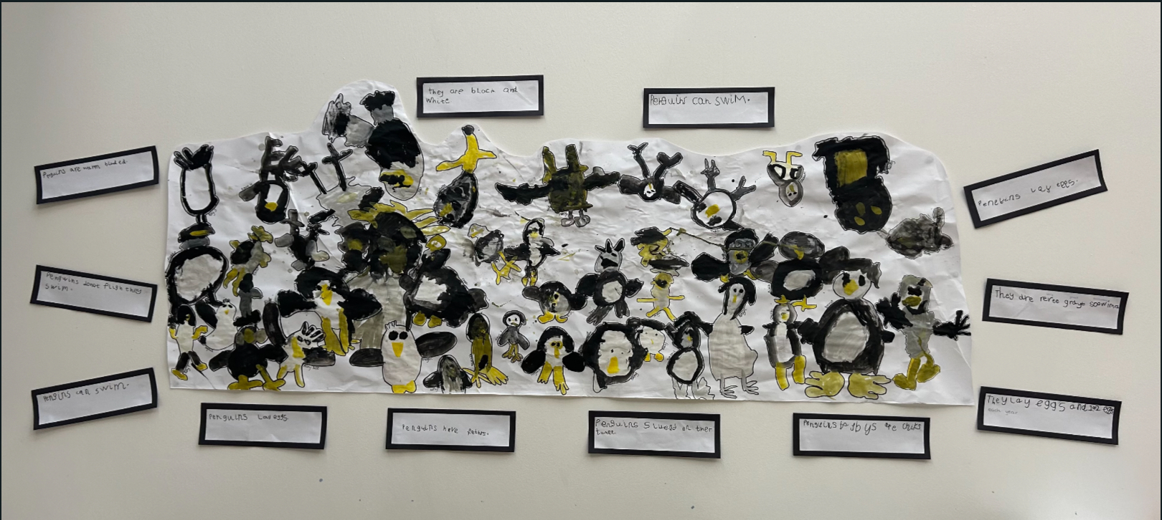

PARENTS OF NURSERY & P1 CHILDREN


Reminder that this survey is now open.

Local Authorities in Scotland are required to consult with parents every 2 years, to support their planning for the delivery of Early Learning and Childcare (ELC).

This questionnaire is designed to help Scottish Borders Council identify what the needs of families are, to support their planning of ELC services. Whilst the Council is not able to meet the individual needs of every family, your response is important to help us asses need, identify gaps and plan future provision. The survey is anonymous and your answers will remain confidential. Information in this survey will be dealt with in accordance with Scottish Borders Council’s Data protection policies: SBC Privacy Statement

The can be accessed via the QR code or this link:
https://scotborders.citizenspace.com/children-and-young-people/provision-of-elc-2024

SENIOR PHASE UPDATE
We are delighted to report that all UCAS applicants for 2023-24 have now completed the application process. We have 20 young people leaving us this year who are hoping to take up a variety of degree courses in universities across the land.
Borders College applications for School Academy and full time courses starting in August are now open. We advise that applications are summitted as soon as possible to increase chances of getting into the desired course.

School Academy Courses for senior pupils moving into S4, S5 and S6 in June 2024 offer a wide range of vocational courses to study alongside school based National and Higher qualifications. See here for the extensive list of course available in a range of levels of study. For session 2024-25 most courses will take place at the Galashiels Campus on a Friday from 10am-14:30. SBC will provide Transport and we anticipate that buses will leave from Jedburgh Grammar Campus at 9am and return before 3.30pm. By moving college courses to a Friday, we significantly reduce the weekly travel time for young people while also ensuring that they will not miss any other certificated classes.

DEVELOPING THE YOUNG (& OLDER!) WORKFORCE
Reminder that Scottish Borders Council and CGI are holding a Recruitment Event and Open Day on Wednesday 7th February. This event may provide inspiration for parents and carers as well as potential school leavers. Drop in to Inspire Learning: Tweedbank (just opposite Tweedbank Train Station) between 12 noon and 8pm and explore vacancies in a range of great sectors.

Opportunities available:

Scottish Borders Council
- Adult social care
- Catering
- Education
- HGV Drivers
- Occupational Therapy
- Social work
- Teaching

You can find out more about the roles available with Scottish Borders Council here

CGI
- Architects (Technical and Solution)
- Business Analysts
- Application Support Analysts
- Software Developers
- Project Managers
- Testers
- Technical IT Analysts

Book a recruitment chat with CGI here





