Jedburgh Grammar Campus Parent Council Meeting and AGM
Tuesday 22nd November 2022 6.30pm
P7 Classroom Jedburgh Grammar Campus

Present: Fiona Ralston, Katrina Barbour, Lynsey Graham, Diane Palmer, Davina Hyland, Joanna Pringle, Paul Fagan, Julie Forsythe, Ellen Palmer, Rodney Newing, Grant Kearney, Susan Oliver, Alison Monteith, Lynne Mackay, Tara Bolland, Jodie Sandilands, Diana Hickson
Apologies: Heather Cassils, Shirley McGlasson, Alasdair Edwards, Joanne Stenhouse, Lynsey Laing, Debs Marshall, Gemma Keddie, Katie Warnock, Leanne Stevenson.

AGM 2022,
Diana Hickson proposed Lynsey Graham as Chairperson, seconded by Grant Kearney and agreed by all.
Julie Forsythe proposed Ellen Palmer as Treasurer, seconded by Joanna Pringle and agreed by all.
Lynsey Graham proposed Jodie Sandilands and Debs Marshall as joint secretaries, seconded by Fiona Ralston and agreed by all.
Office bearers are now
Chair – Lynsey Graham
Treasurer – Ellen Palmer
Secretary – Jodie Sandilands and Debs Marshall.
Headteacher’s Report
Staffing Update
- Mrs Wilcock (Principal Teacher Pastoral) completed a handover with Mrs Walker and will be covering her maternity leave.
- Mrs Judeé (French/Spanish teacher) starts Wednesday 23rd November.
- Interviews for our Pupil Equity Funded Youth Worker are taking place Thursday 1st December and we are also currently recruiting Additional Needs Assistants (1 permanent and 2 temporary).
General Update
- FAMILY ENGAGEMENT/LEARNING
Positive response to parents evenings. Staff happy to offer hybrid option in April if this suits parents.
Peep Learning Together Programme is now running for ELC parents on Monday afternoons and Flying Start sessions are running on Tuesday afternoons for P1 parents. In addition, ELC parents are invited to have a cuppa and chat with staff at informal drop-in sessions on Wednesdays 9.00am – 9.40am. All of these sessions take place in the junior dining area. For more details please contact Mrs Warnock Katie.warnock@scotborders.gov.uk
- PARENT VOICE: NATIONAL CONSULTATIONS
The National Discussion (Complete by 5th December)
The National Discussion is being jointly led by Scottish Government and COSLA.
  - Arising from recommendations in the Muir Report (2022), Putting Learners at the Centre
  - The National Discussion is focused on gathering views from the public on a future vision for Scottish Education.
- What kind of education will be needed by children and young people in Scotland in the future?
- How do we make that a reality?
- How can every child and young person’s individual needs be supported and addressed in the future?
- What is one thing that needs to stay and why?
- What are the most important priorities for a future Scottish education system?
- How can we ensure that everyone involved in education in Scotland has a say in future decisions and actions?
- How can children and young people be catered for and supported in the future? (i.e physical and mental wellbeing)
- How can the right of every person to have opportunities to develop their full potential be achieved in future?
- How can children and young people be helped to learn about our changing world, so feel able to positively contribute?
- Do you have any other comments that you would like to provide about a vision for the future of Scottish Education?
- You are able to upload a file to help summarise your response.
Complete survey here National Discussion
Professor Hayward's Independent Review of Qualifications and Assessment (S4-S6) - public consultation (Complete by 16th December)
The Review, on the future of Qualification and Assessment, is focussed on the review of qualifications and assessment in the senior phase (S4-S6).
The Review is independent from the Scottish Government, local authorities and other public bodies. Professor Louise Hayward will provide recommendations to the Cabinet Secretary in March 2022
This was influenced by:
  - Recommendations in the OECD’s independent review of Scotland’s school curriculum
  - The COVID-19 pandemc and a renewed debate around assessment following the cancellation of National 5, Higher and Advanced Higher exams in 2020 and 2021
  - Professor Gordon Stobart’s OECD paper setting out possible options for Scotland’s future approach to assessment and qualifications
  - Professor Ken Muir’s Report (2022) – Putting learners at the centre
  - Angela Morgan’s Report (2020) Support for learning: all our children and all their potential
Give feedback here Hayward Review
- CURRICULUM RATIONALE – draft shared with PC members. Any feedback can be emailed to jgcparentcouncil@gmail.com or directly to SOliver@scotborders.gov.uk
- ACHIEVEMENT – survey to be carried out with all pupils to capture the wide range of participation in clubs/groups/activities outwith the classroom and ascertain any areas where further opportunities/engagement could be developed. P4-S6 will complete the survey during class time; P1-3 parents will receive the survey electronically.
Key dates:
Thu 24th Nov: School closed P1-S6 due to industrial action. ELC open to all children who usually attend on Thursdays.
Careers fair will be re-scheduled.
Mon 28th Nov: St Andrew’s Day holiday (ELC and school closed)
Tue 29th Nov: Cheviot local holiday (school closed, ELC open to 50 week children only)
Fri 2nd Dec: Jedburgh Winter Parade & Christmas Light Switch On 5.30pm
Wed 7th Dec: Skills Development Scotland Option Choices webinar for S2/3 parents
Parents/carers can register here: https://optionchoiceswebinar.eventbrite.co.uk
Fri 9th Dec: S4-6 Christmas Ceilidh (evening)
Tue 13th Dec : JGC Winter Concert (evening)
Thu 15th Dec: P1 & P2 Nativity 6pm. Afternoon performance tbc
Tue 20th Dec: S1-3 Christmas Party (evening)
Thu 22nd Dec: Last day of term
Fri 23rd Dec: ELC open to 50 week placement children only
Mon 9th Jan: JGC re-opens to all children, young people and staff
Thu 12th Jan: Parent Council
School holidays can be found on the SBC website: School term dates for 2022-23
Jedburgh schools take Cheviot local holidays, which this session are Tuesday 29th November and Monday 13th February.
Curriculum Rationale Document
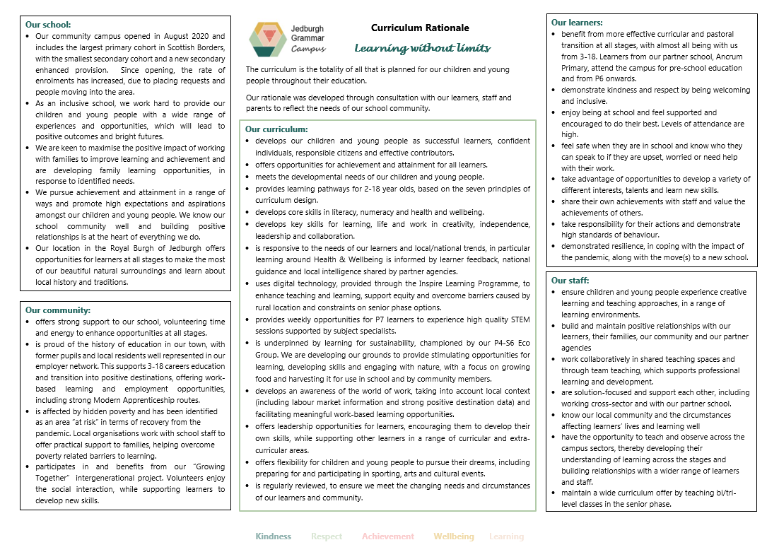
Please read the two mentioned consultations and comment directly to them, any comments on the curriculum rationale are to go directly to school.
This brought up discussion on the qualifications offered and the introduction of National Progression Awards.
Achievement – the children are being asked to fill in surveys to ensure all are making personal achievements both in and out of school.
School has high use of the Expressions App compared to other schools
High school homework is now on Showbie, there are drop-in support sessions every Wednesday for parents who are struggling with it.
Fundraising
Car boot sale went well raising £225 from cars as well as other money from Treasure hunt. P7 did well on the refreshment stall. Hoping to fix another car boot for around 26th March tbc. Other ideas include hamper raffles and or refreshments at events such as Winter Concert (13th Dec) and P1-2 Nativity (15th Dec), Escape rooms, Fashion Shows and further inflatable sessions.
To come up with a network of volunteers through a WhatsApp group. School can help circulate the details.
AOB
The school showed their thanks to the outgoing office bearers and Diane thanked her fellow outgoing office bearers.
Careers Fair – will go ahead at some point, postponed due to strike action
Work Experience week in S4 no longer for all, only undertaken if it will help the young person in their future career pathway.
To look at careers advice timings to make sure it is always before any subject options are made.
Next Meeting
12th January 2023

